**Car Rental Management System**



Session: 2021 – 2024

**Submitted by:**

Afraz Butt , 2021-CS-12

**Supervised by:**

Dr. Awais Hassan

Department of Computer Science

**University of Engineering and Technology**

**Lahore, Pakistan**

**Table Of Contents:**

1. Project Abstract 03
2. Project Description 03
3. Users of the Application 04
4. Functional Requirements 04
5. Wireframes 05
6. Data Structures 15
7. Data Flow Diagram 17
8. Functions Headers and Description 20
9. Flow Chart Diagram of All Functions 24
10. Complete Code 25
11. Test Cases of The Project 58
12. Possible Weakness in the Project and Future Direction

pertaining to the project 62

1. Conclusion 62
2. Future Planning 62

**Project Abstract:**

Car Rental Management System is a console-based Application, intended for the use of businesses.

Car industry is progressing by leaps and bounds in Pakistan. Between 2014 and 2018, this industry witnessed growth by a factor of 171%. In between different sectors and agents, this industry employs about 3.5 million people.

Pakistan is a middle-income country. This means many people cannot afford to buy a car in Pakistan. Obviously, these people then turn to rentals to use cars.

**Project Description:**

The system is designed to provide maximum services to both the Admin of the Car Rental Agency as well as the customer himself. The main idea is to provide all relevant features to the respective user, as well as to streamline the technology gap that currently exists between the Rental Agencies and their Customers in Pakistan. This will be exactly in line with the Government’s vision of a Technological Pakistan.

The concepts used in this project include Variables, Flag Variables, Functions, Loops (while and for), Parallel Arrays and File Handling.

The following topics are covered in this Documentation:

* The functional requirements, pertaining to each user type of the system.
* The corresponding wireframes to each user type, for each option, in CLI format.
* Data flow diagram.
* Data Structures used in the system (arrays, variables, files etc.)
* The headers of each function used as well as their short description.
* Flow chart of each function.
* Examining how the system reacts under certain test cases.

Additionally, this documentation also contains the description, where needed, of various processes and logic used in driving the program. This will clearly show to the evaluator, the purpose and logic behind such codes. This fact is also reinforced by adding comments in the code and using indentations and whitespaces, appropriately and effectively.

**Users Of the Application:**

This application is intended for two types of users:

1. Administrator of the Rental Agency (henceforth referred to as “ADMIN”)
2. Customer

Both types of users have different functionalities which will be fully discussed in the “Functional Requirements” section of the report.

**Functional Requirements:**

**As Admin:**

As admin, I will be able to:

* Add a car to the system
* Sort the added cars according to both kms driven and oil change
* View added Cars
* Update Car Details
* Delete Car Details
* Setting Prices Of different types of cars
* Create Maintenance Schedule
* View Maintenance Schedules
* Add new Users (Customer/Admin) to the system
* Validate Customer Records
* Generate Tax Returns
* Display Cash Reports
* Generate Recommendations based on customer reviews

**As Customer:**

As Customer, I will be able to:

* Initiate a Car Rental
* Check Booking Schedule
* Manage Multiple Bookings
* Add Reviews about previous Experiences
* View my Records
* Update My Personal Records (Phone number, Driving License Expiry date, address)

**Wireframes:**

Following are the wireframes of the completed application.

**Main Login Prompt:**

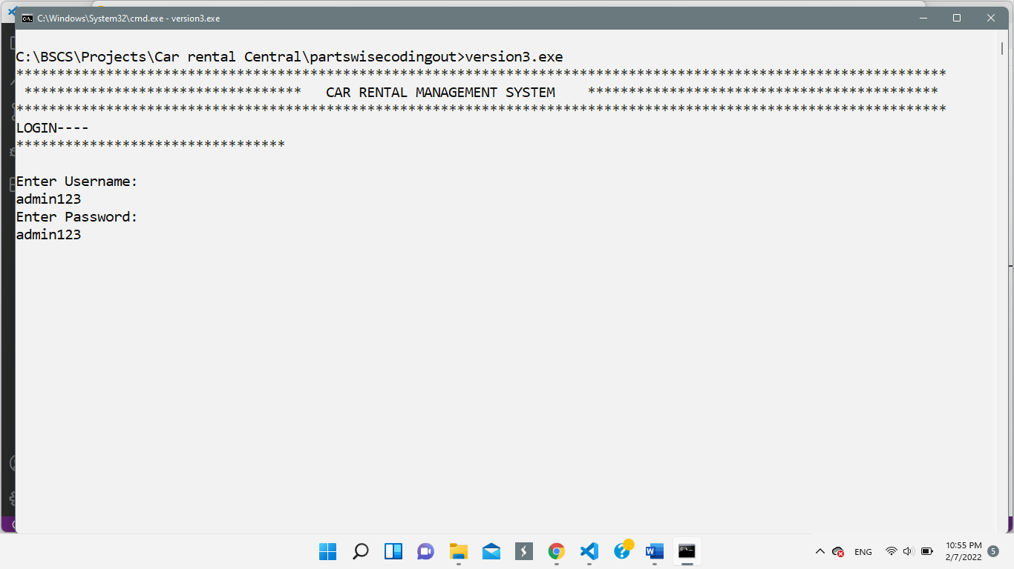

Because of the nature of the business application, the prompt to sign up for the application has been deliberately not kept. Access is given to the admin for adding up users (including customer accounts, separate from rental customers) of the application, to maintain the security (financial) of the admin and the business.

**Admin Menu:** 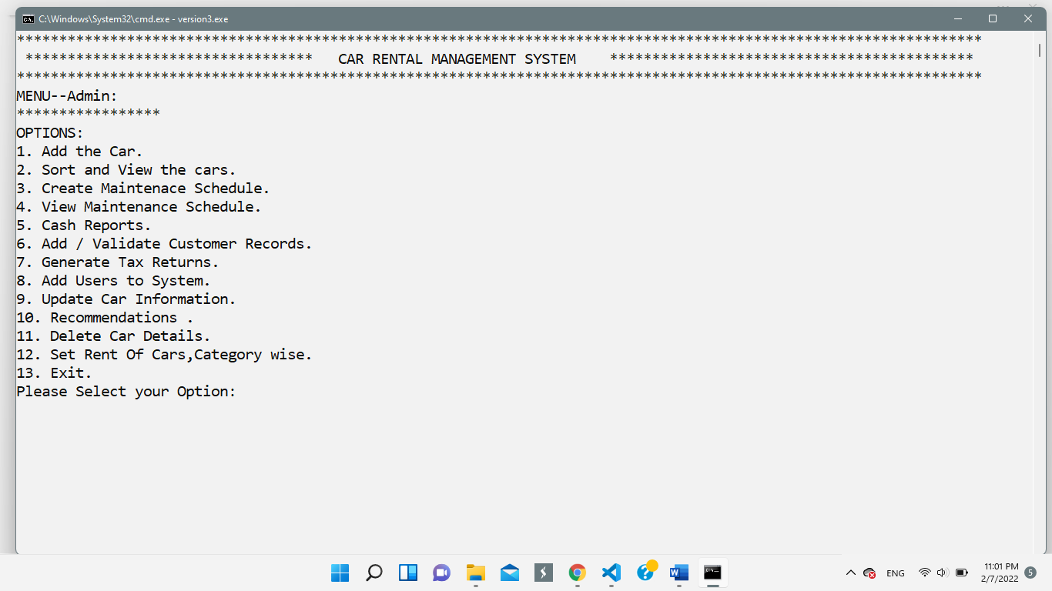

**Admin Options:**

* **Option-1: To Add A car**

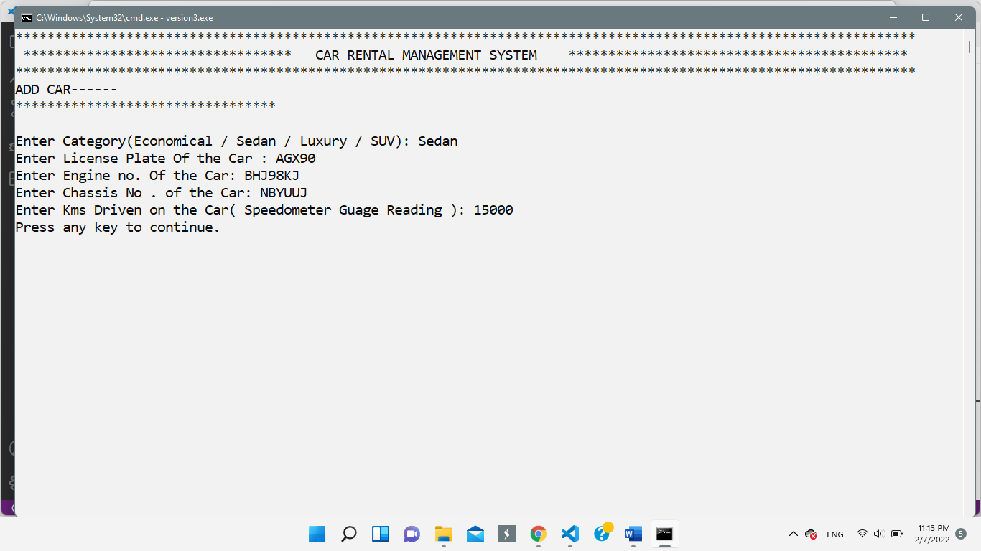

* **Option-2: To Sort and View the Cars**

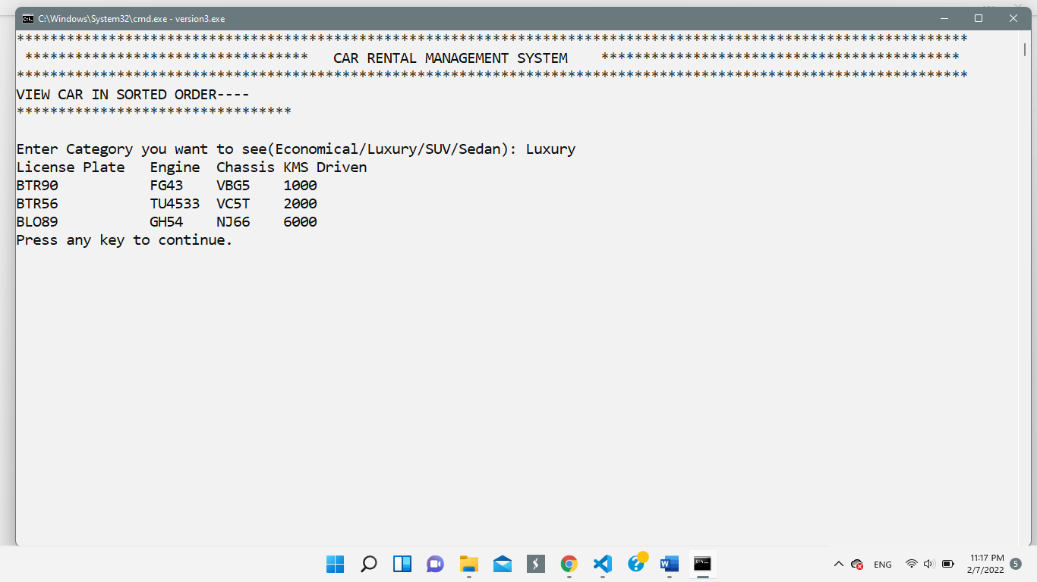

* **Option-3: Create Maintenance Schedule**

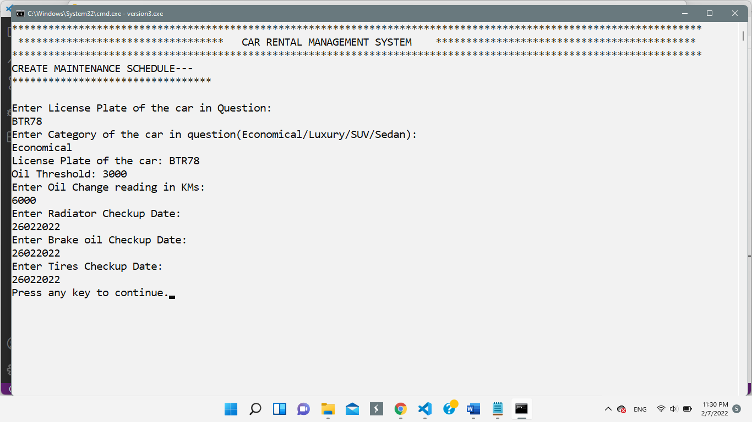

* 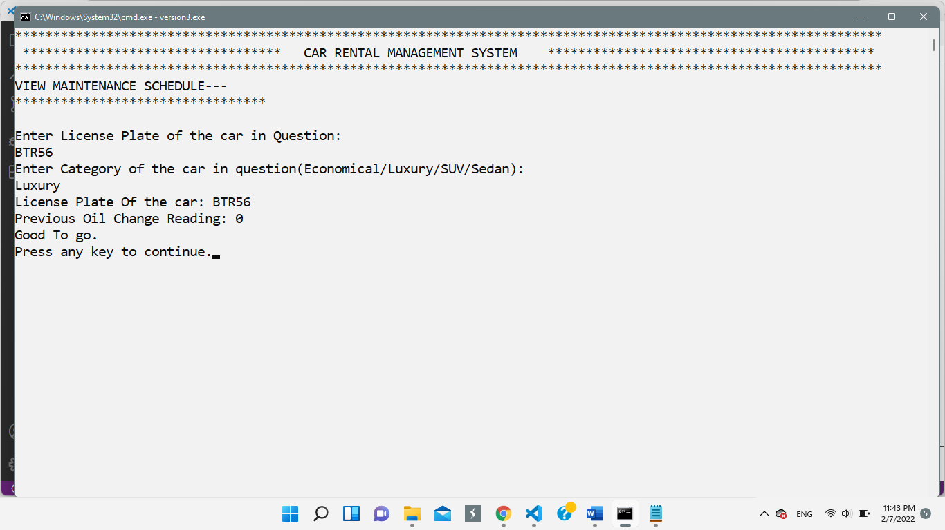**Option-4: To View Maintenance Schedule**
* **Option-5: Cash Reports**

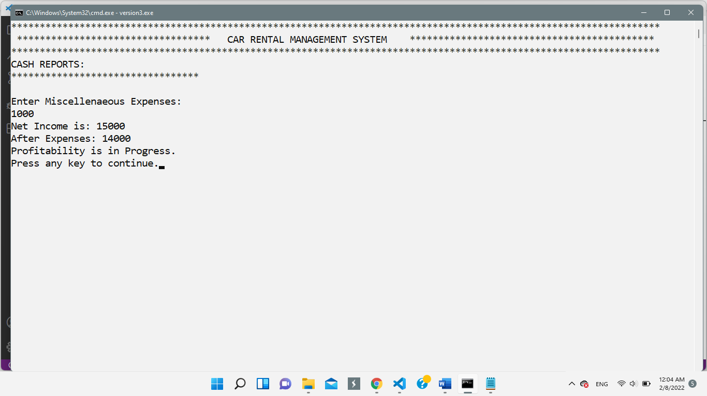

* **Option-6: Add/Validate Customer Records (Add Customer to the System)**

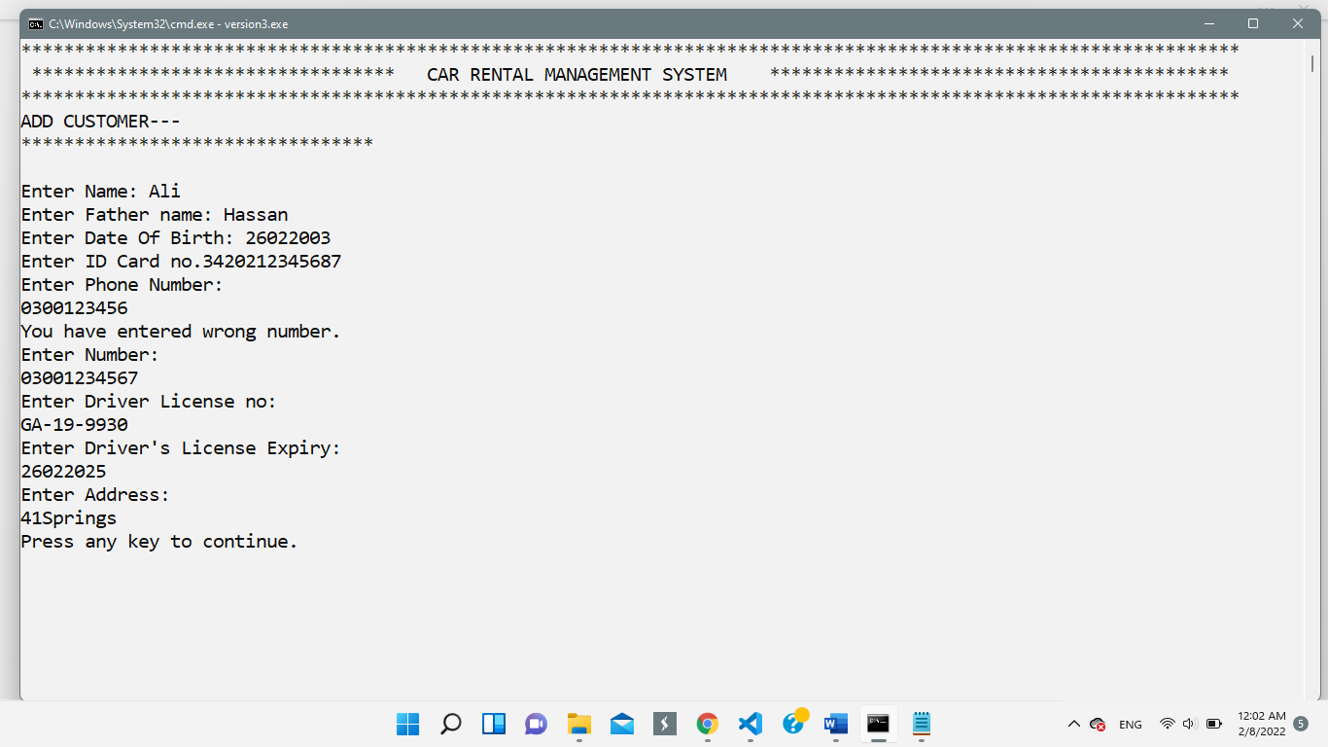

* **Option-7: Generate Tax Returns**

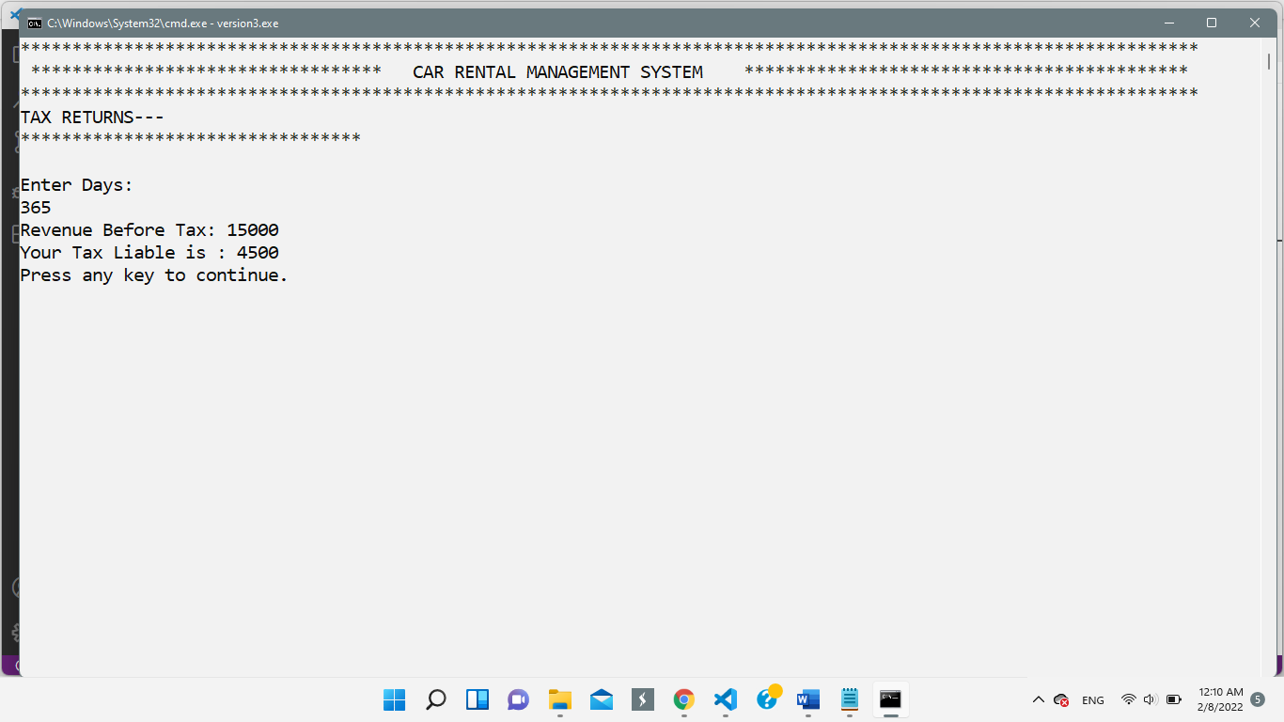

* 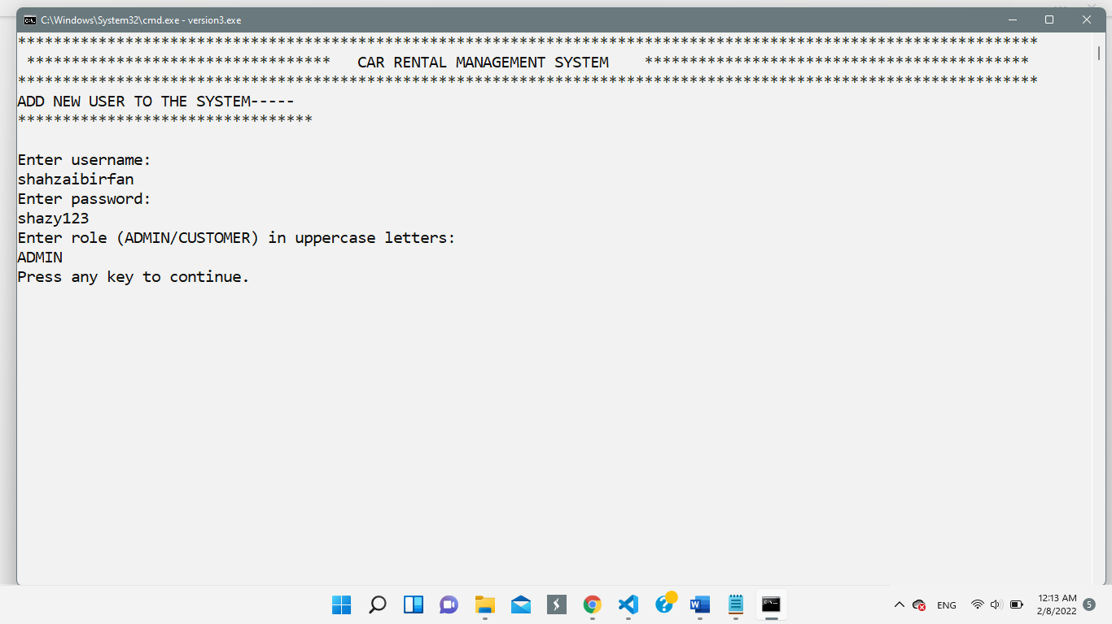**Option-8: Add Users to the System**
* **Option-9: Update Car Information**

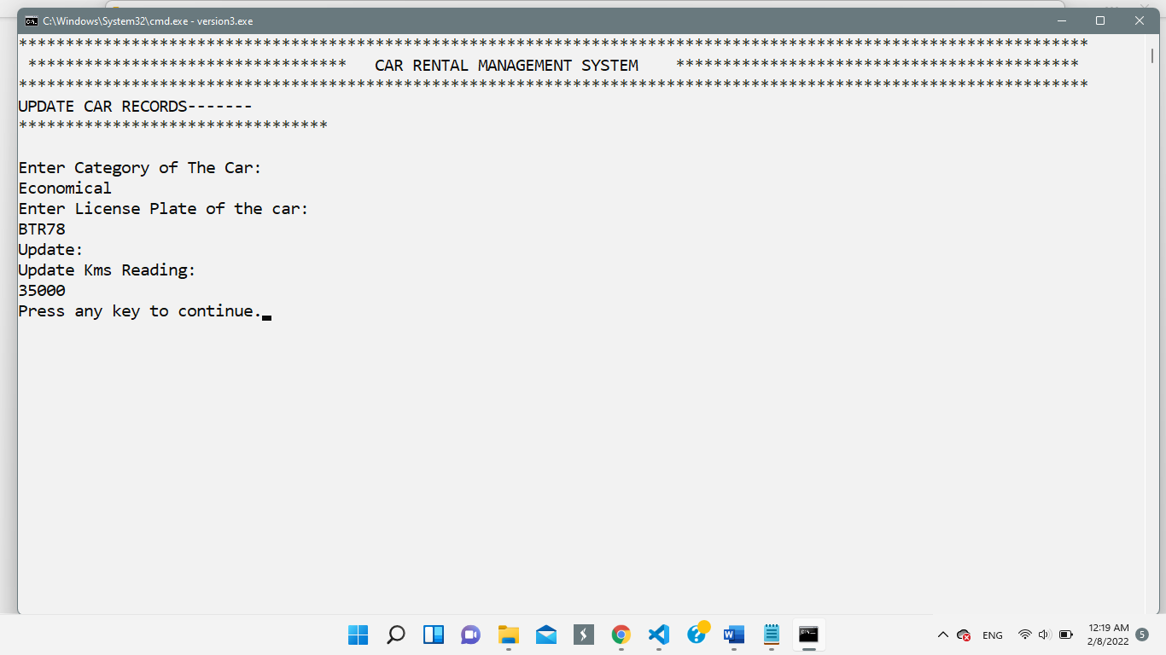

* **Option-10: Recommendation-I**

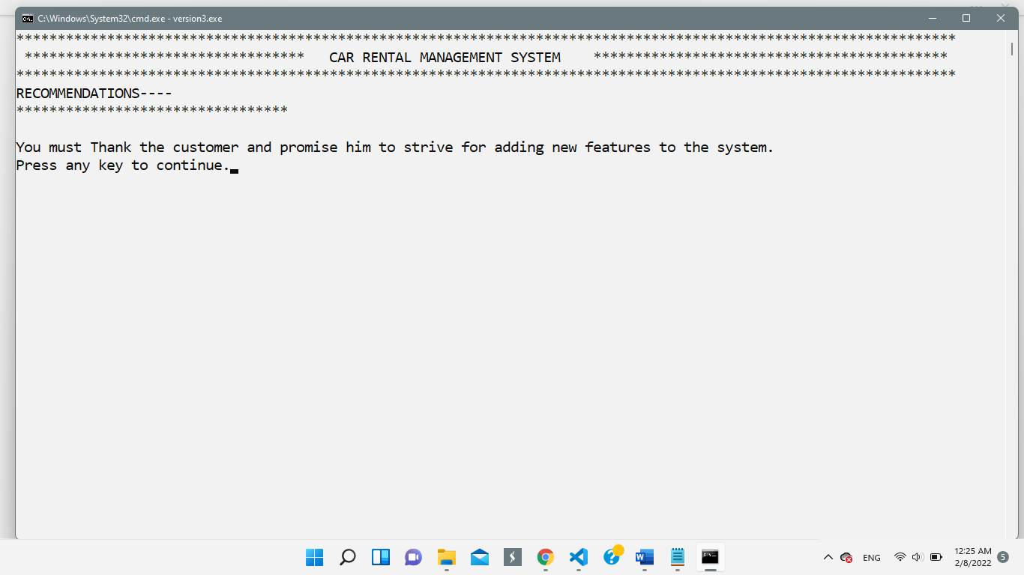

* 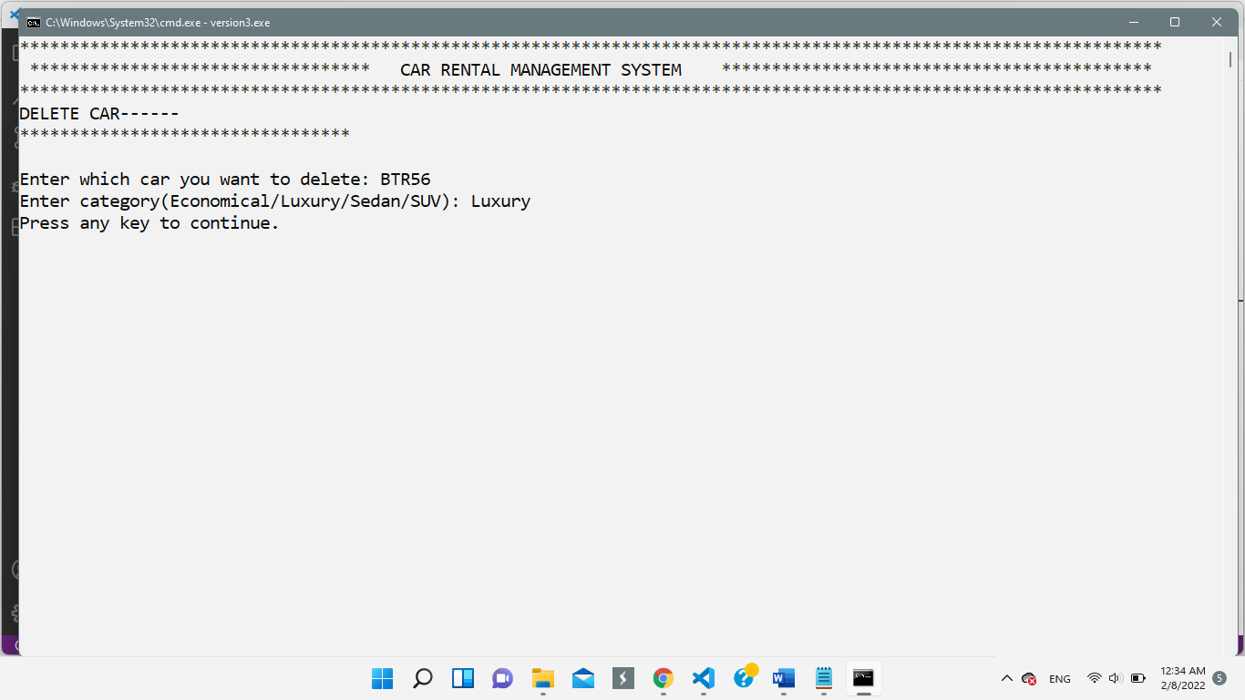**Option-11: Delete Car Details**
* **Option-12: Set Rent of Cars, Category Wise**

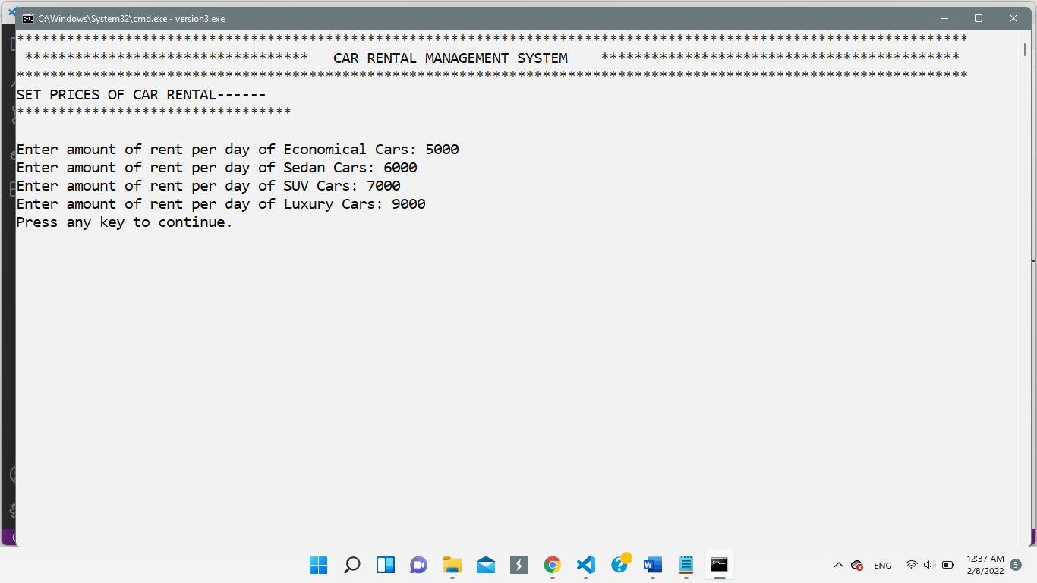

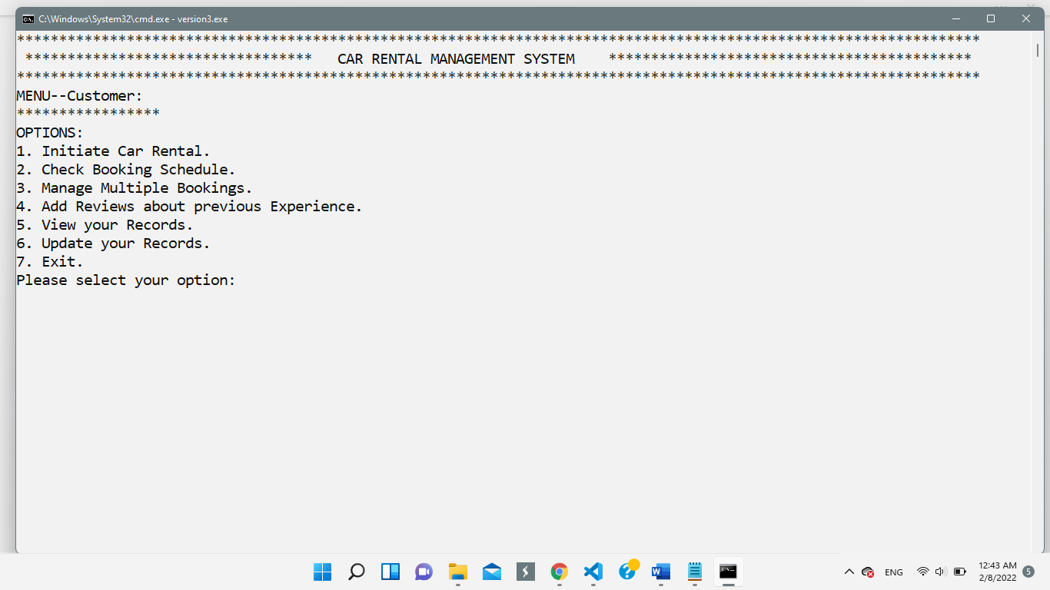 **Customer Menu:**

**Customer Options:**

* **Option-1: Initiate A Car Rental (Recommendation II)**

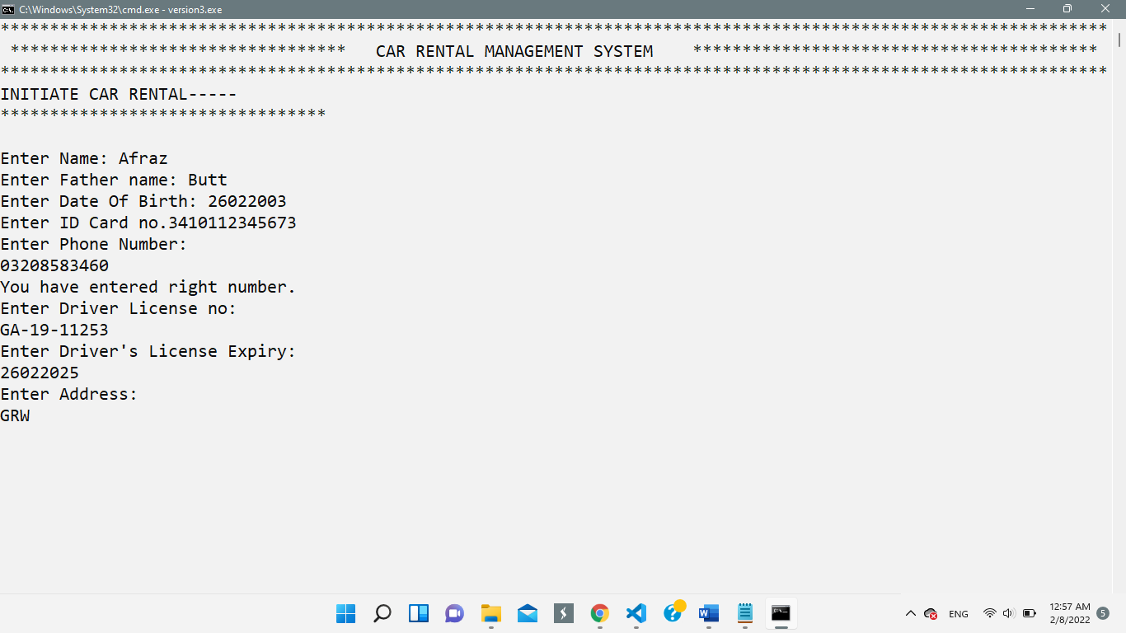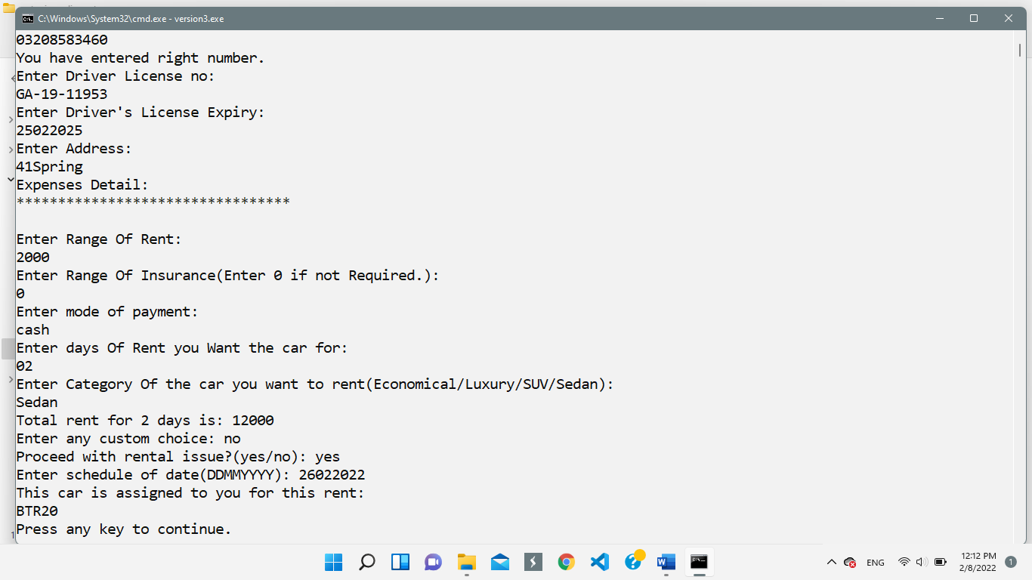

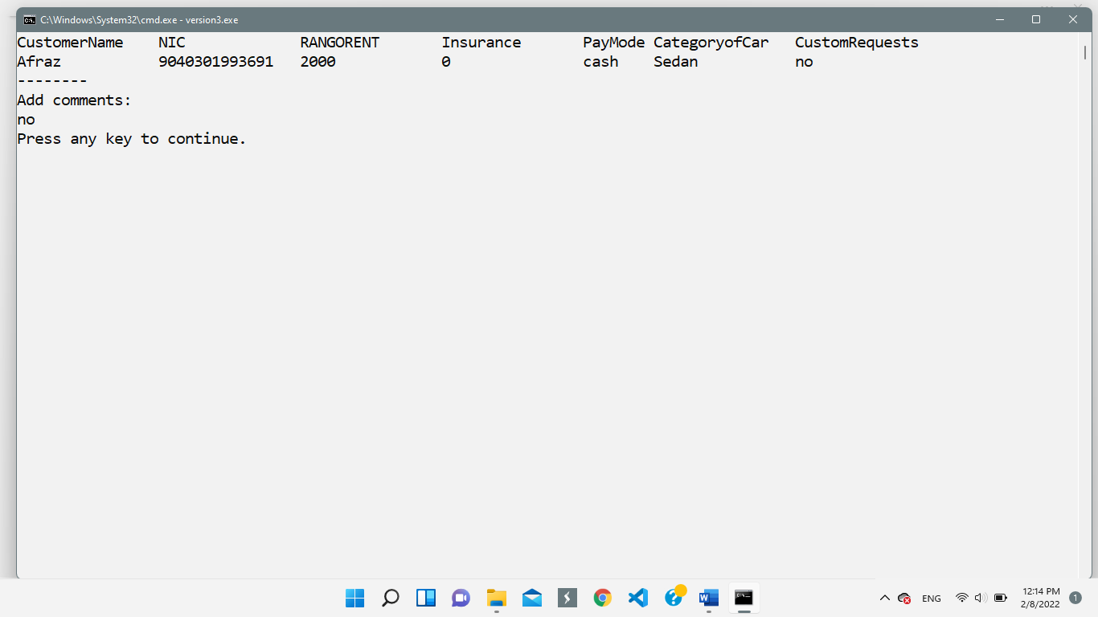

In this Part, the recommendation feature is implemented in the form of suggestion of cars. The system will automatically suggest the customer about the car in the system, if available.

* 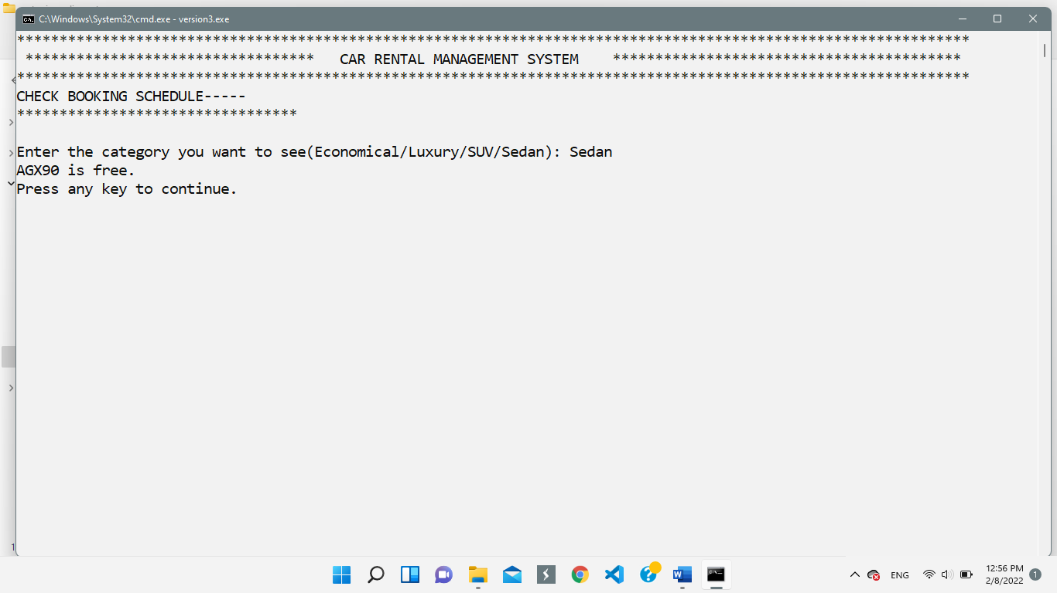**Option-2: Check Booking Schedules of the Car**
* **Option-3: Manage Multiple Bookings**

In this option, the user can manage multiple bookings. The flow of the code is the same as option 1, with the added difference that the program will execute under the same customer’s name, hence the purpose of multiple bookings.

* **Option-4: Add Reviews About Previous Experiences**

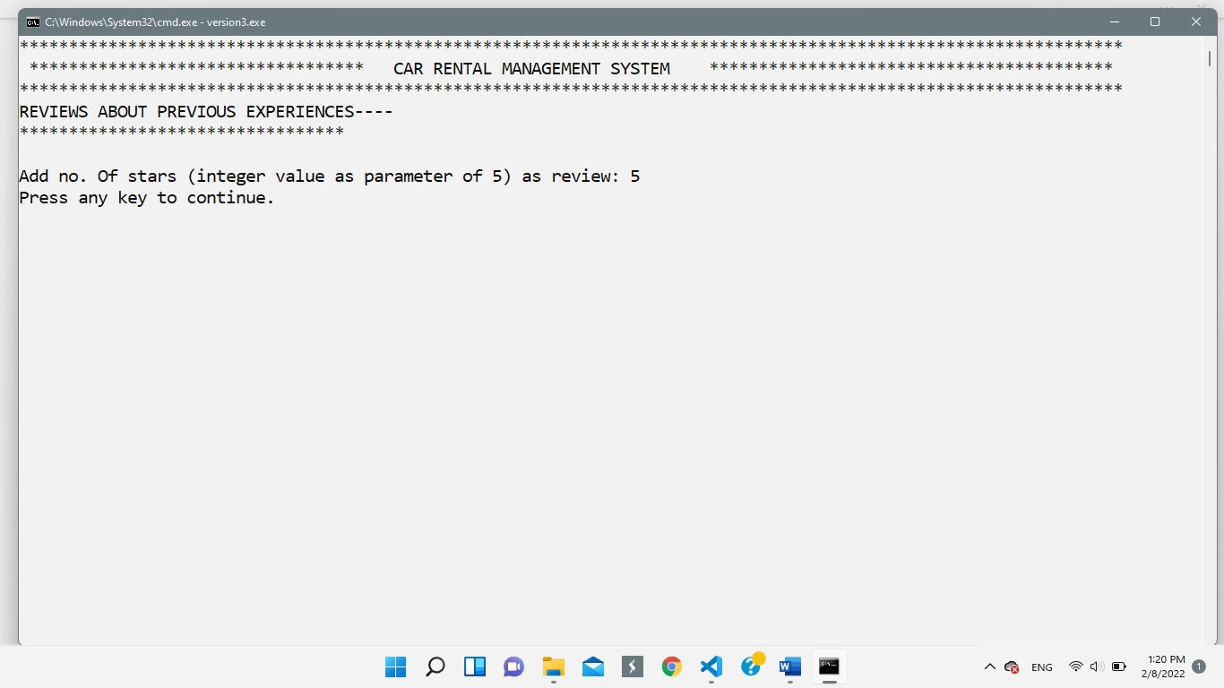

* 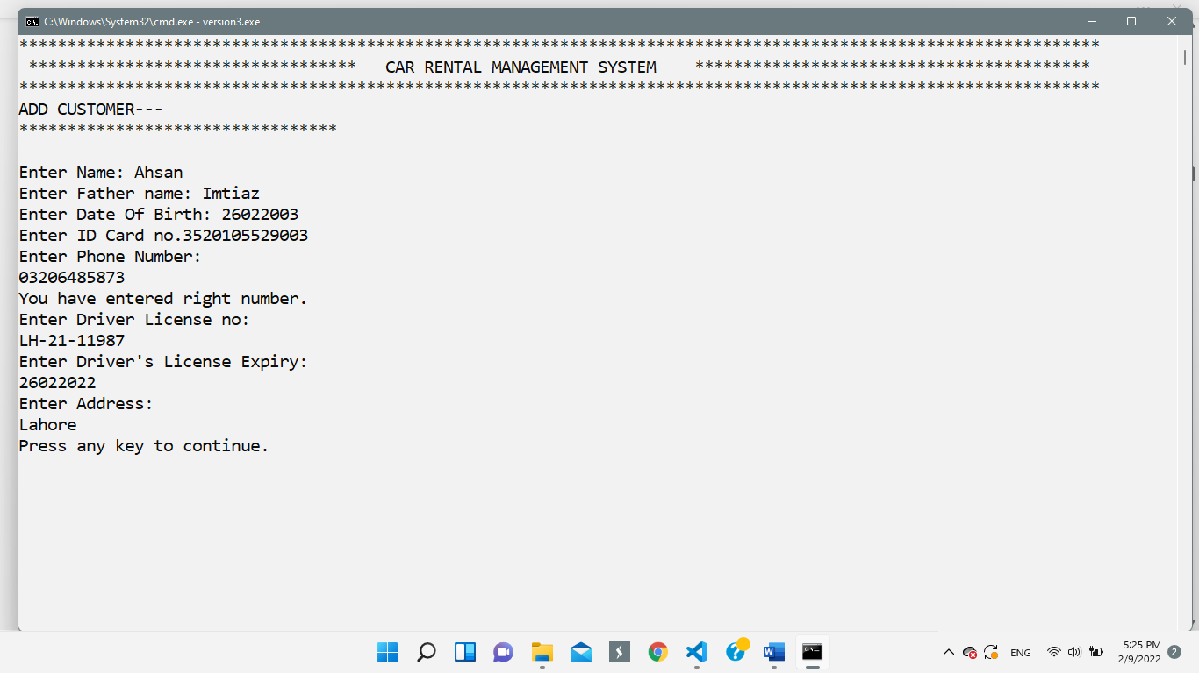**Option-5: View Personal Records**
* **Option-6: Update Personal Records**

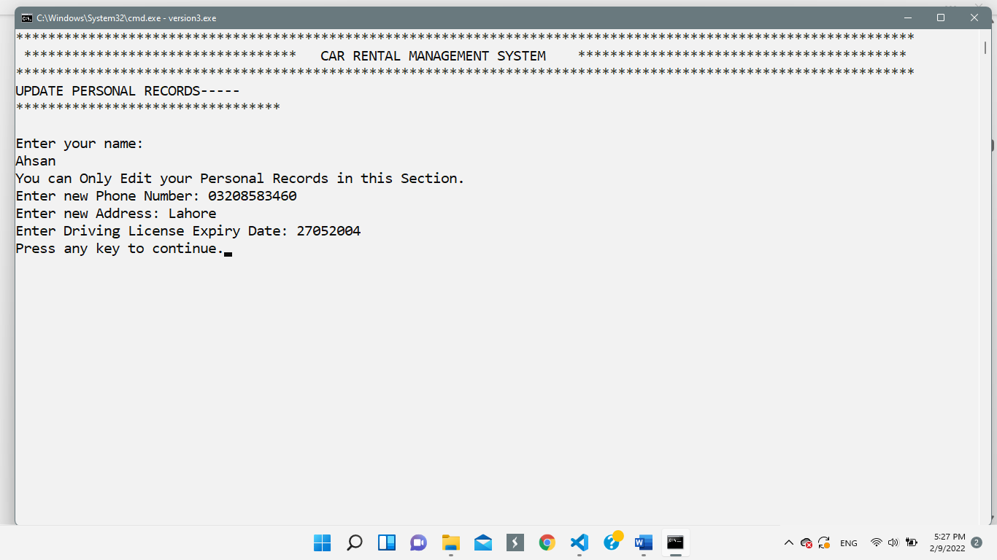

**Data Structures (Arrays):**

1. int kmsEconA[TOTAL_LIMIT]
2. int kmsEconD[TOTAL_LIMIT]
3. int kmsSedanA[TOTAL_LIMIT]
4. int kmsSedanD[TOTAL_LIMIT]
5. int kmsSUV_A[TOTAL_LIMIT]
6. int kmsSUV_D[TOTAL_LIMIT]
7. int kmsLuxuryA[TOTAL_LIMIT]
8. int kmsLuxuryD[TOTAL_LIMIT]
9. string LicensePlateEcon[TOTAL_LIMIT]
10. string LicensePlateSed[TOTAL_LIMIT]
11. string LicensePlateSUV[TOTAL_LIMIT]
12. string LicensePlateLux[TOTAL_LIMIT]
13. bool checkEcon[TOTAL_LIMIT]
14. bool checkSed[TOTAL_LIMIT]
15. bool checkSUV[TOTAL_LIMIT]
16. bool checkLux[TOTAL_LIMIT]
17. string scheduleddatesE[TOTAL_LIMIT]
18. string scheduleddatesSE[TOTAL_LIMIT]
19. string scheduleddatesSUV[TOTAL_LIMIT]
20. string scheduleddatesLUX[TOTAL_LIMIT]
21. int OC_Econ[TOTAL_LIMIT]
22. int OC_Sed[TOTAL_LIMIT]
23. int OC_SUV[TOTAL_LIMIT]
24. int OC_Lux[TOTAL_LIMIT]
25. string Radi_Econ[TOTAL_LIMIT]
26. string Radi_Sed[TOTAL_LIMIT]
27. string Radi_SUV[TOTAL_LIMIT]
28. string Radi_Lux[TOTAL_LIMIT]
29. string Brake_Econ[TOTAL_LIMIT]
30. string Brake_Sed[TOTAL_LIMIT]
31. string Brake_SUV[TOTAL_LIMIT]
32. string Brake_Lux[TOTAL_LIMIT]
33. string Tires_Econ[TOTAL_LIMIT]
34. string Tires_Lux[TOTAL_LIMIT]
35. string Tires_Sed[TOTAL_LIMIT]
36. string Tires_SUV[TOTAL_LIMIT]
37. string custName[TOTAL_LIMIT]
38. string custPat[TOTAL_LIMIT]
39. string custDoB[TOTAL_LIMIT]
40. string custnic[TOTAL_LIMIT]
41. string custPhone[TOTAL_LIMIT]
42. string custaddress[TOTAL_LIMIT]
43. string custdl[TOTAL_LIMIT]
44. string custdlexp[TOTAL_LIMIT]
45. string usernameA[TOTAL_LIMIT]
46. string passwordsA[TOTAL_LIMIT]
47. string rolesA[TOTAL_LIMIT]

Here, TOTAL_LIMIT is a constant integer variable, having value set to 20. In future, if required, this value can be changed accordingly.

**Data Flow Diagram:**

* **User Data**

The user data first flows from file to array. Then, if the option is toggled, the data flows from input (by user) to array and file.

New User Information gets stored in the file from array

Program Starts

Array

After Selected Option working

* **Car and Maintenance Data:**

The Car Data first flows from file to array. Then, relevant operation is performed on it and the data flows back to array. If the admin adds new Car, that data also flows from input to array and then to file.

App Start

Admin Add

New Car

/Maintenance

Array

File Handling, append mode

* **Income Prices of the Rentals:**

App Start

Array

User set new price

File Handling, out mod

* **Customer Records:**

File Handling

Customer Update Their Records

Program Starts

Array

**Function Headers and description:**

Following are given the description and headers of all the functions used in the program. Their Algorithms will be discussed in the next section.

1. **void header()**

**Description:** To print the header.

1. **void clearScreen()**

**Description:** To Clear The Screen after each option is selected and its working, implemented.

1. **void starspaces()**

**Description:** To Implement lines of asterisks, for spacing.

1. **string loginMenu()**

**Description:** This function, after taking input from the user, authenticates it with data in the array, and returns the role of the user, if the data was correct. Otherwise, it would return “Wrong credentials”.

1. **string menuadmin()**

**Description:** This function, takes input from admin in his menu. And returns the digit entered by the admin as a string value.

1. **char menucustomer()**

**Description:** This function, takes input from the customer in his menu, and returns the digit, as a character.

1. **void Add_Car();**

**Description:** This function, after taking all inputs, passes them to Function 8.

1. **void AddCartoArray(**string category, string LicensePlate, string engine, string chassis, int kmsdriven**)**

**Description:** This function, after being passed inputs from Function 7, then stores them into relevant arrays and files.

1. **void SortCars(**string category**)**

**Description:** This function sorts the added cars according to increasing kms readings.

1. **void ViewCars()**

**Description:** To View Cars.

1. **void AddnewUser()**

**Description:** To Take Input from user and pass them to function 12.

1. **void addUser(**string name, string pass, string role**)**

**Description:** This function, after being passed inputs from function 7, then stores them into relevant arrays and files.

1. **void CreateMaintenance(**string licenseplate, string category**)**

**Description:** To create maintenance schedule of the car.

1. **void viewMaintenance(**string licensePlate,string economical**)**

**Description:** To view maintenance schedule of the car.

1. **void SortOil(**string category**)**

**Description:** To sort the cars according to oil change readings.

1. **void addcustomer()**

**Description:** To take input from the admin and pass it to Function 17.

1. **void AddCustomertoArray**(string name, string fathername ,string dOB, string customernic, string customerphone, string dlno, string dlexp, string address **)**

**Description:** To take parameters passed from function 17 and storing them into relevant arrays and files.

1. **int getSum()**

**Description:** To return the sum of all car rental income data, that was loaded from the file.

1. **void viewCar(**string category**)**

**Description:** To View all cars of a particular category.

1. **void updatecar(**string category**)**

**Description:** To Update Car Records .

1. **void StartRental()**

**Description:** To initiate car rental process.

1. **void checkBookingStatus(**string category**)**

**Description:** To check booking status of the cars in a specific category.

1. **void addreviews()**

**Description:** To add reviews (This will generate recommendations on admin side).

1. **void updateRecords(**string name**)**

**Description:** To Update Customer Personal Records.

1. **void viewRecords(**string name**)**

**Description:** To view customer records.

1. **void loadData()**

**Description:** To load Data from file to memory each time the program starts.

1. **string parseData(**string row, int field**)**

**Description:** To parse each data in the CSV file and populate it into array. Returns the value in string.

1. **int ParseValue(**string row, int field**)**

**Description:** To Parse Data in CSV file and populate into array. Returns the value in integer.

1. **void storeoil(**string category**)**

**Description:** To store oil change value of each category in file.

1. **void StoreRentalPrices()**

**Description:** To Store Car Rental Prices in a CSV file.

1. **void loadUserData()**

**Description:** To Load User Data from file to array.

1. **void loadCarData()**

**Description:** To Load Car Data from file to array.

1. **void loadMainteneanceData()**

**Description:** To Load Maintenance Data from file to array.

1. **void loadCustomerData()**

**Description:** To Load Customer Data from file to array.

1. **void loadRentalData()**

**Description:** To Load Rental Data from file to array.

1. **void loadIncome()**

**Description:** To Load Income Data from file to array.

1. **void loadStatus()**

**Description:** To Load Status of rental(dates and Boolean values) Data from file to array.

**Flow Chart Diagram of Functions:**

**Complete Code with Corresponding wireframes:**

In this section, complete code along with the wireframe of each section of the application is given. This will help in more dynamic understanding of the project. For further facilitation, comments are also added.

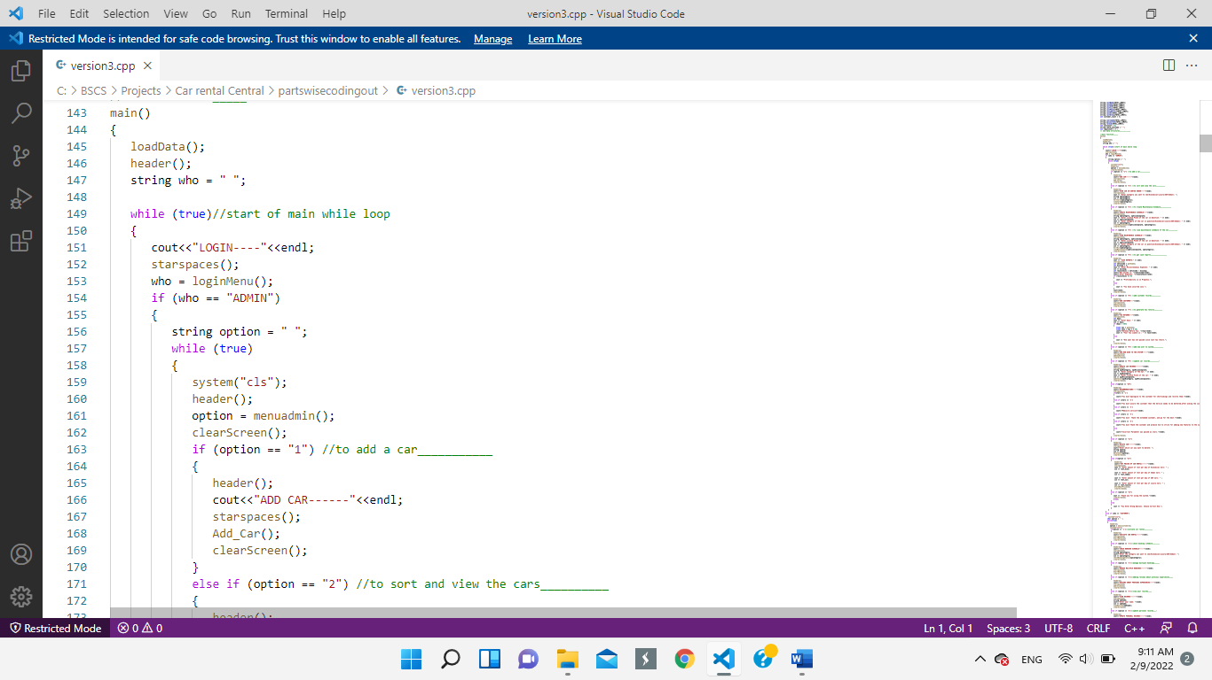**Login Prompt:**

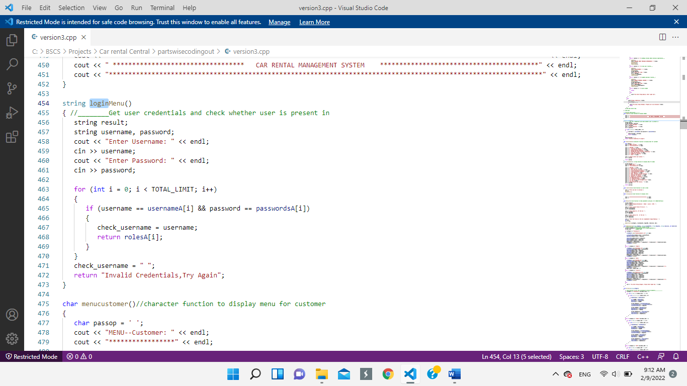

**Wireframe:**



**Admin Menu:**

**Admin Menu:**

**Code:**

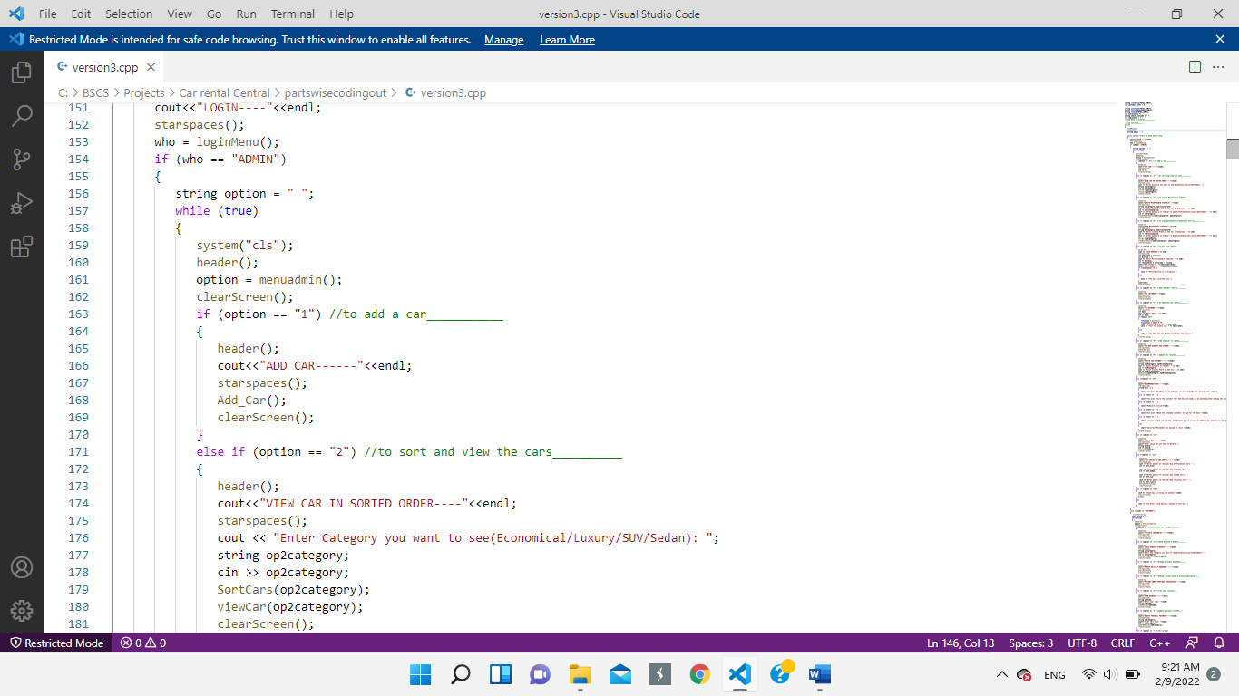

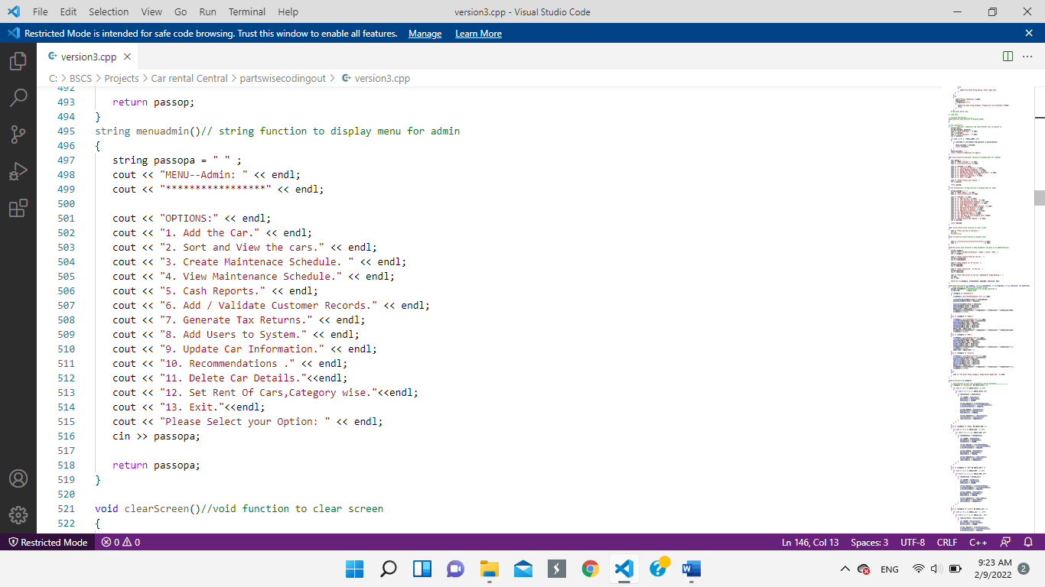

**Wireframe:**



**Admin Option-1: Add A Car**

**Code:**

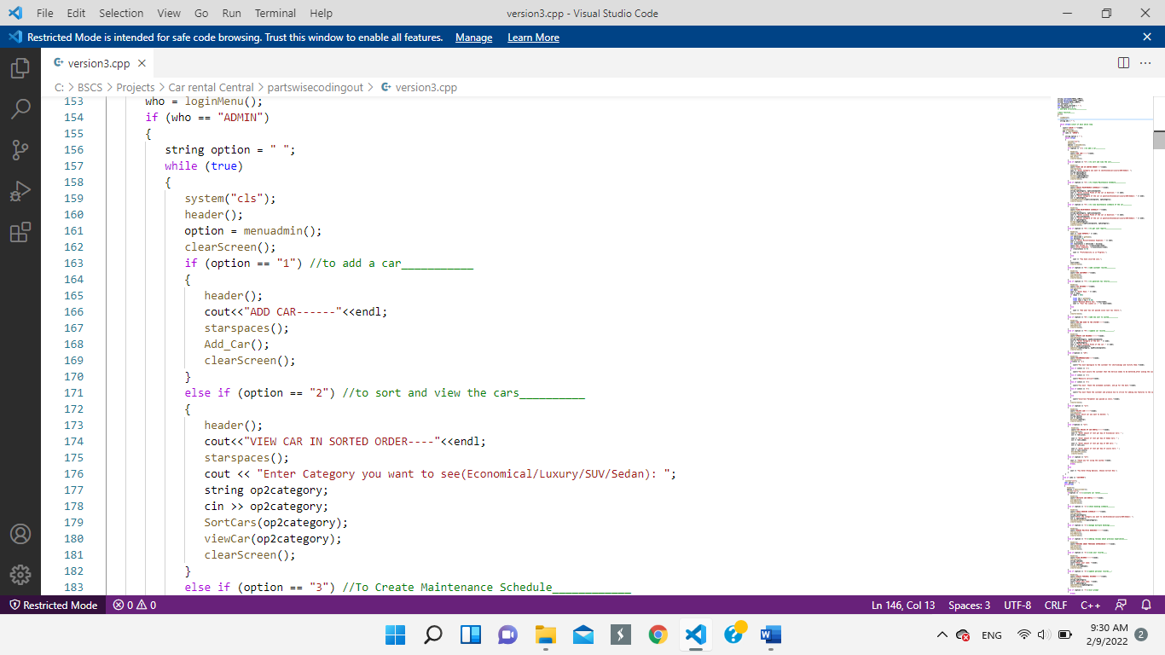

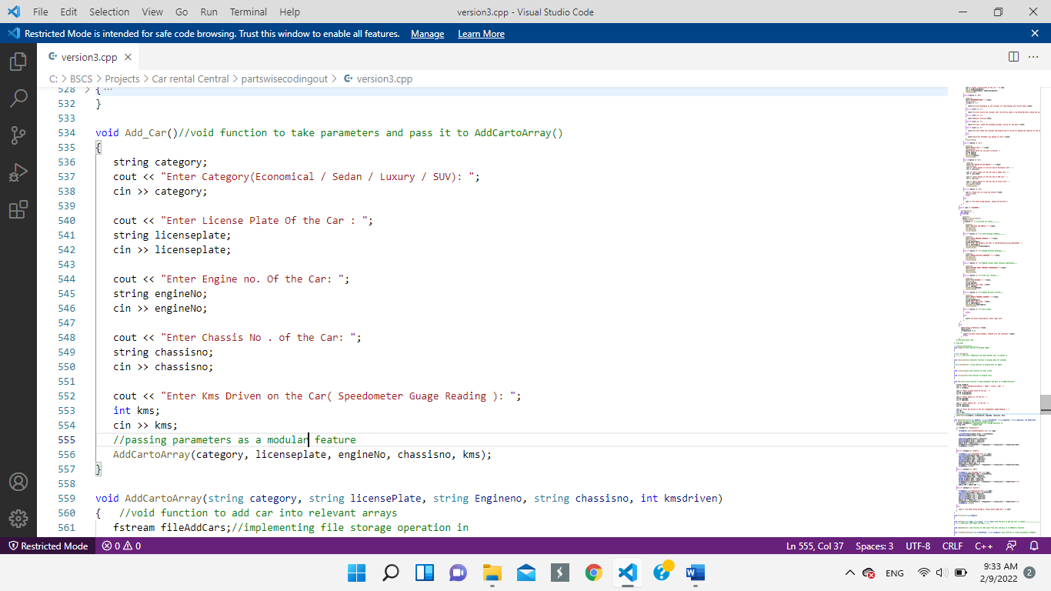

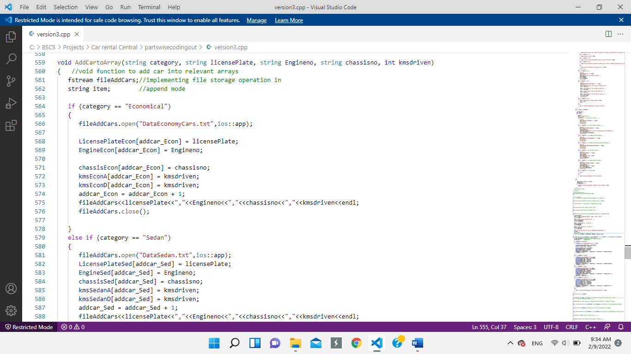

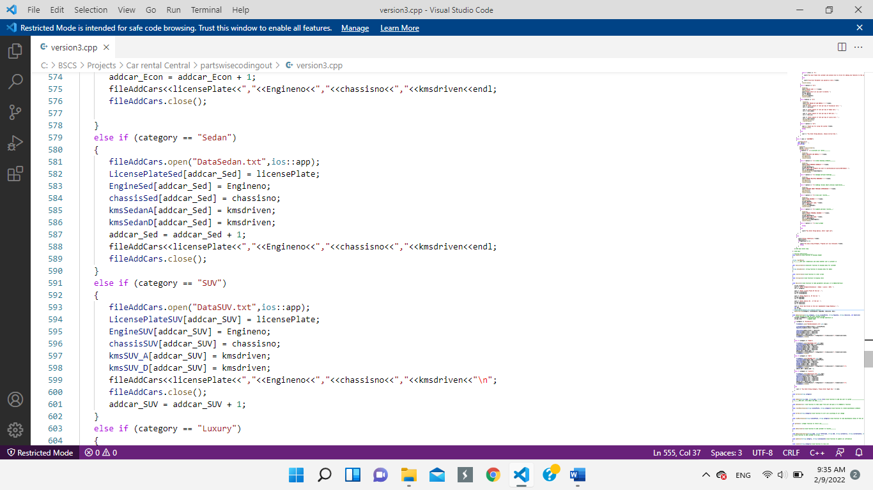



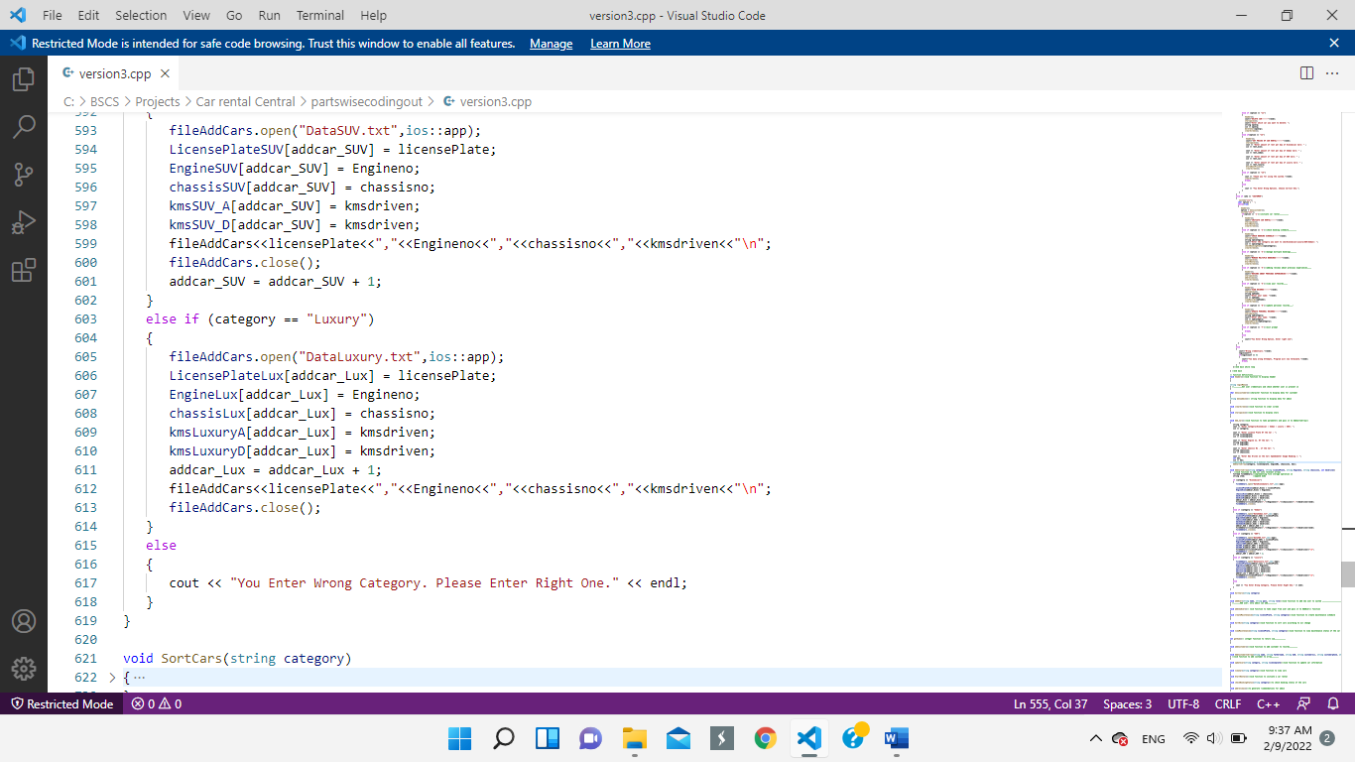

**Wireframe:**



**Admin Option-2: Sort and View Cars**

**Code:**

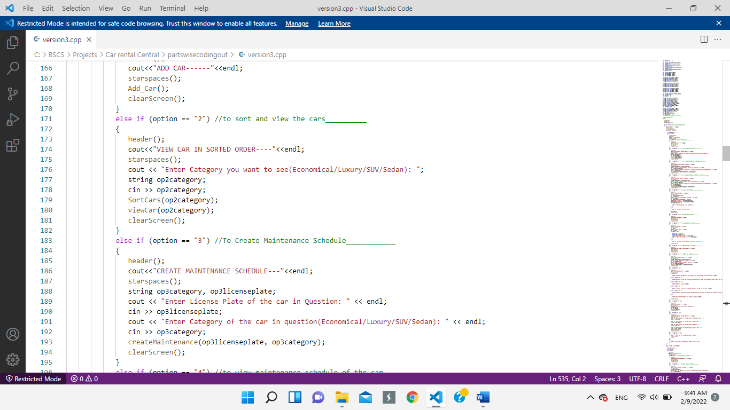

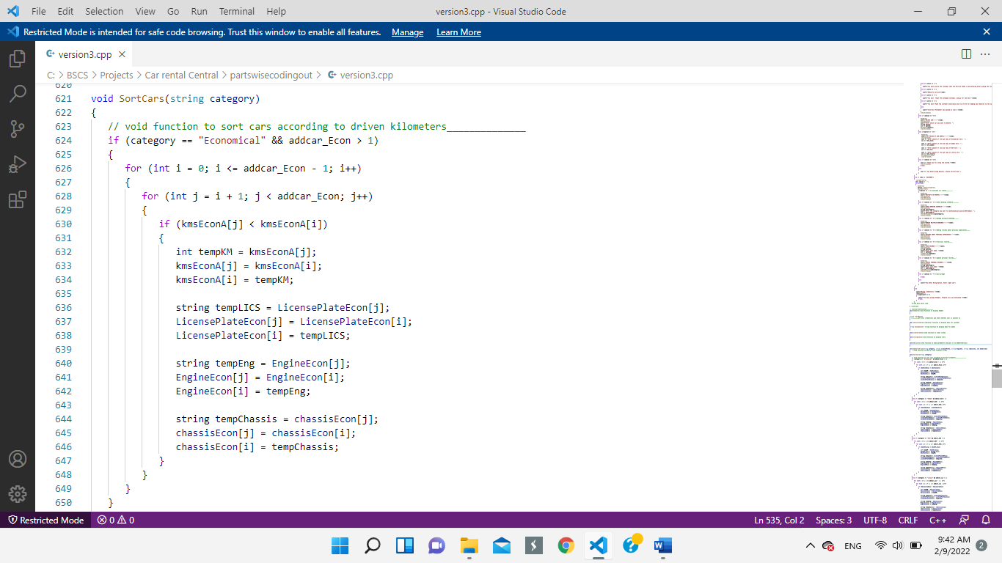

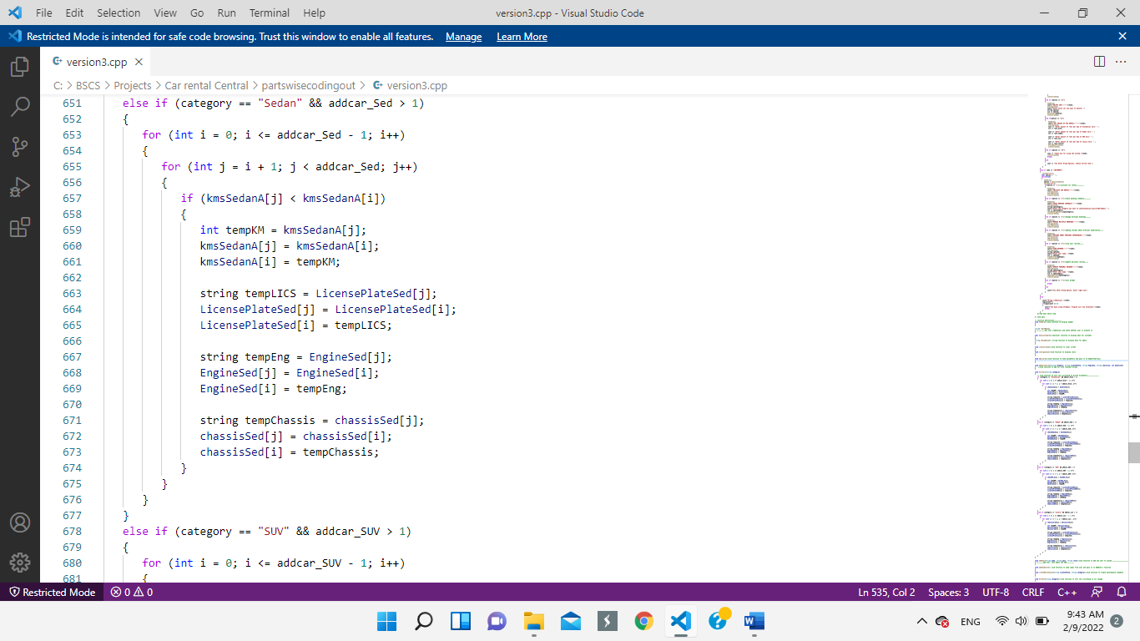

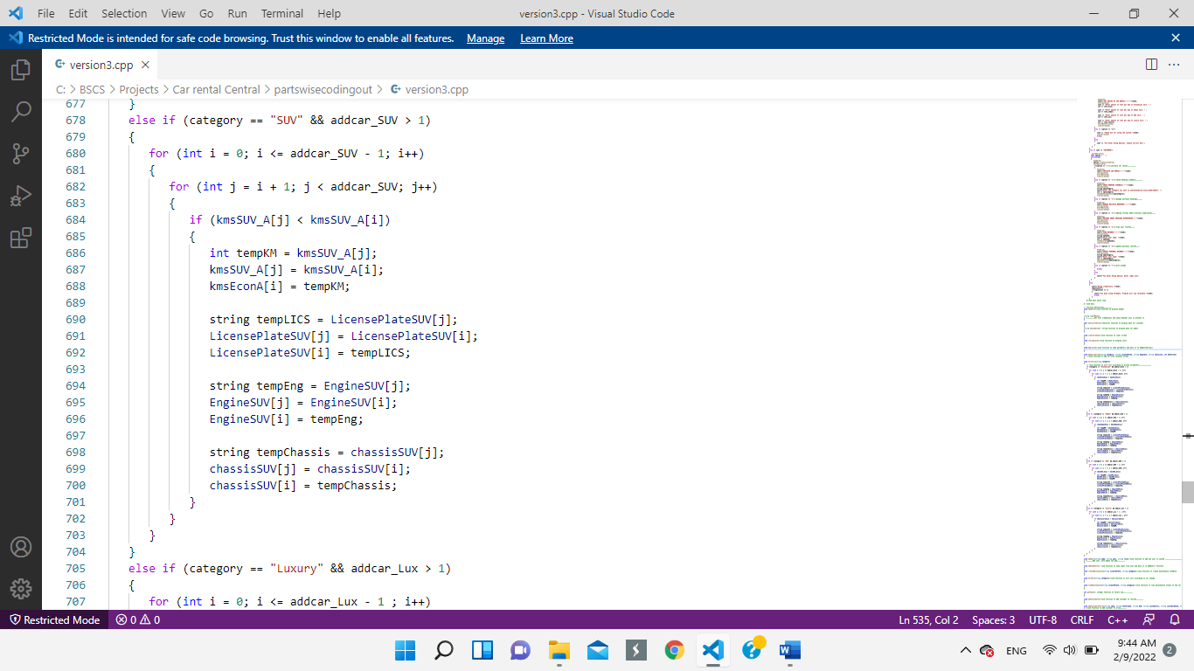

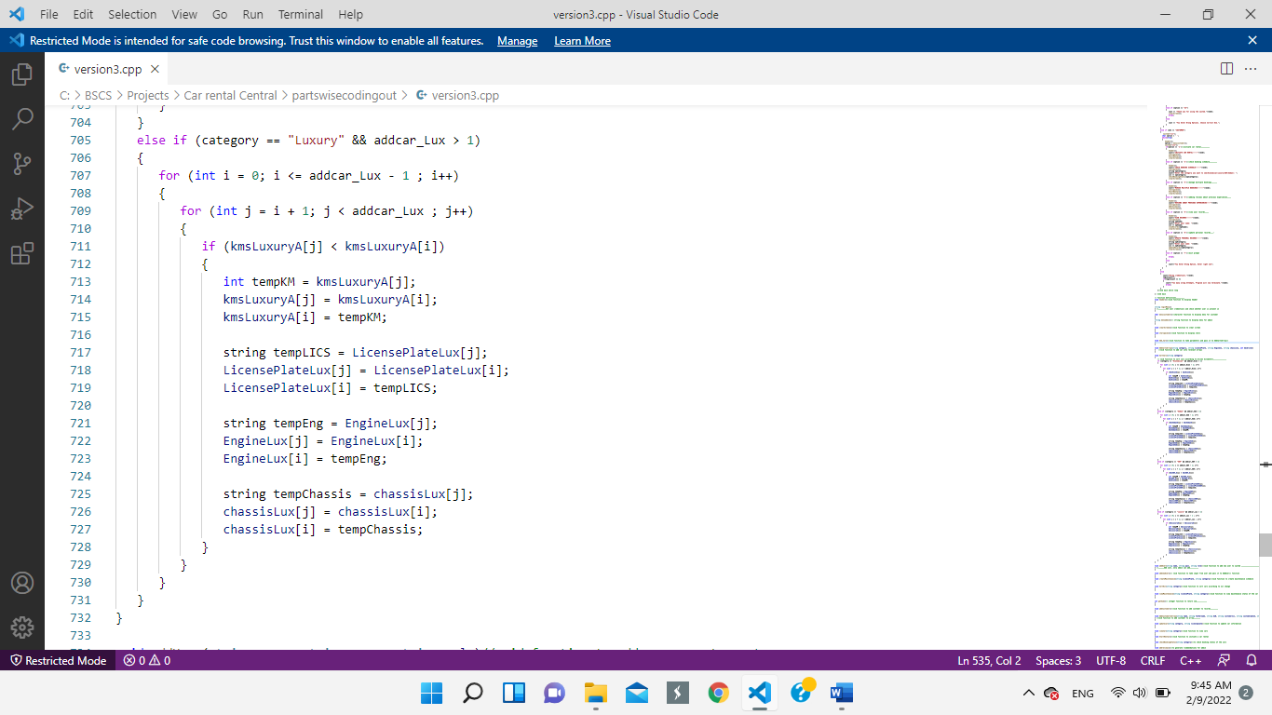

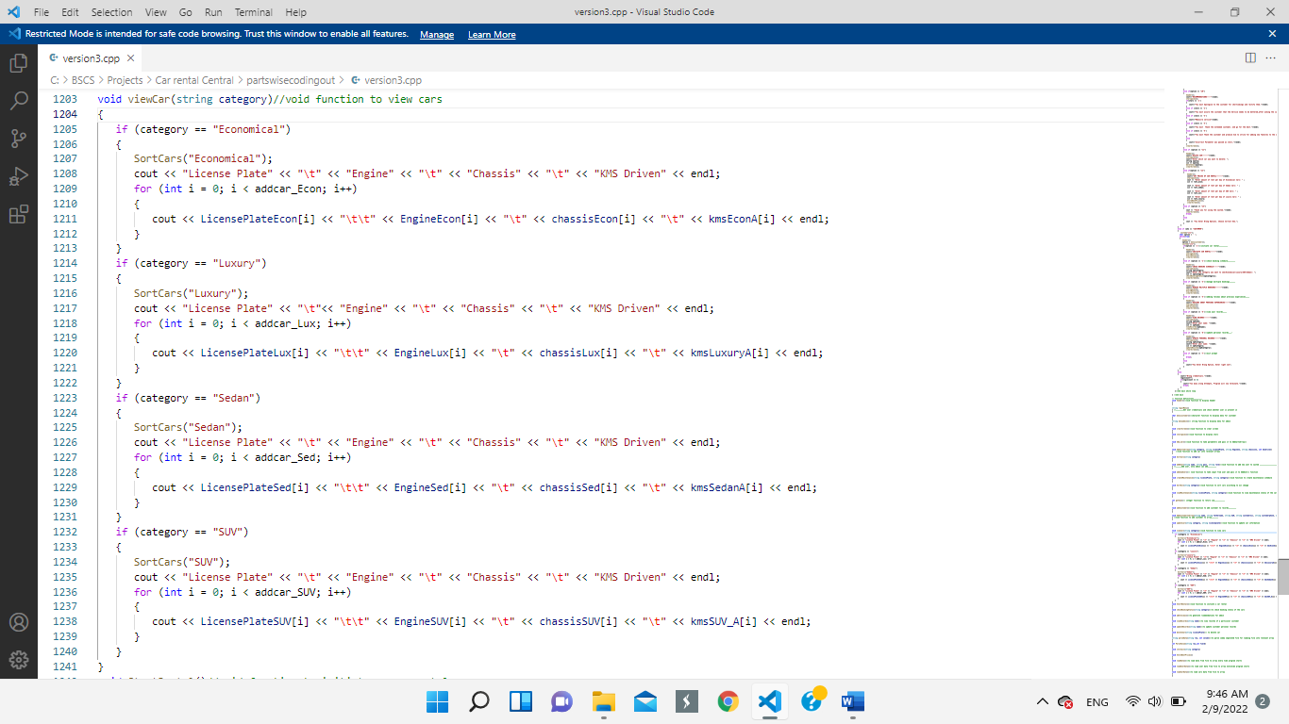

**Wireframe:**

**Admin Option-2: Sort and View the Cars**

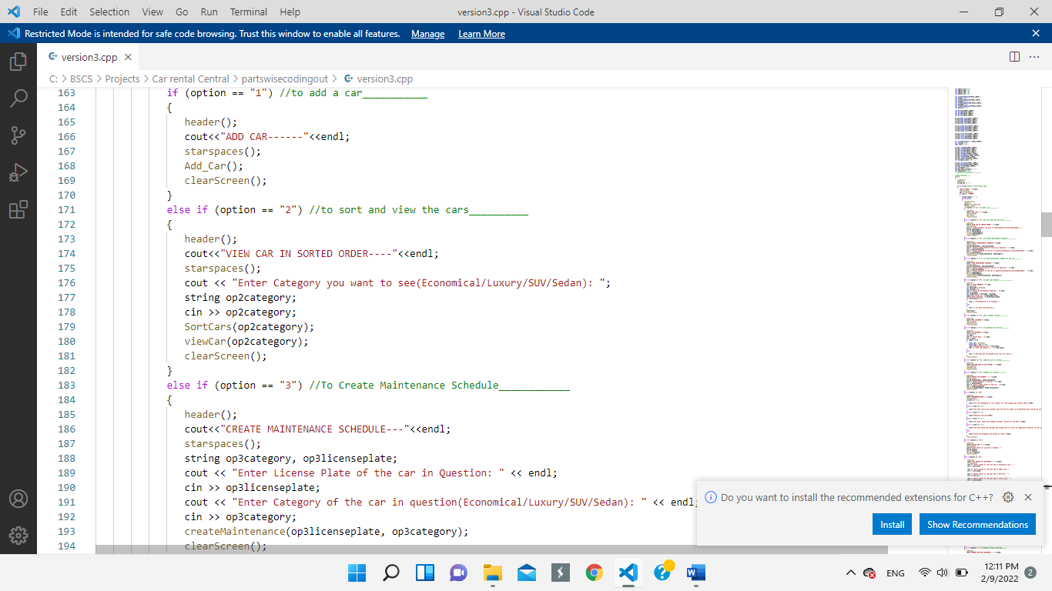 **Code:**

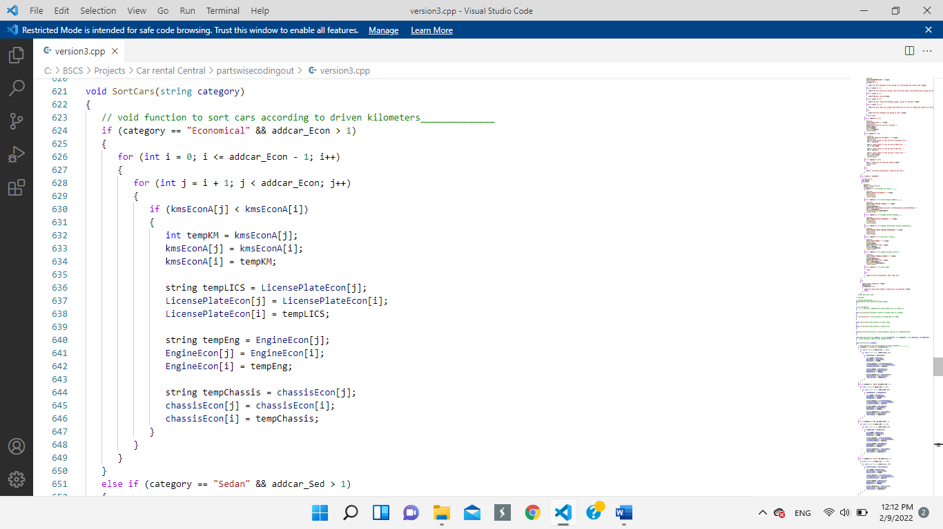

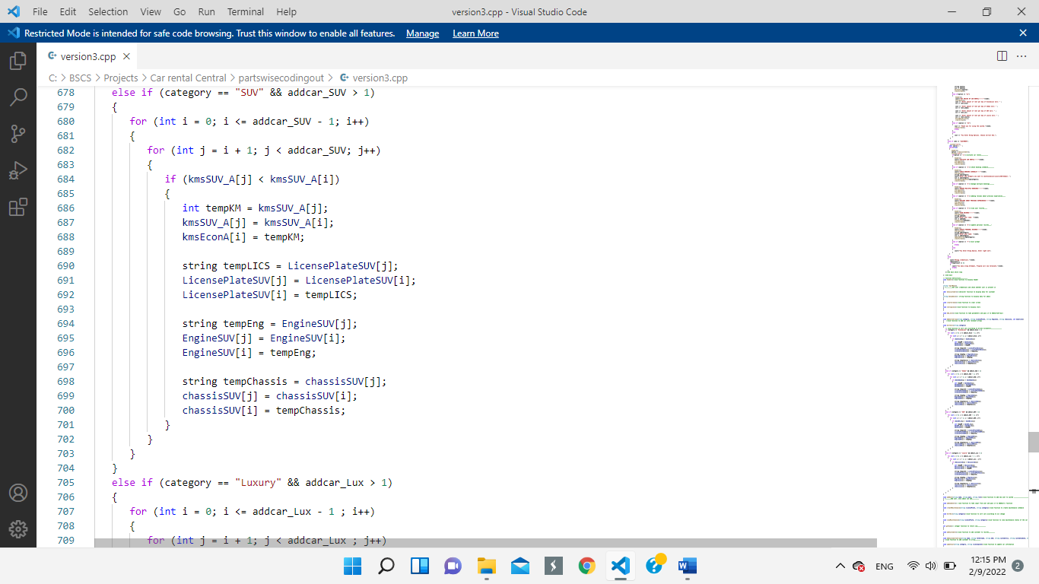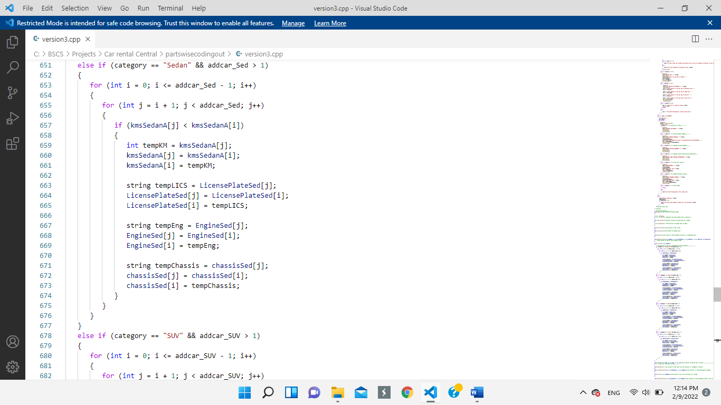

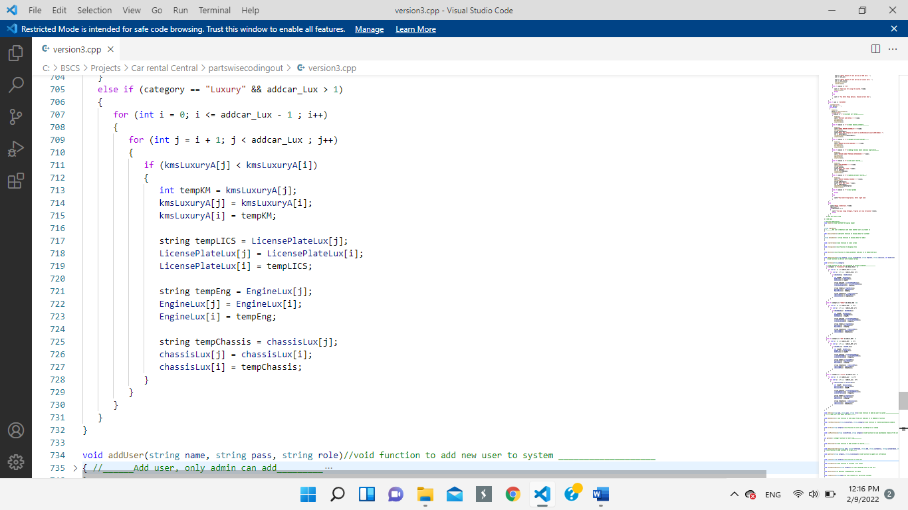

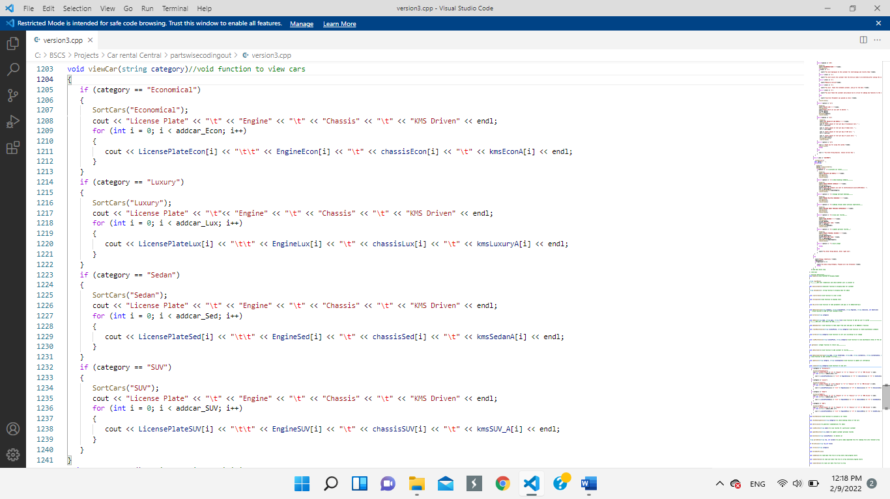

**Wireframe:**



**Admin Option-3: To Create Maintenance Schedule**

**Code:**

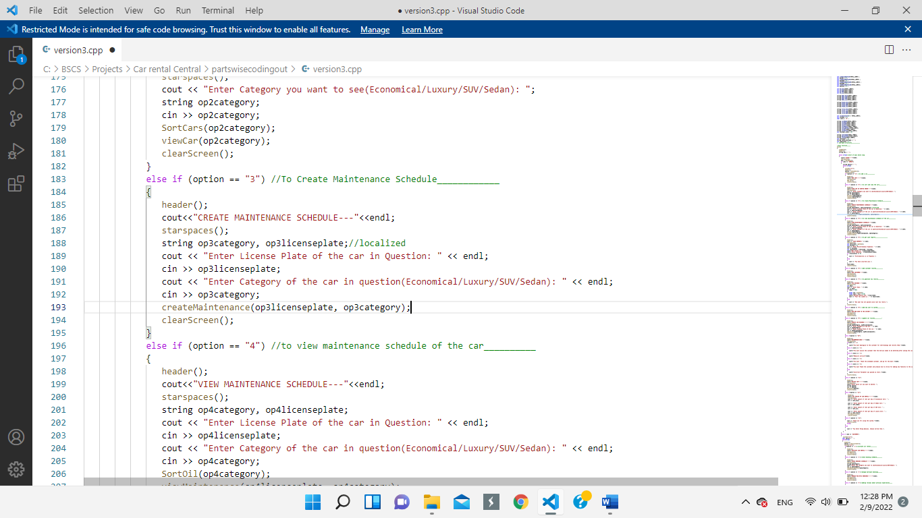

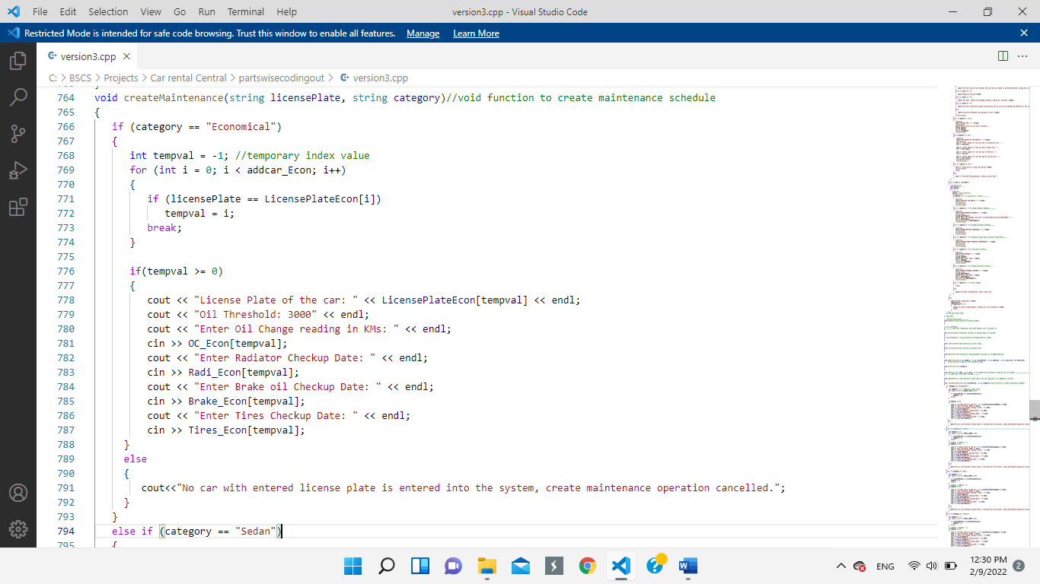

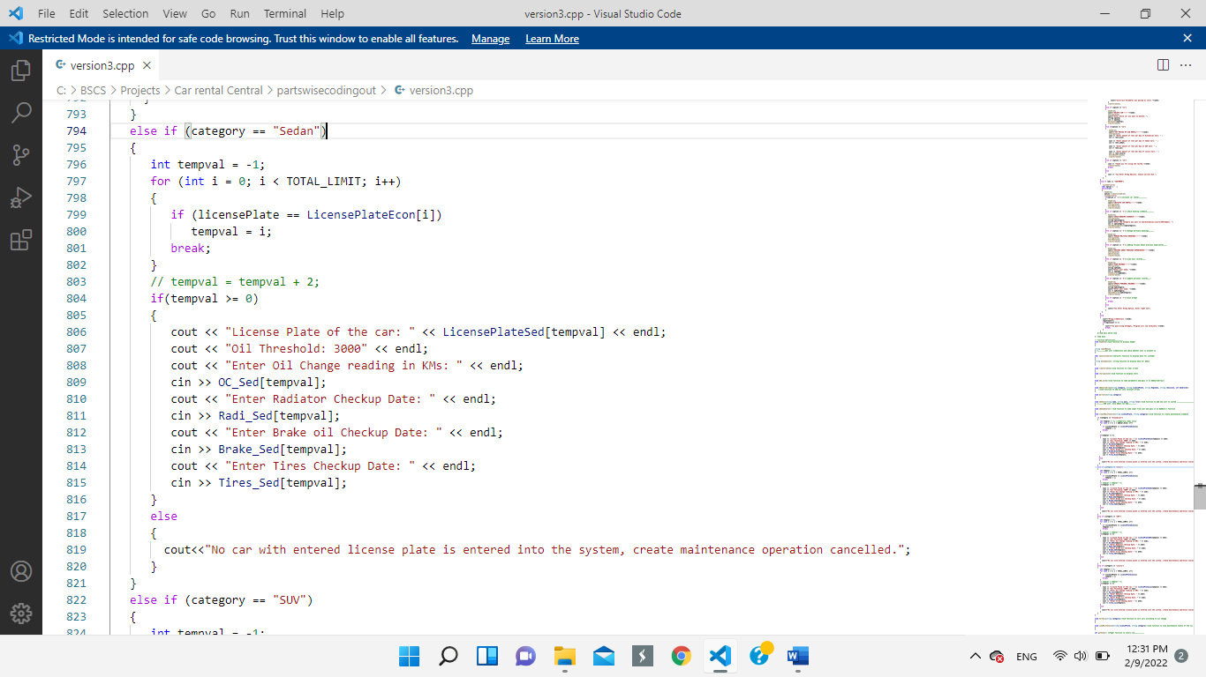

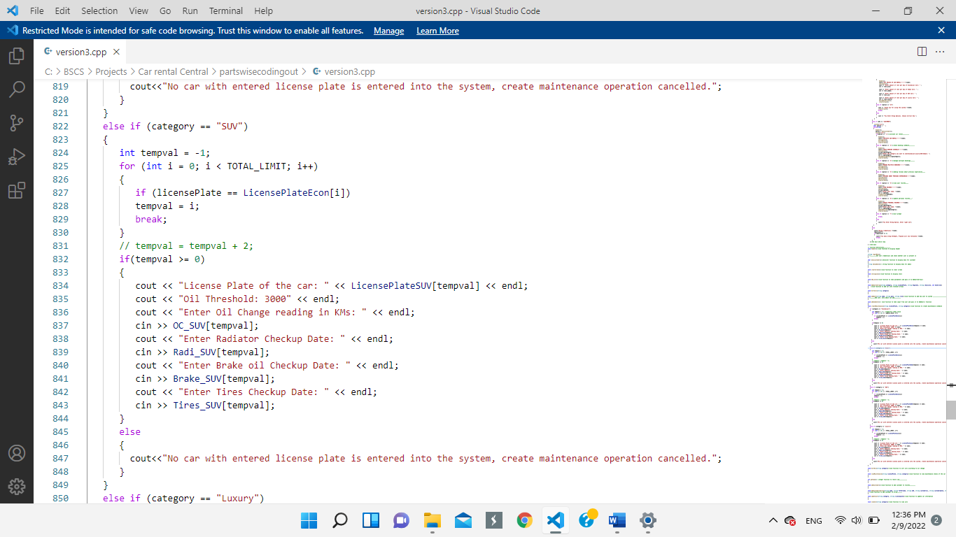

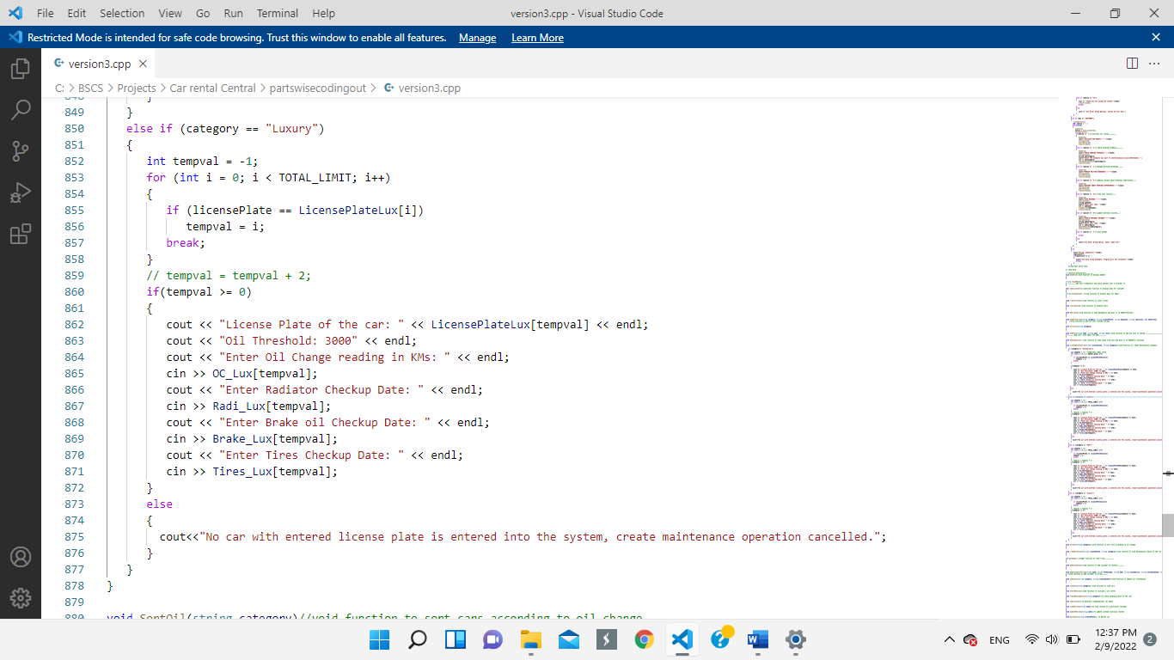

 **Wireframe:**

**Admin Option-4: To View Maintenance Schedule**

**Code:**

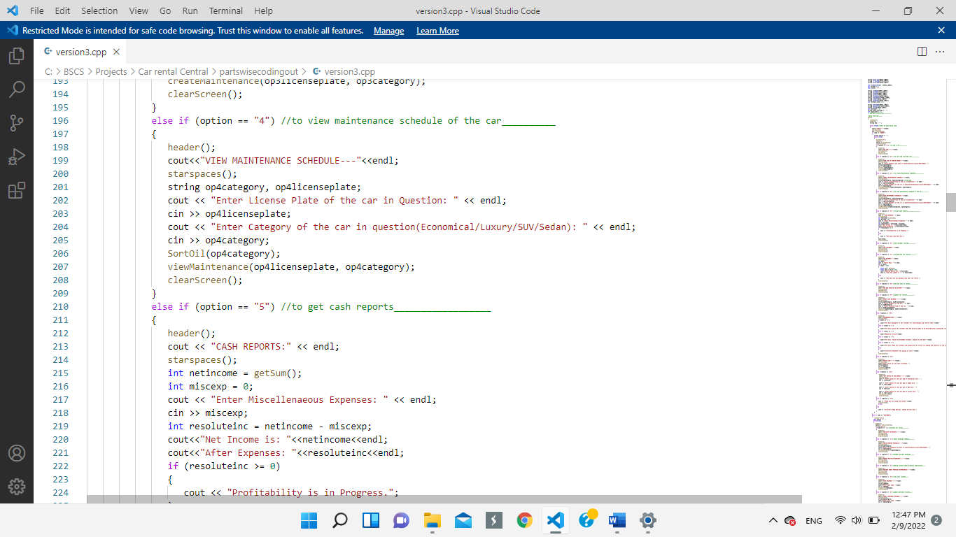

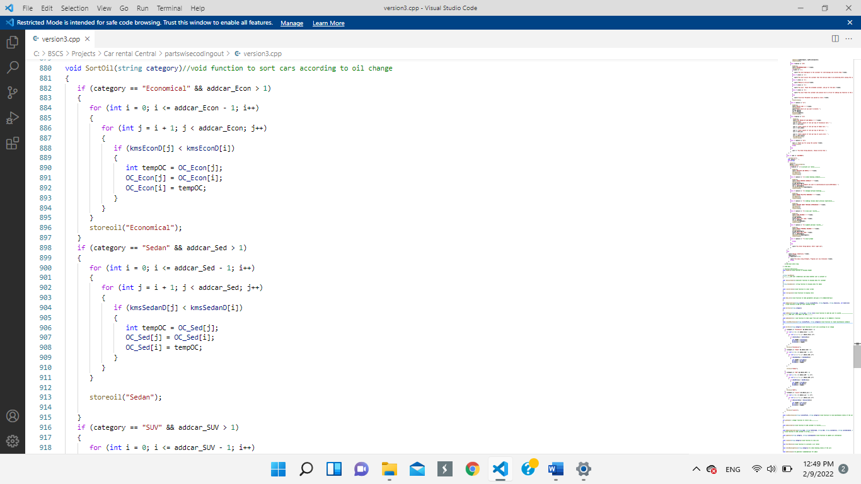

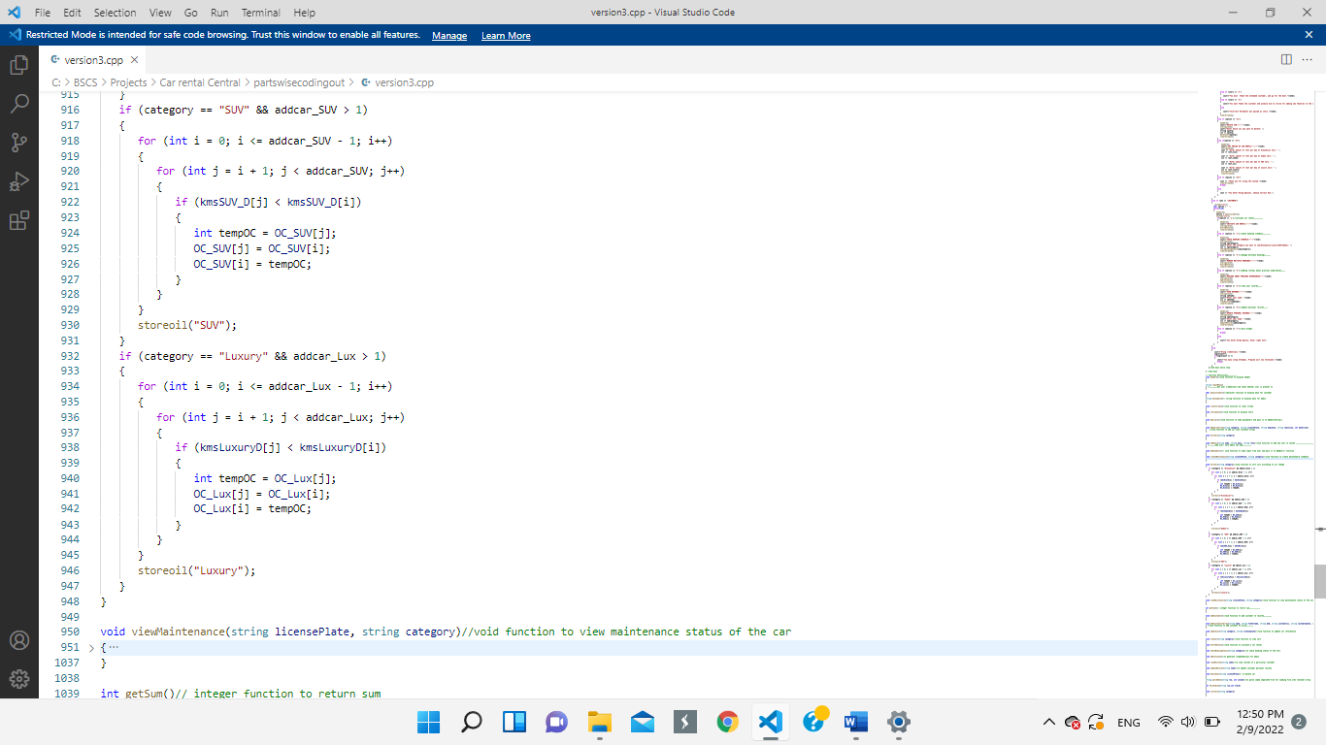

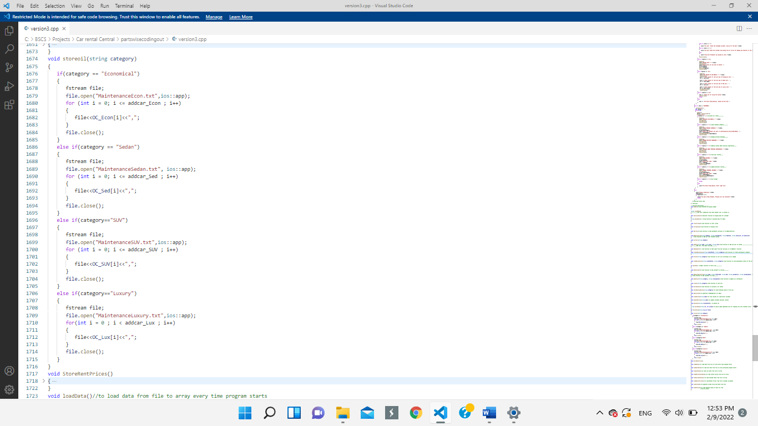

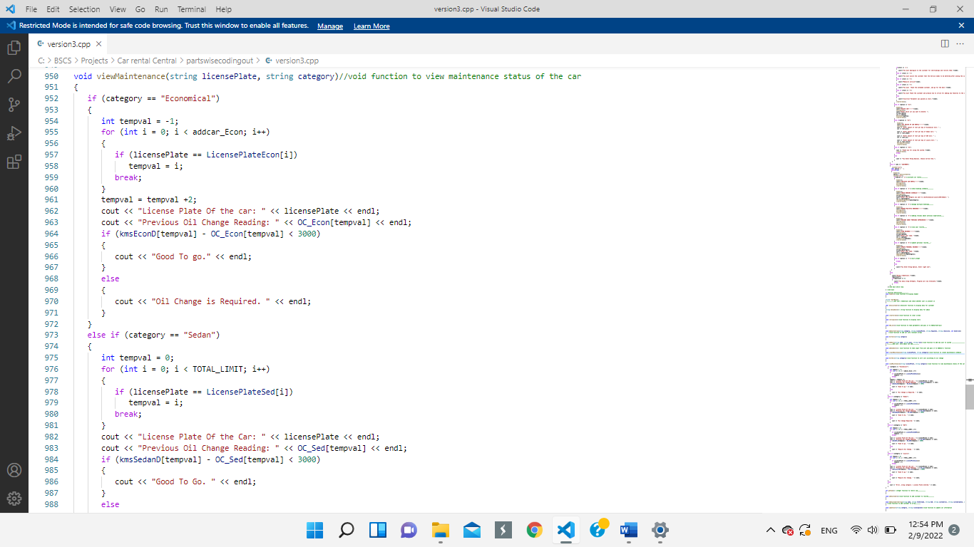

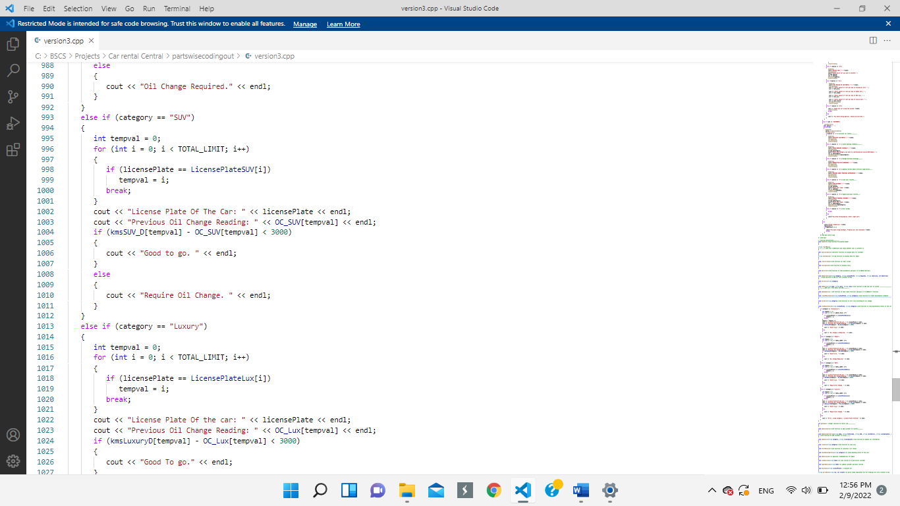

**Wireframe:**



**Admin Option-5: To get cash Reports**

**Code:**

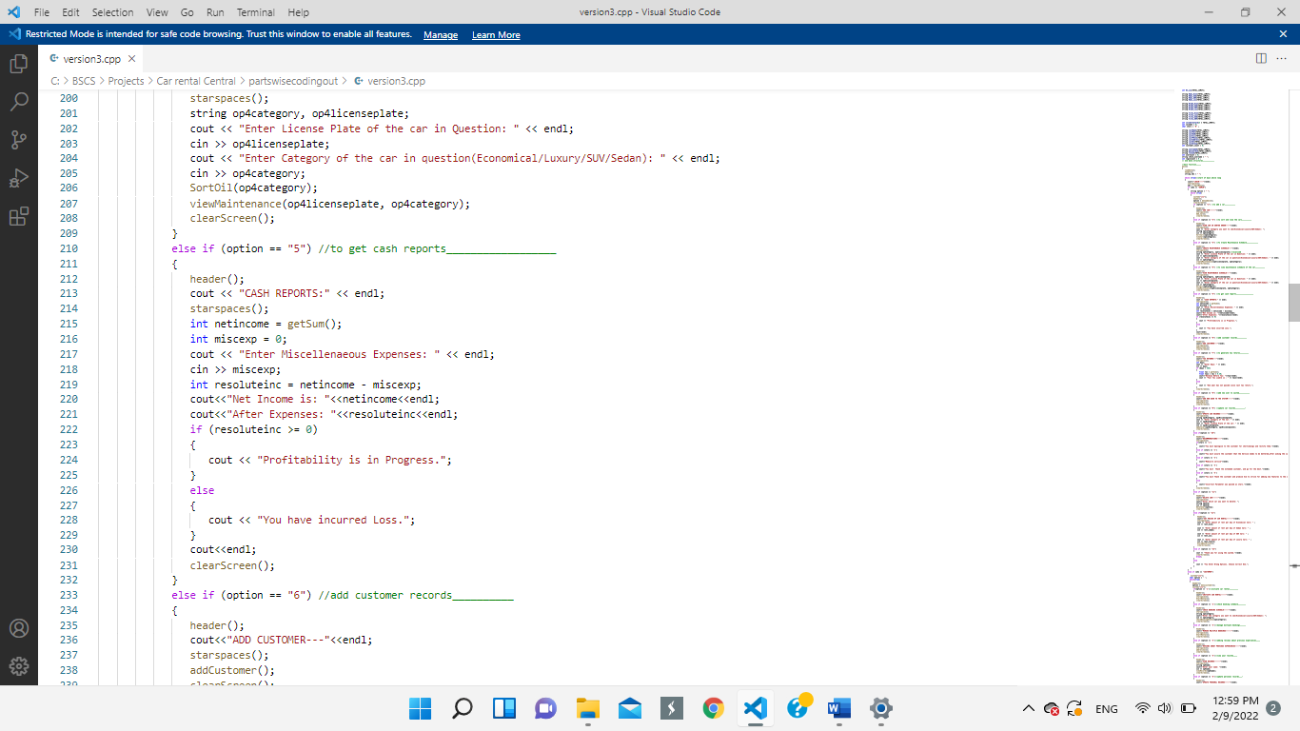

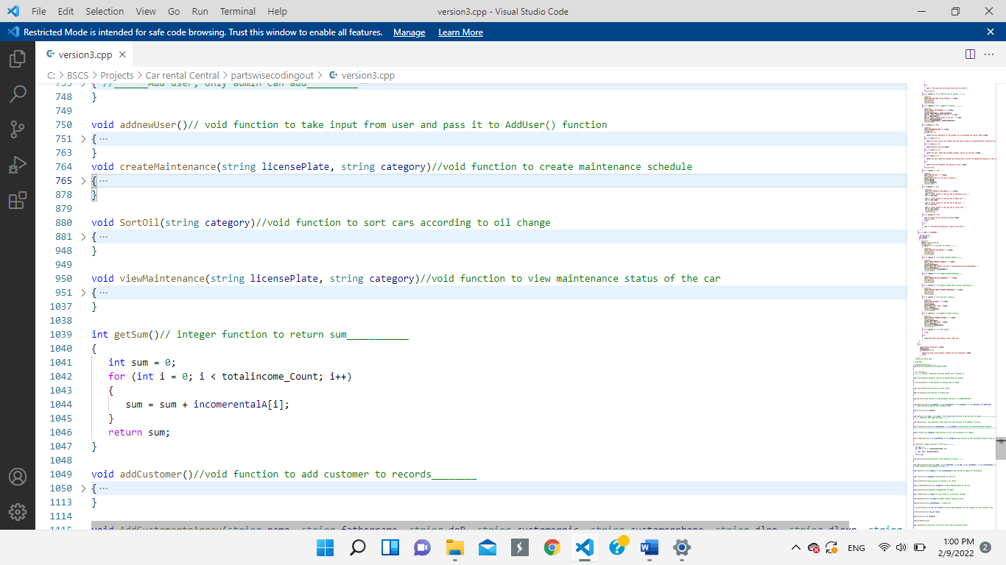

**Wireframe:**



**Admin Option-6: Add A Customer**

**Code:**

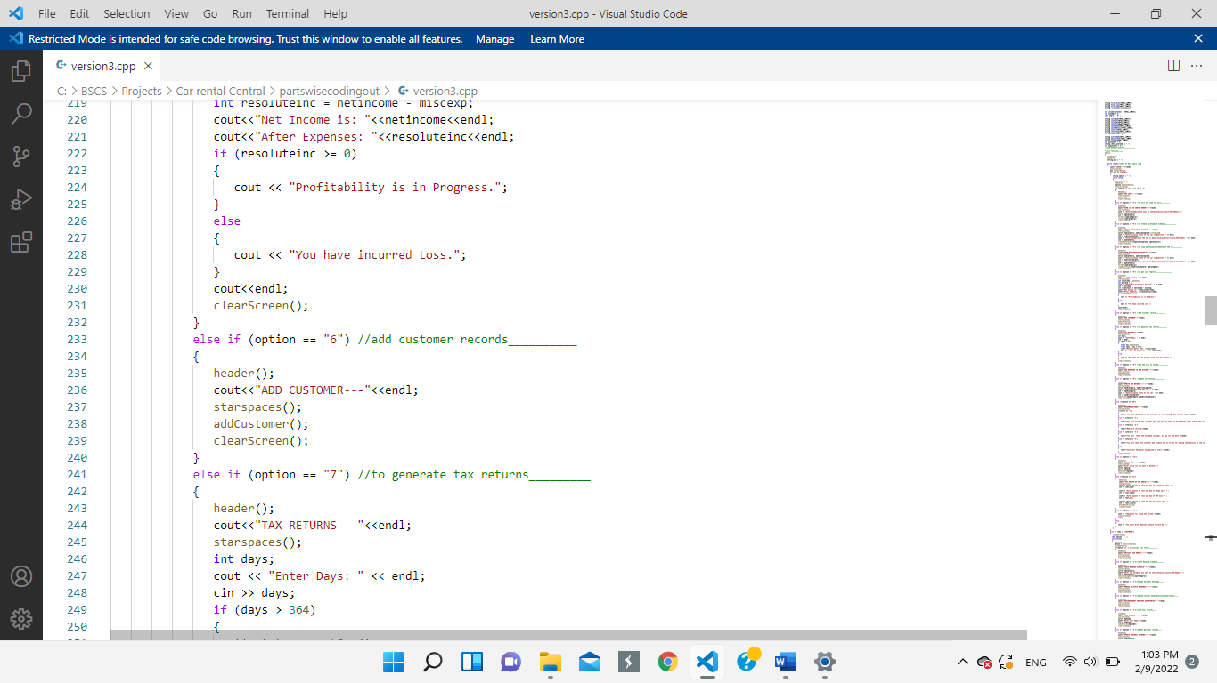

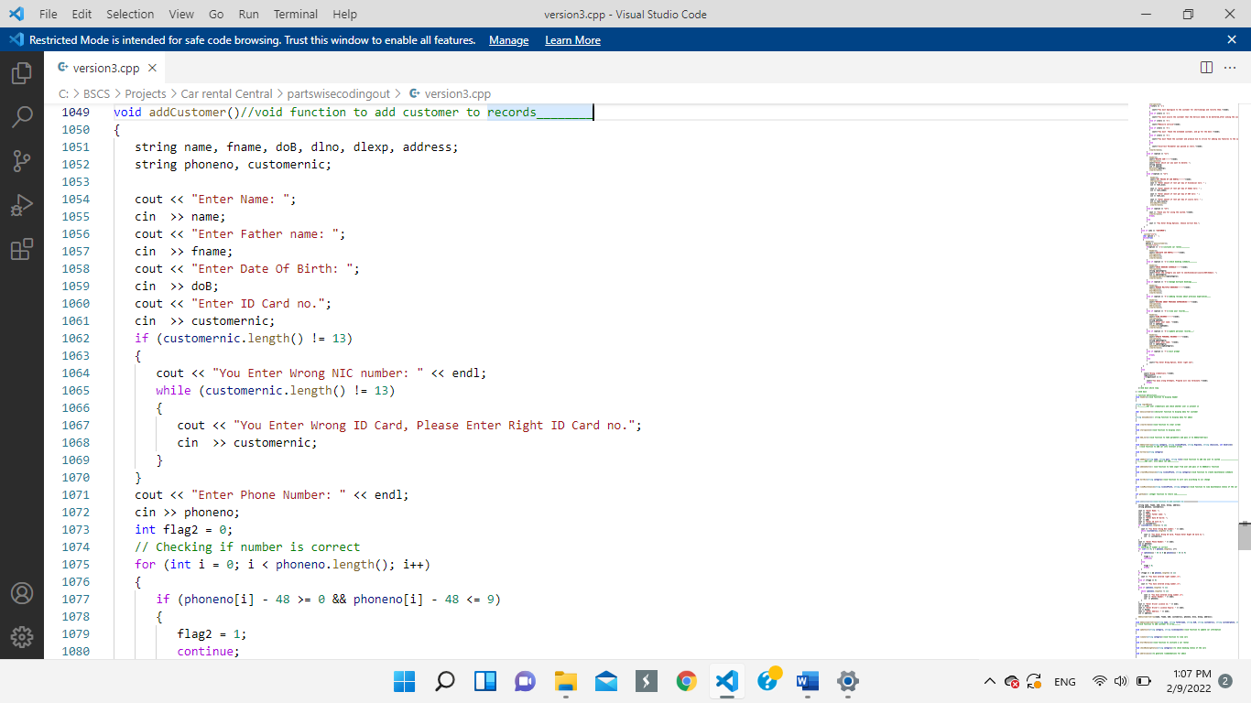

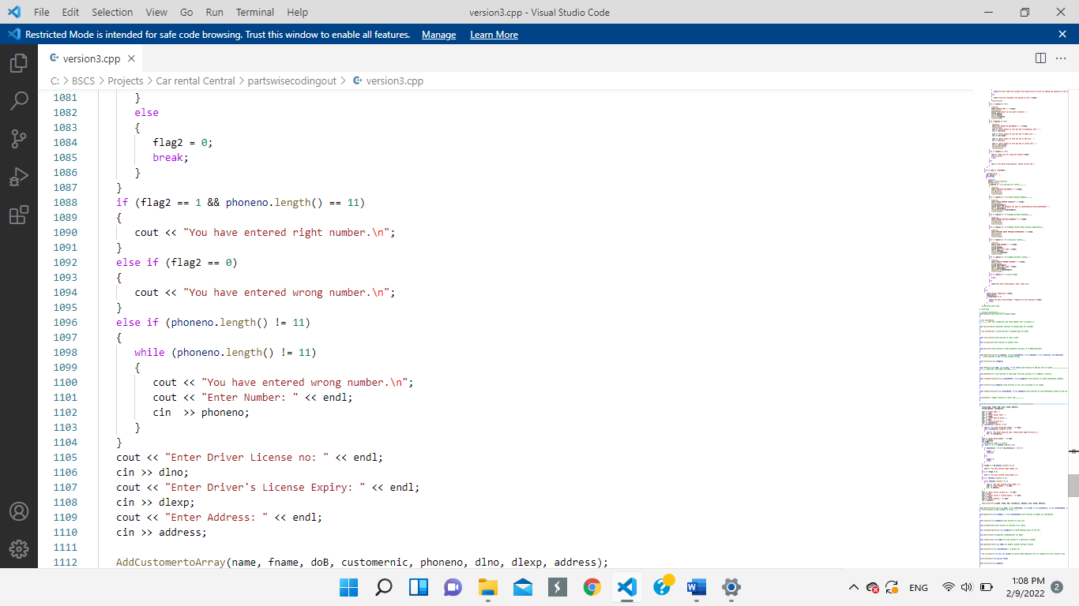

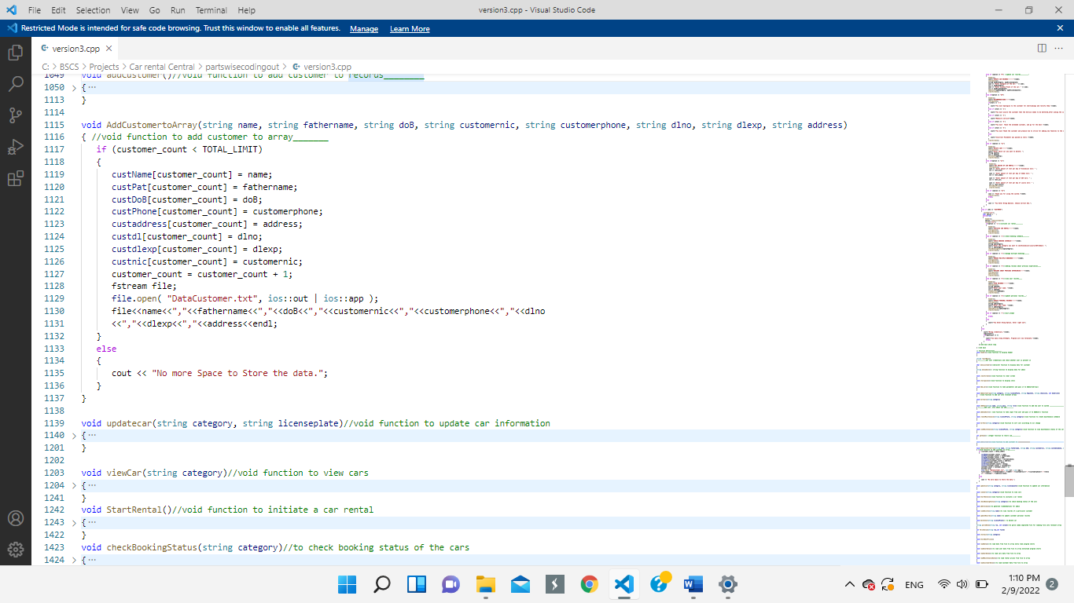

**Wireframe:**



**Admin Option-7: Generate Tax Return**

**Code:**

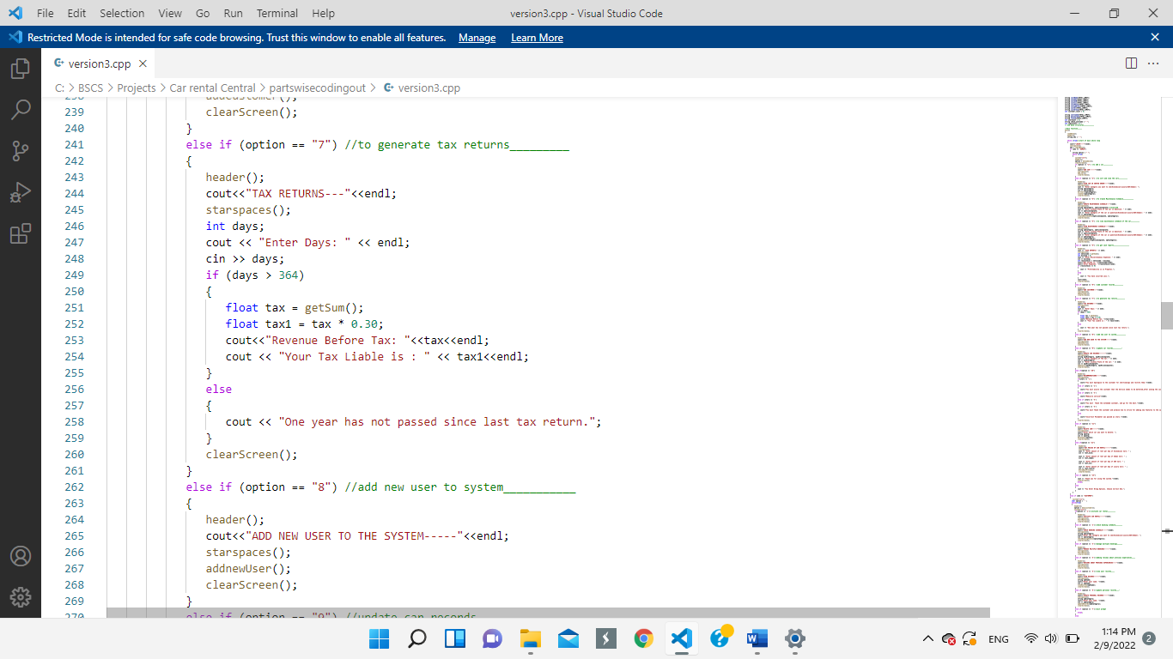

**Wireframe:**



**Admin Option-8: Add Users to the system**

**Code:**

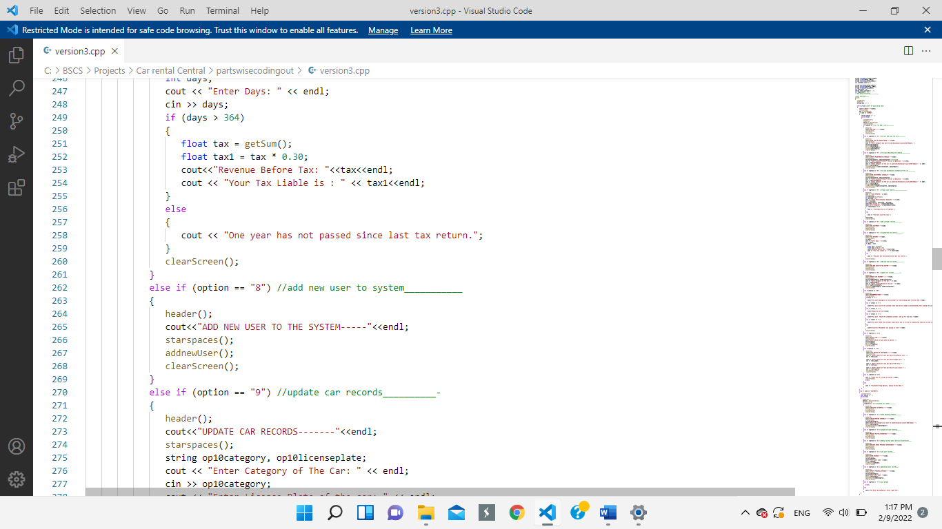

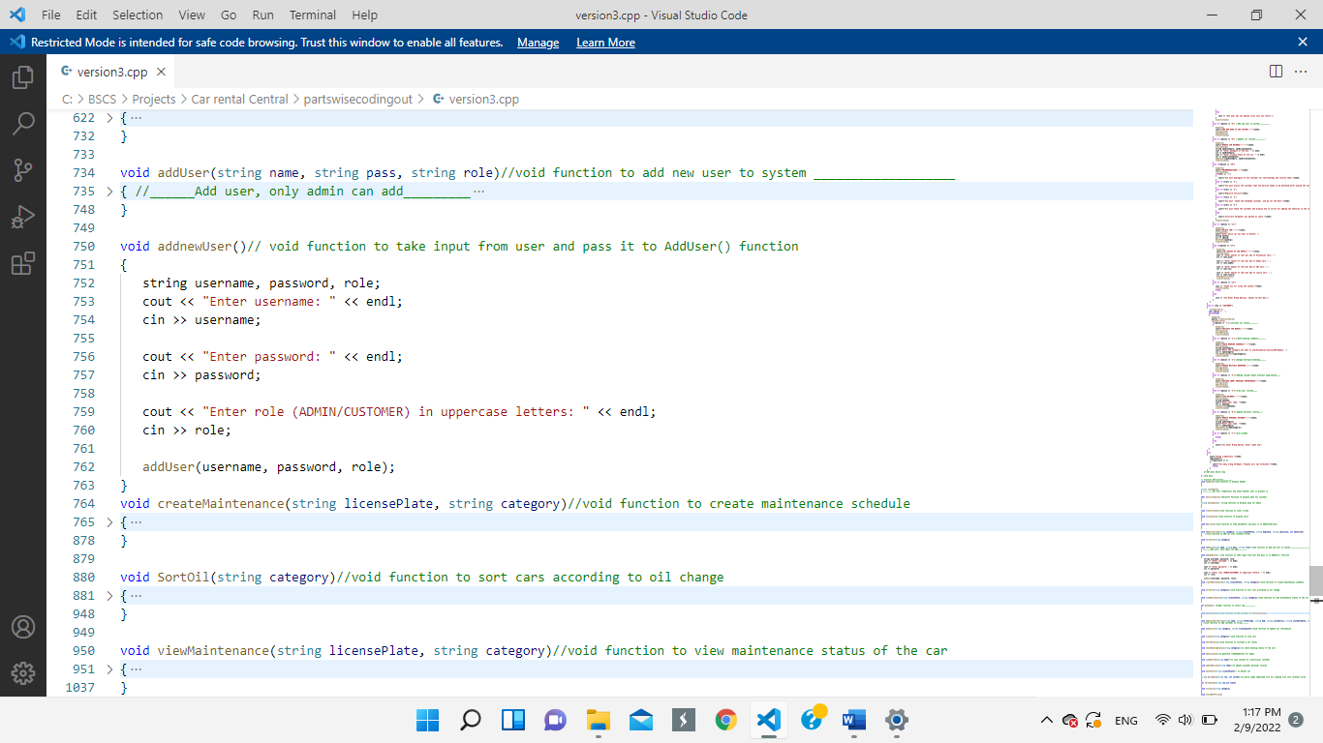

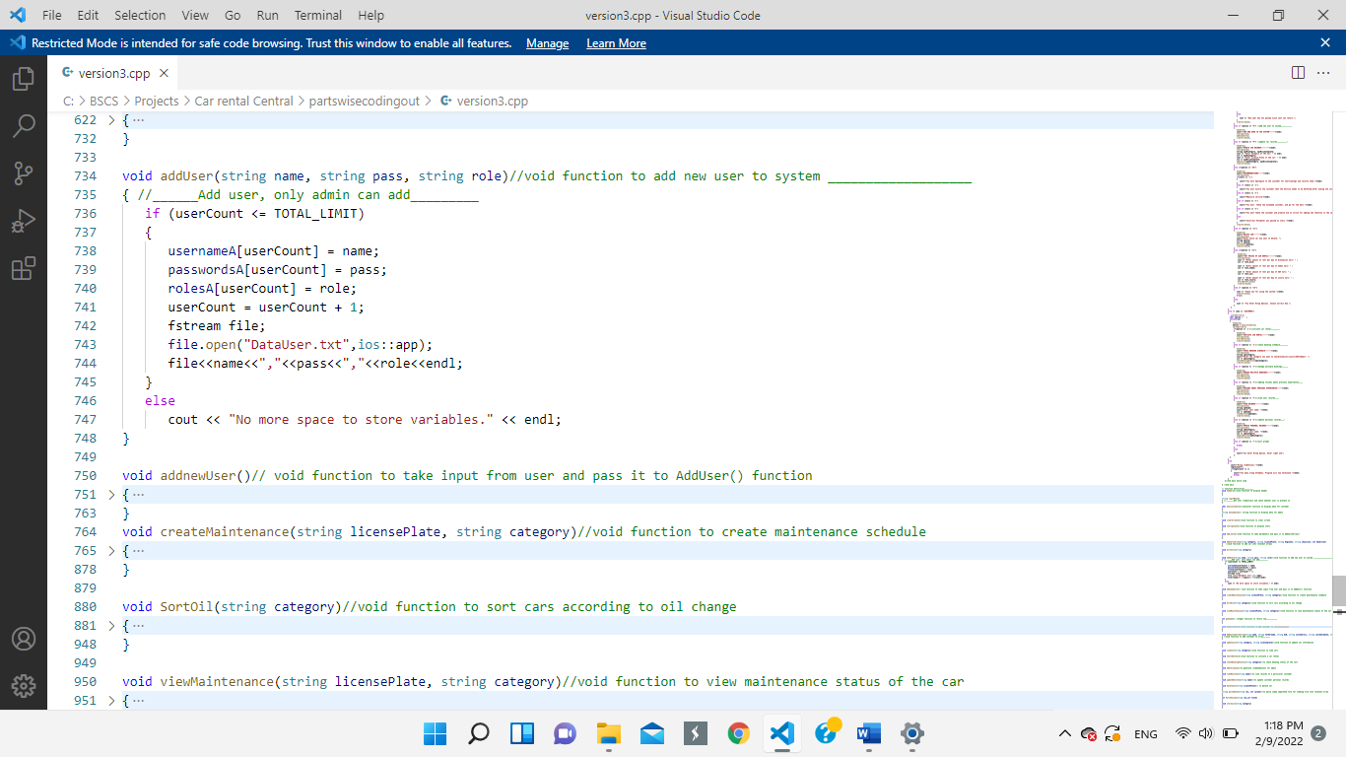

**Wireframe:**



**Admin Option-9: To Update Car Records**

**Code:**

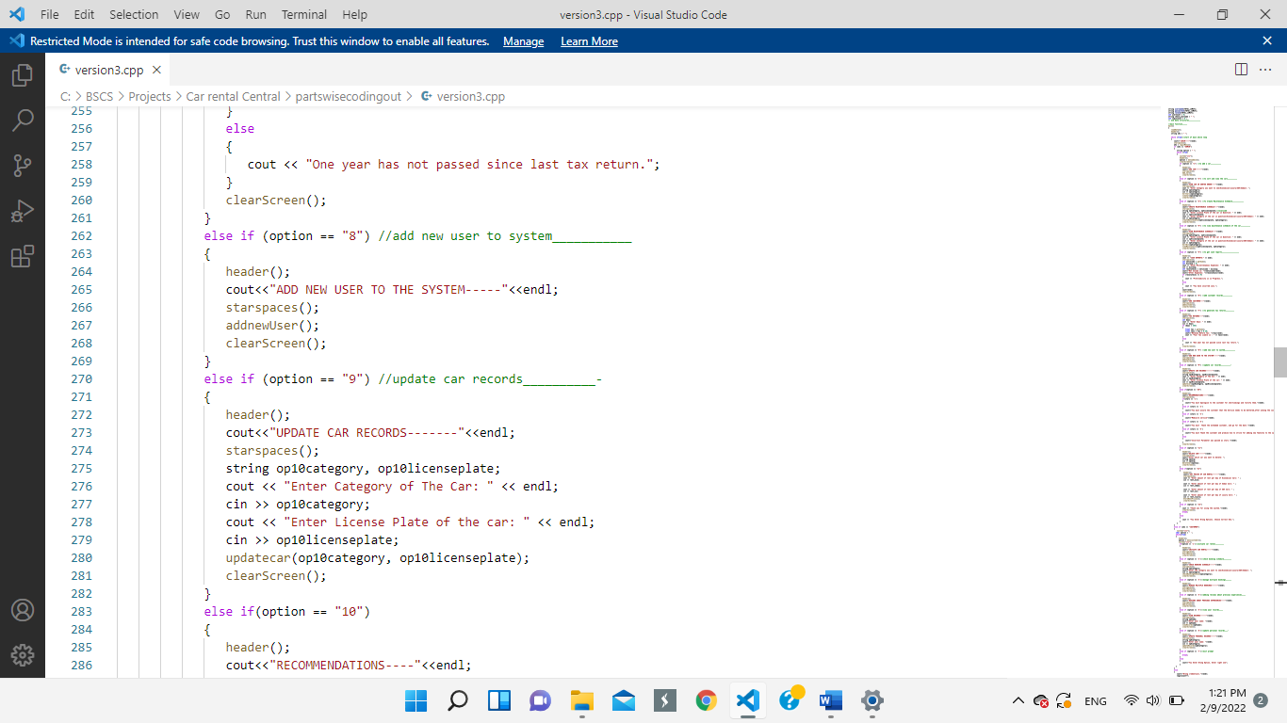

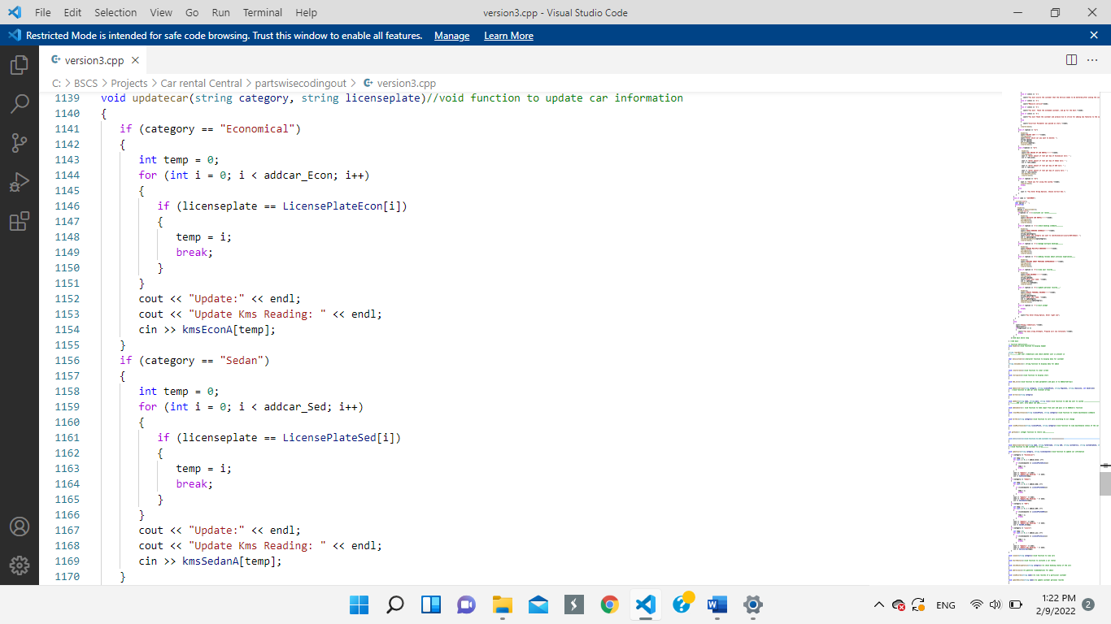

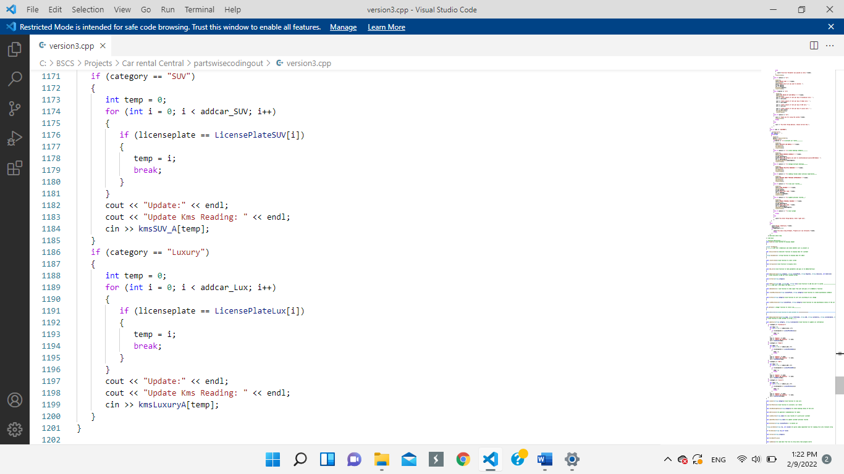

**Wireframe:**



**Admin Option-10: Recommendation I**

**Code:**

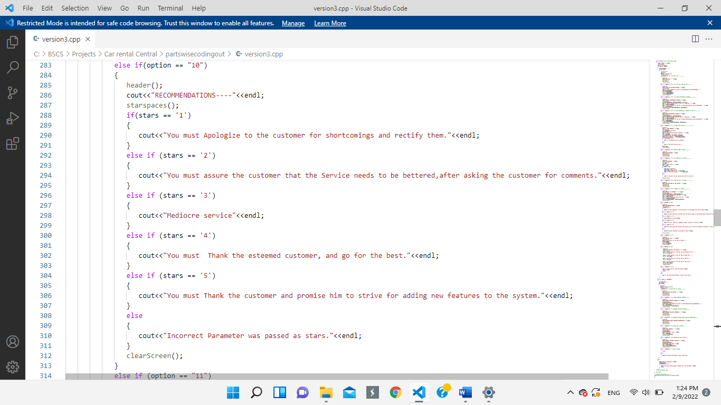

**Wireframe:**



**Admin Option-11: Delete Car**

**Code:**

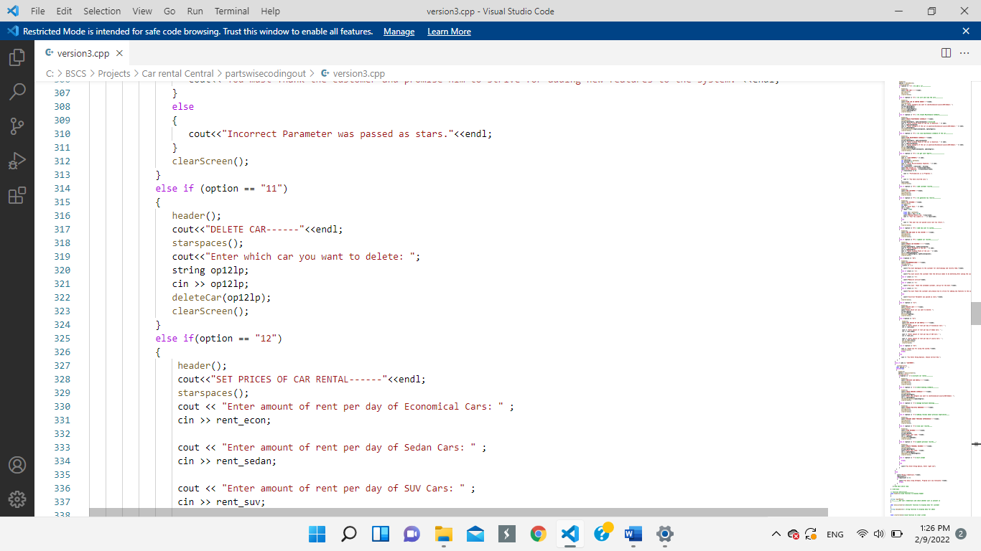

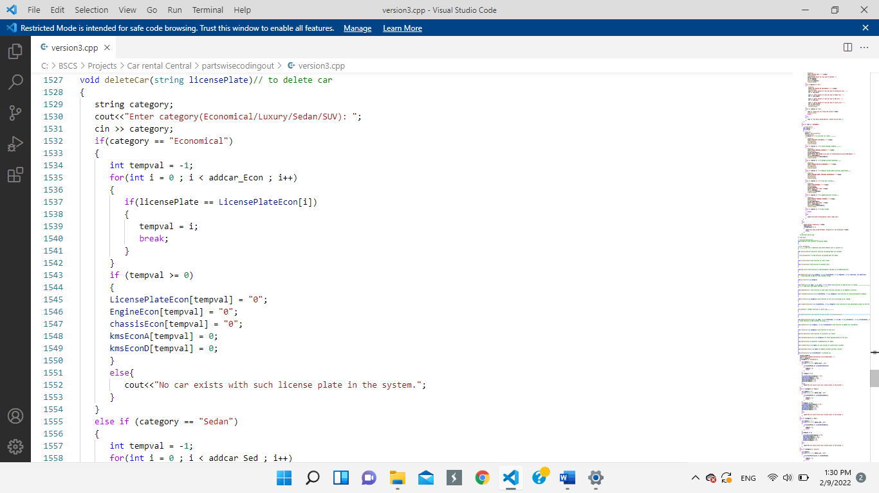

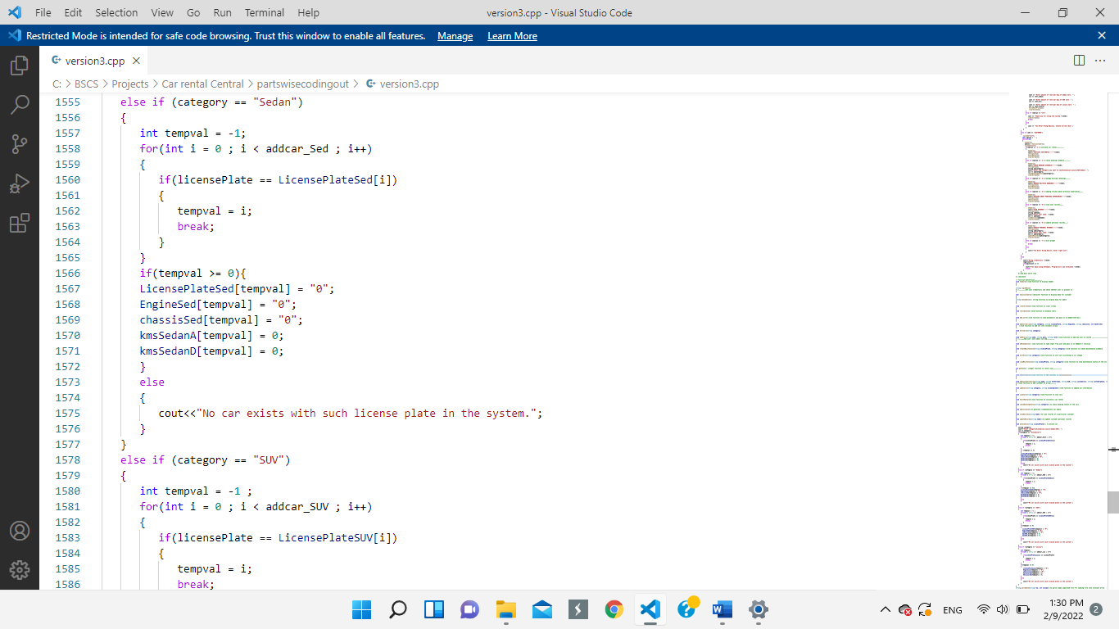

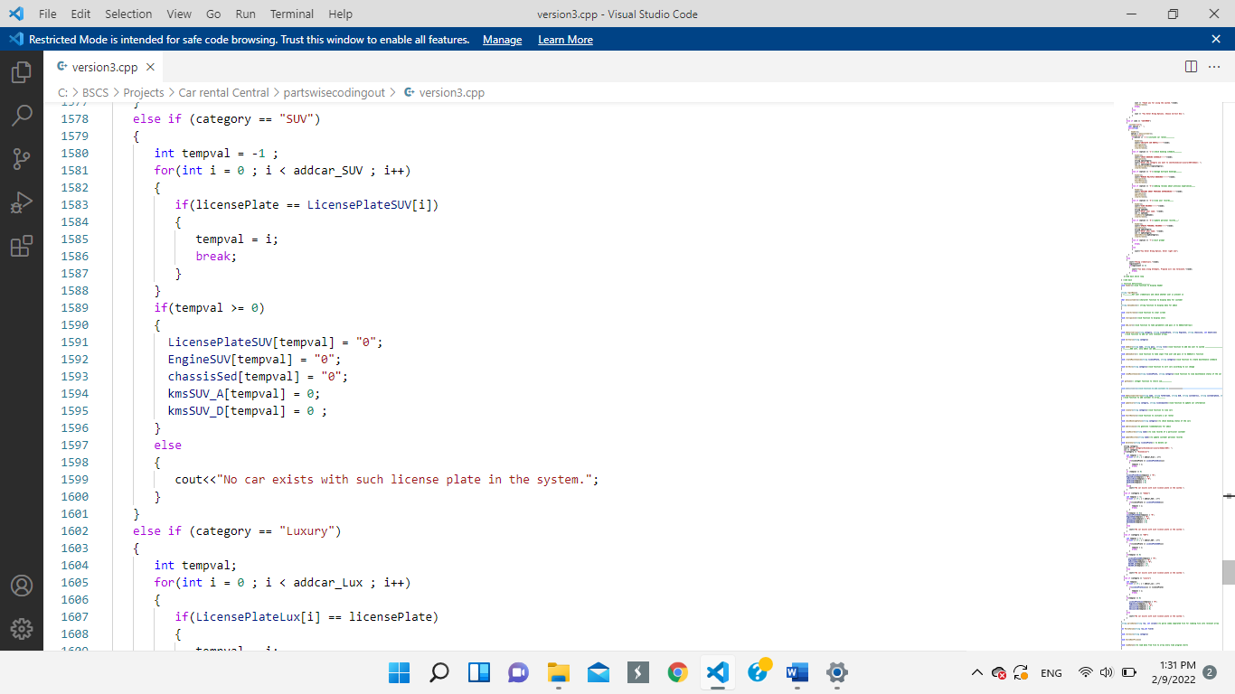

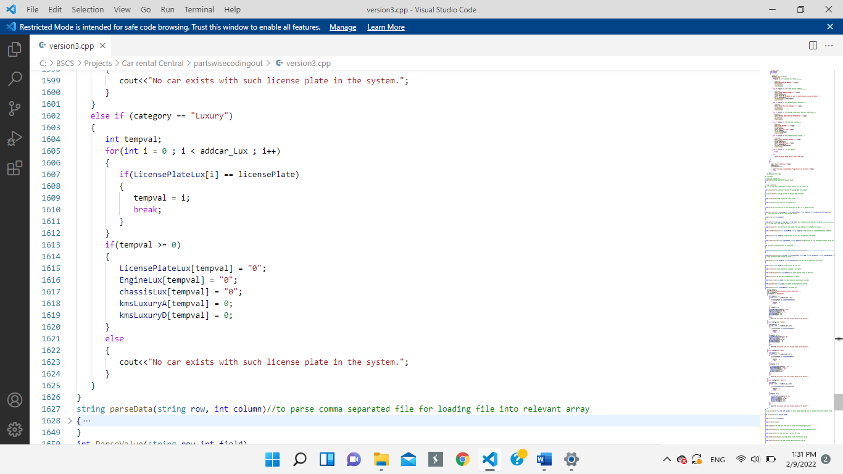

**Wireframe:**



**Admin Option-12: To Set Prices of Car Rentals**

**Code:**

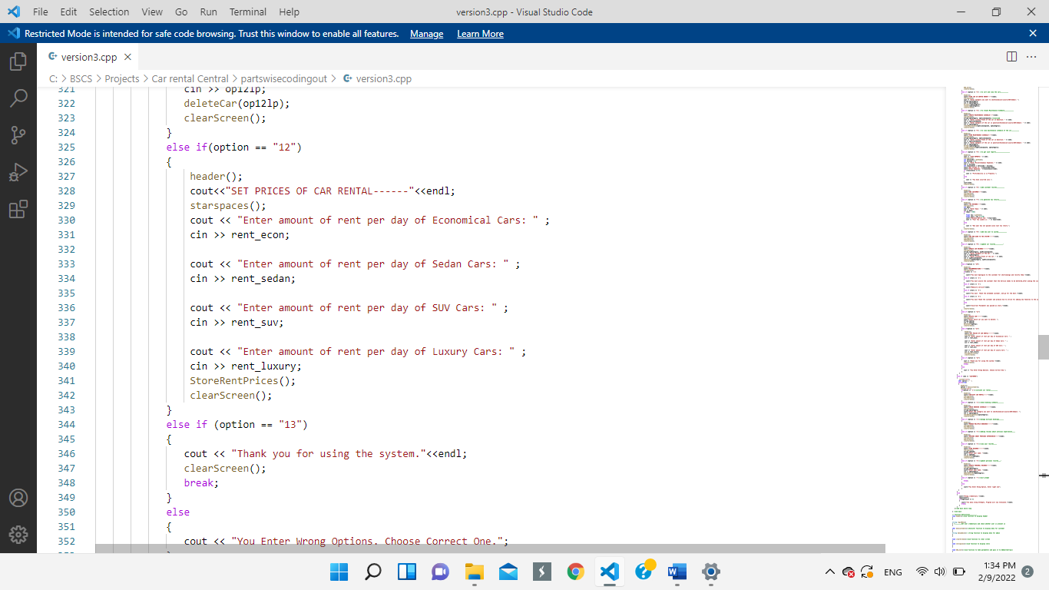

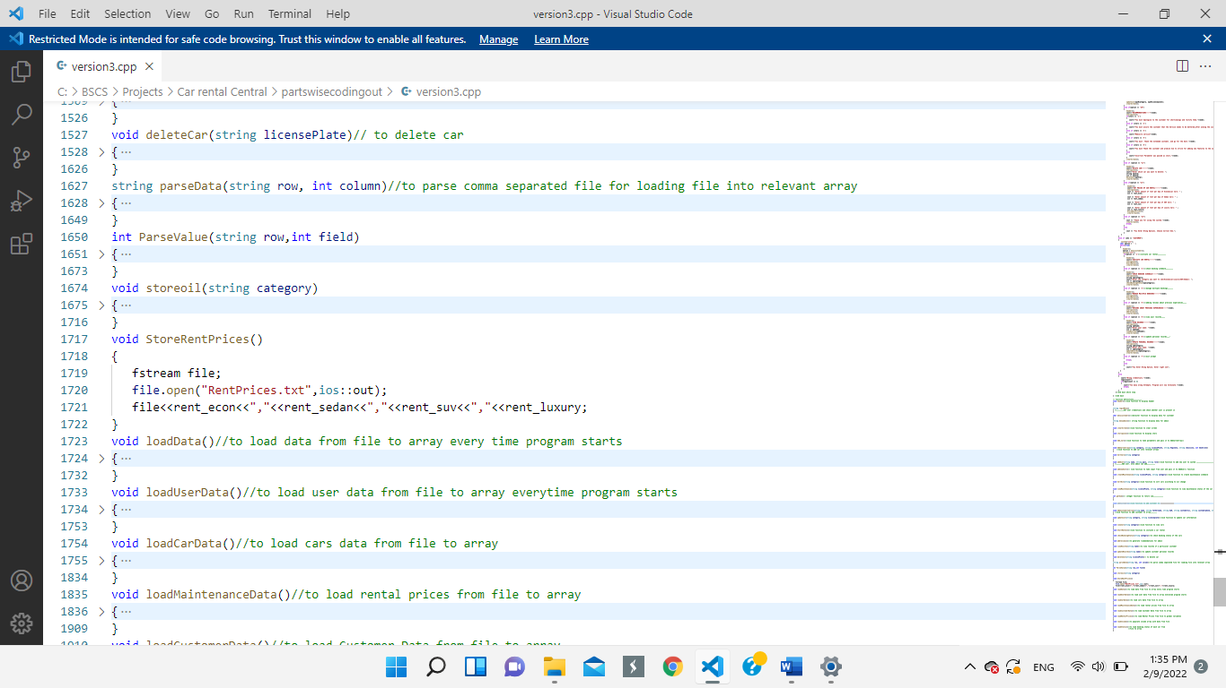

**Wireframe:**



**Customer Menu:**

**Code:**

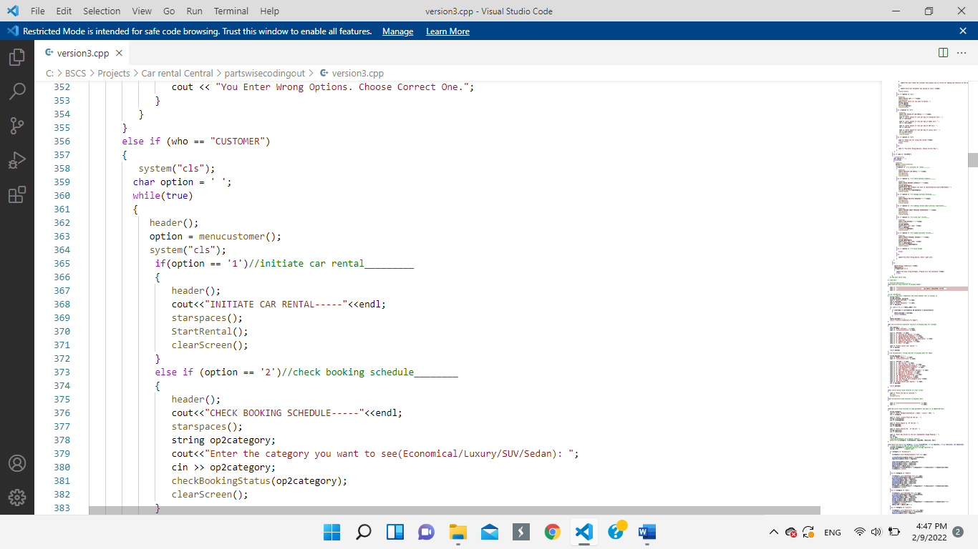

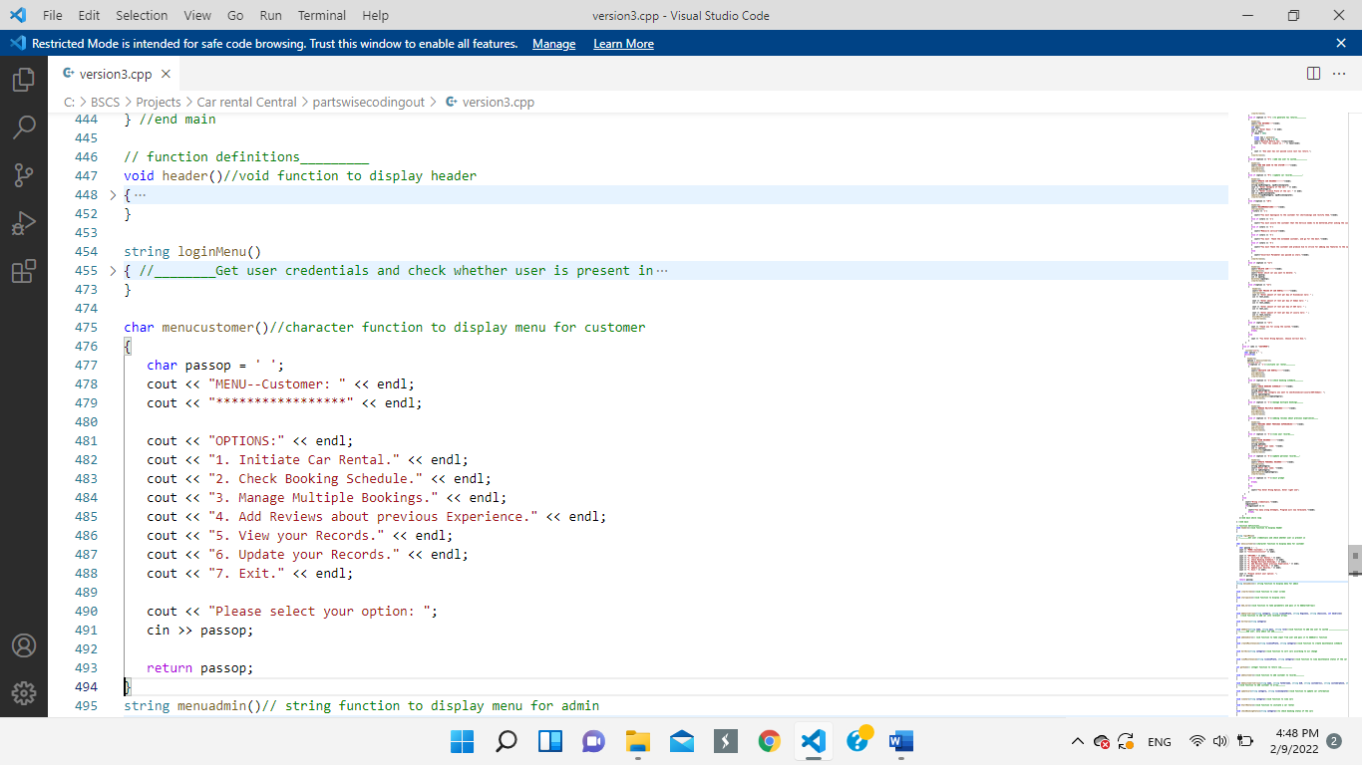

 **Wireframe:**

**Customer Option-1: Initiate Car Rental**

**Code:**

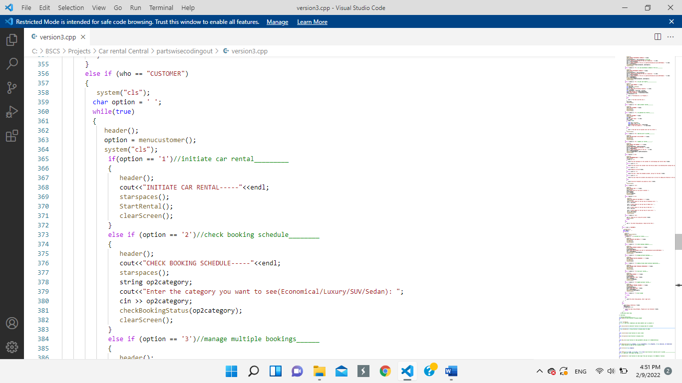

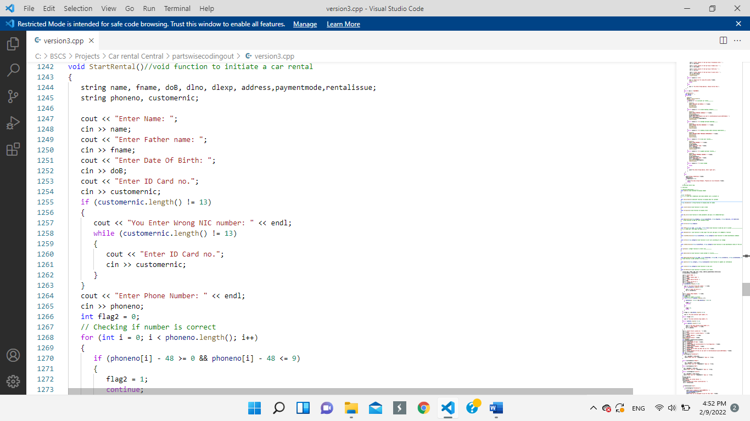

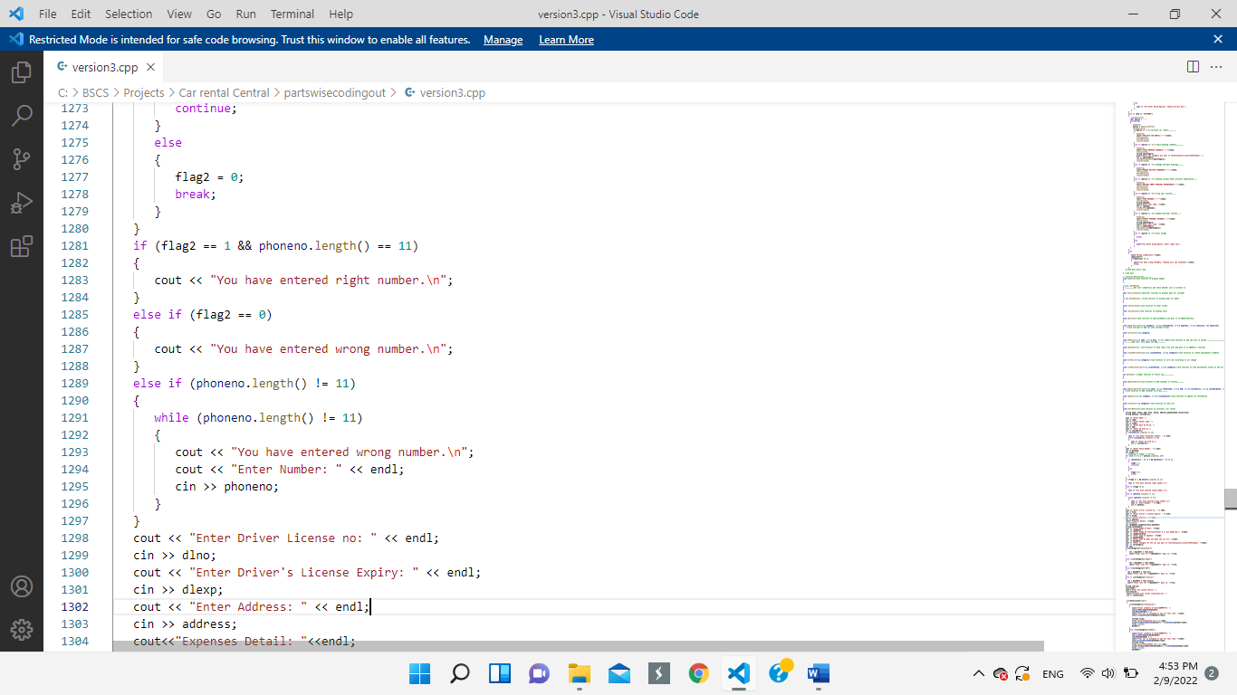

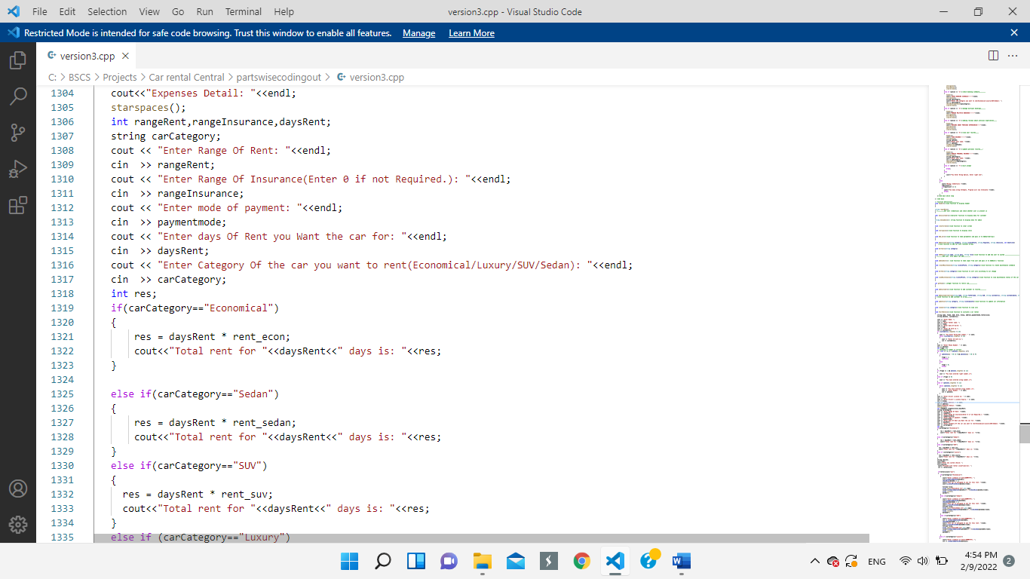

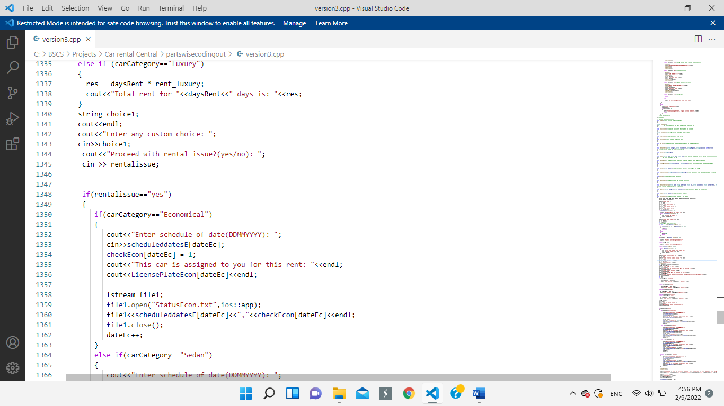

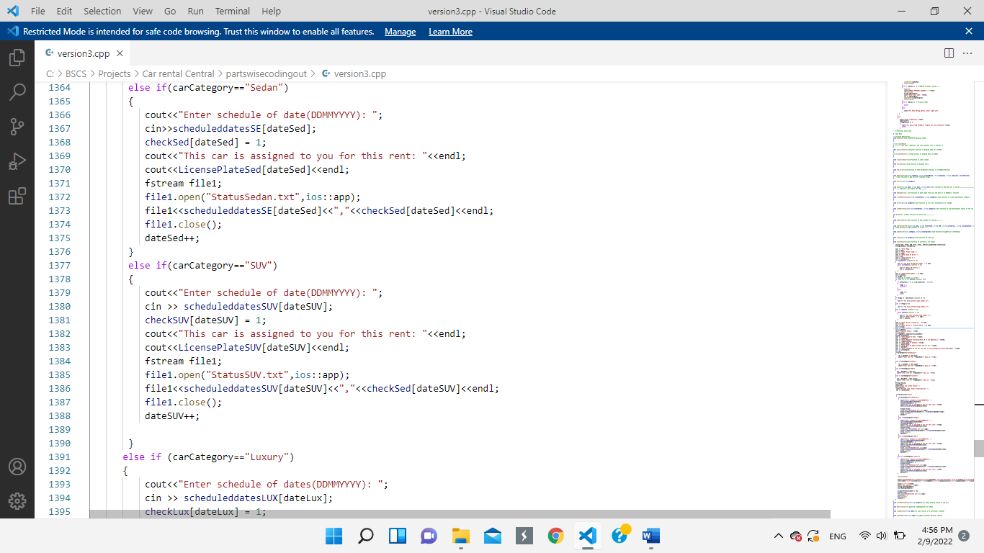

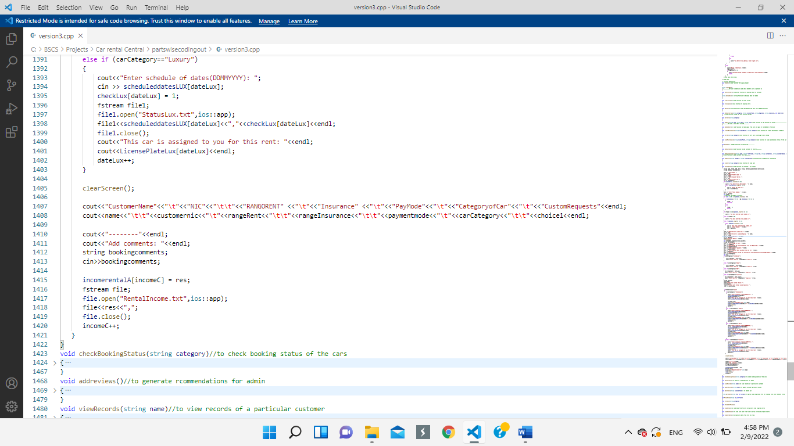

**Wireframe:**





**Customer Option-2: Check Booking Schedule of Cars**

**Code:**

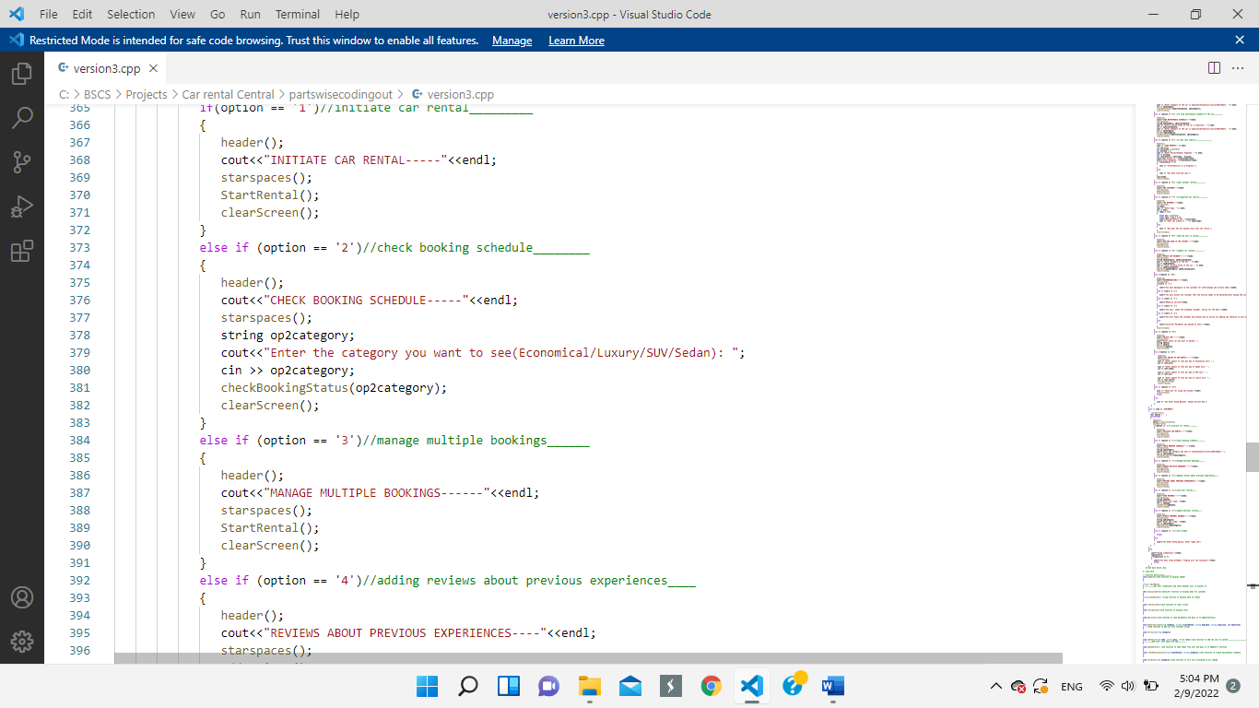

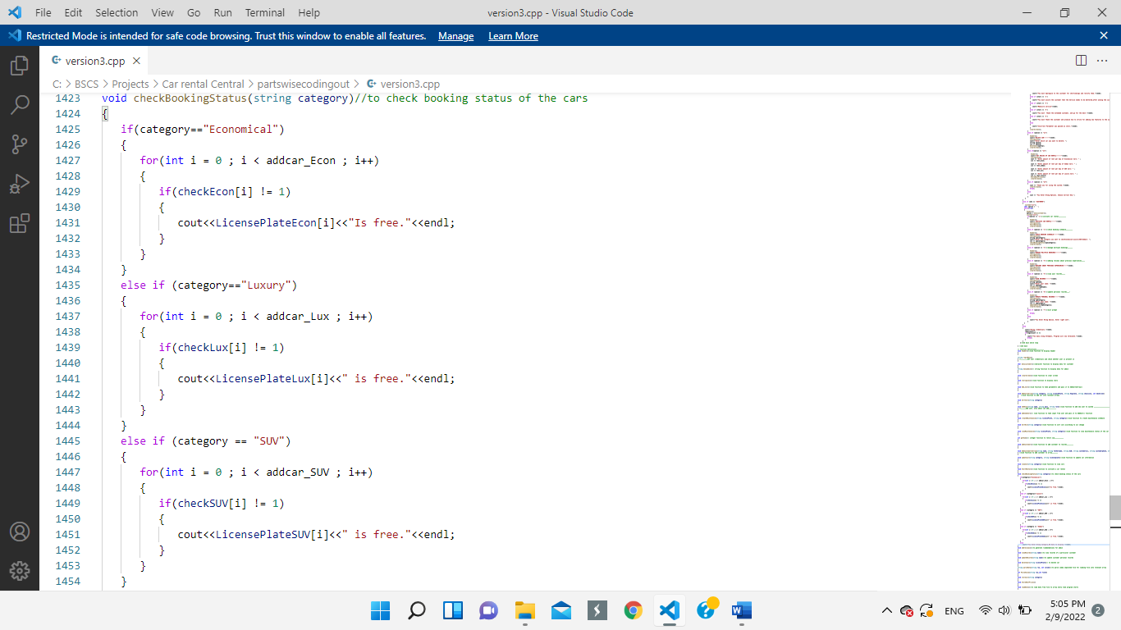

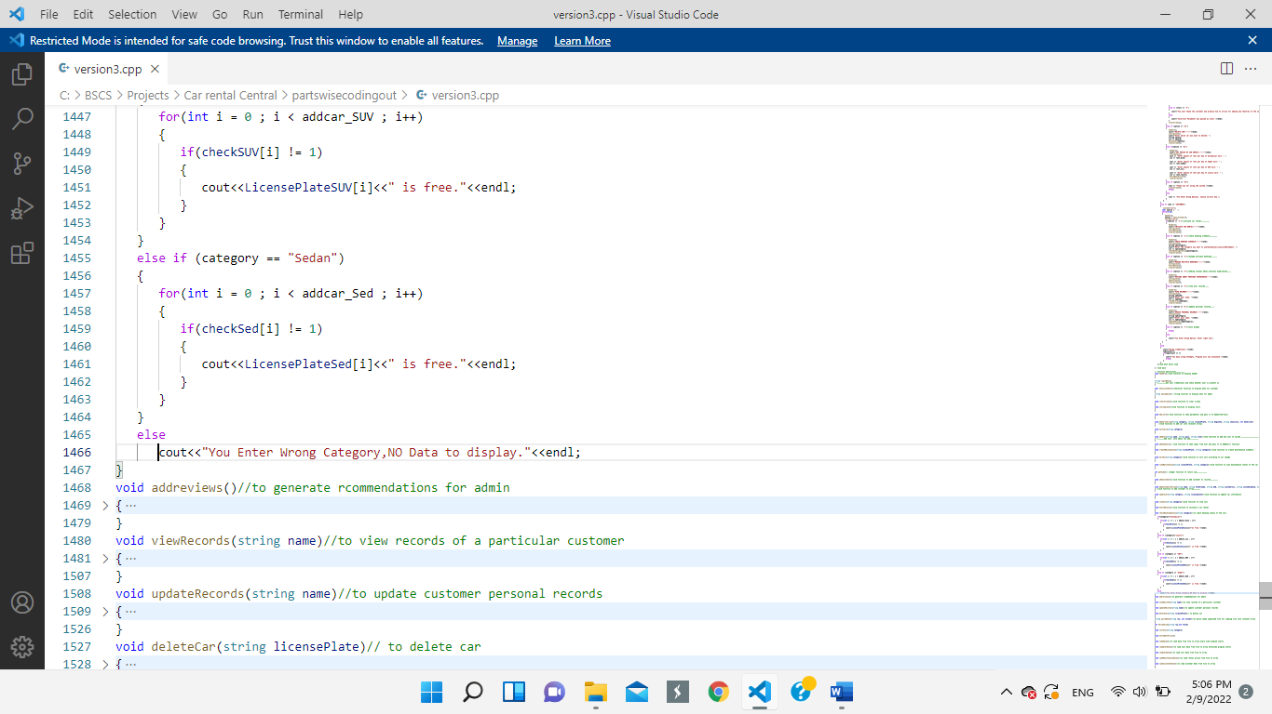

**Wireframe:**



**Customer Option-3: Manage Multiple Bookings**

**Code:**

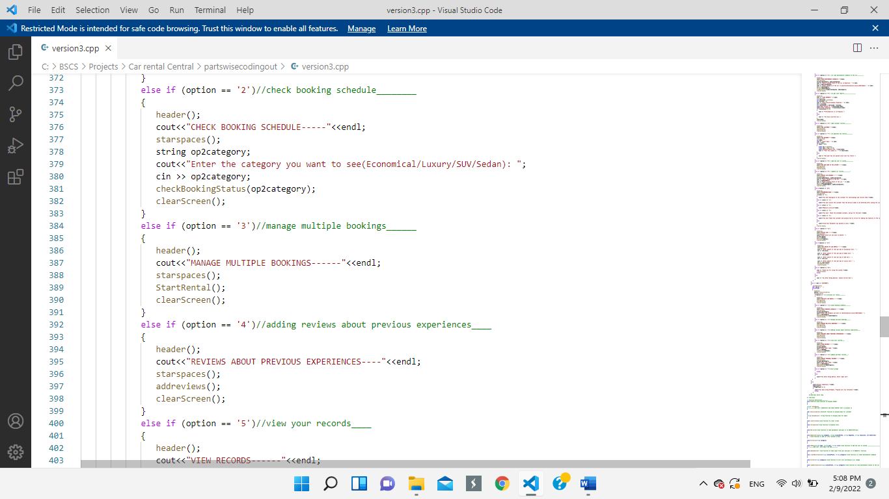

The StartRental() function has already been explained in option 1(page 50).

**Wireframes:**



**Customer Option-4: To Add Reviews About Previous Experiences**

**Code:**

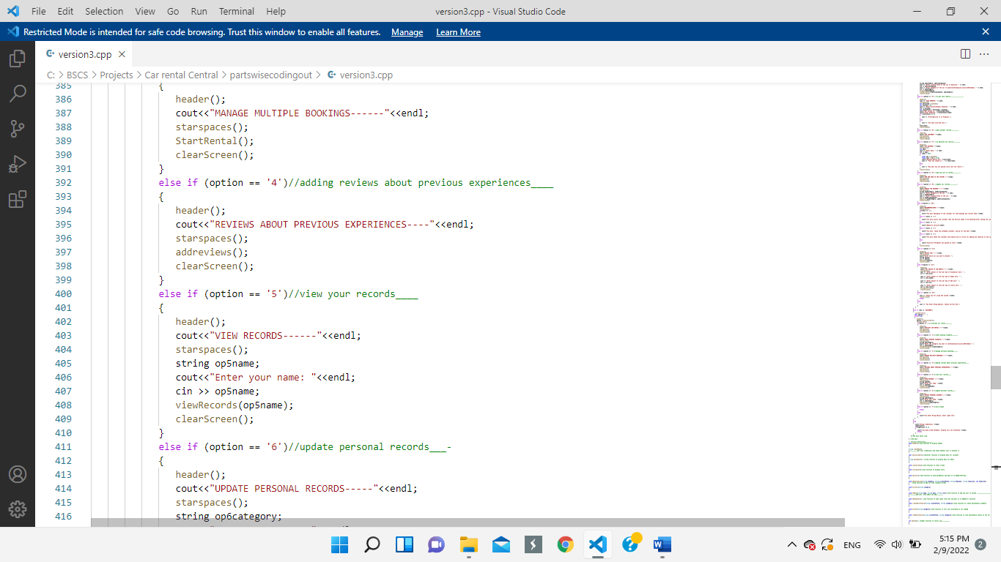

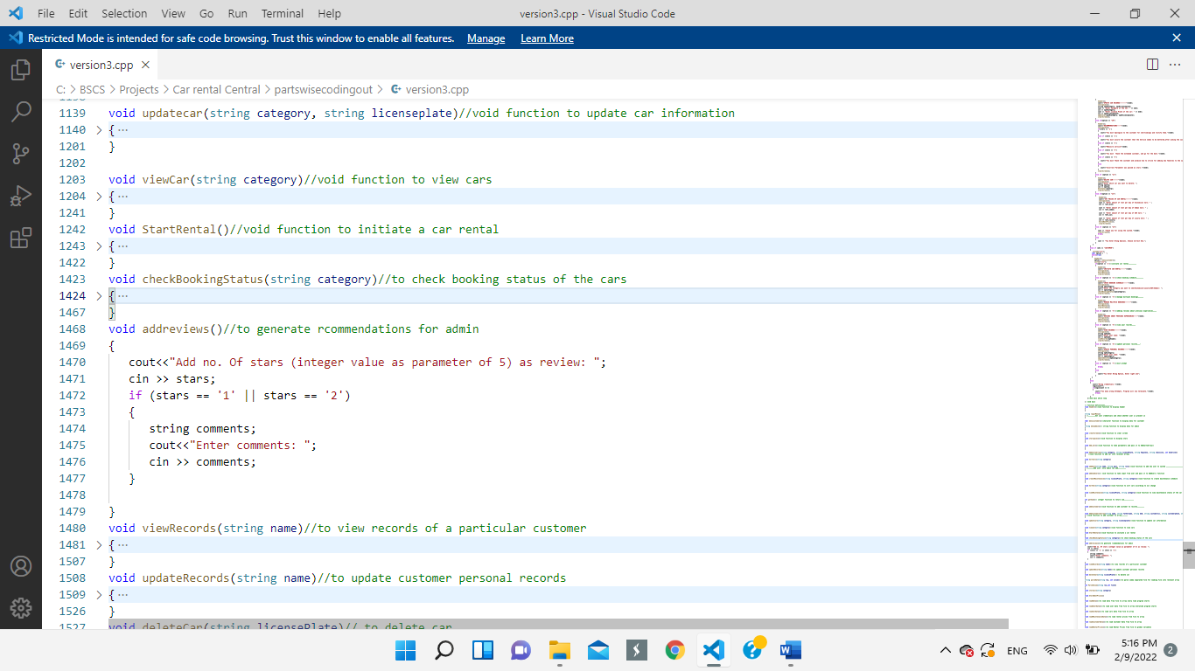

 **Wireframe:**

**Customer Option-5: To View Personal Records**

**Code:**

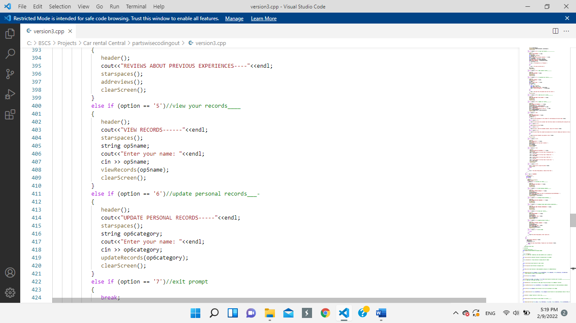

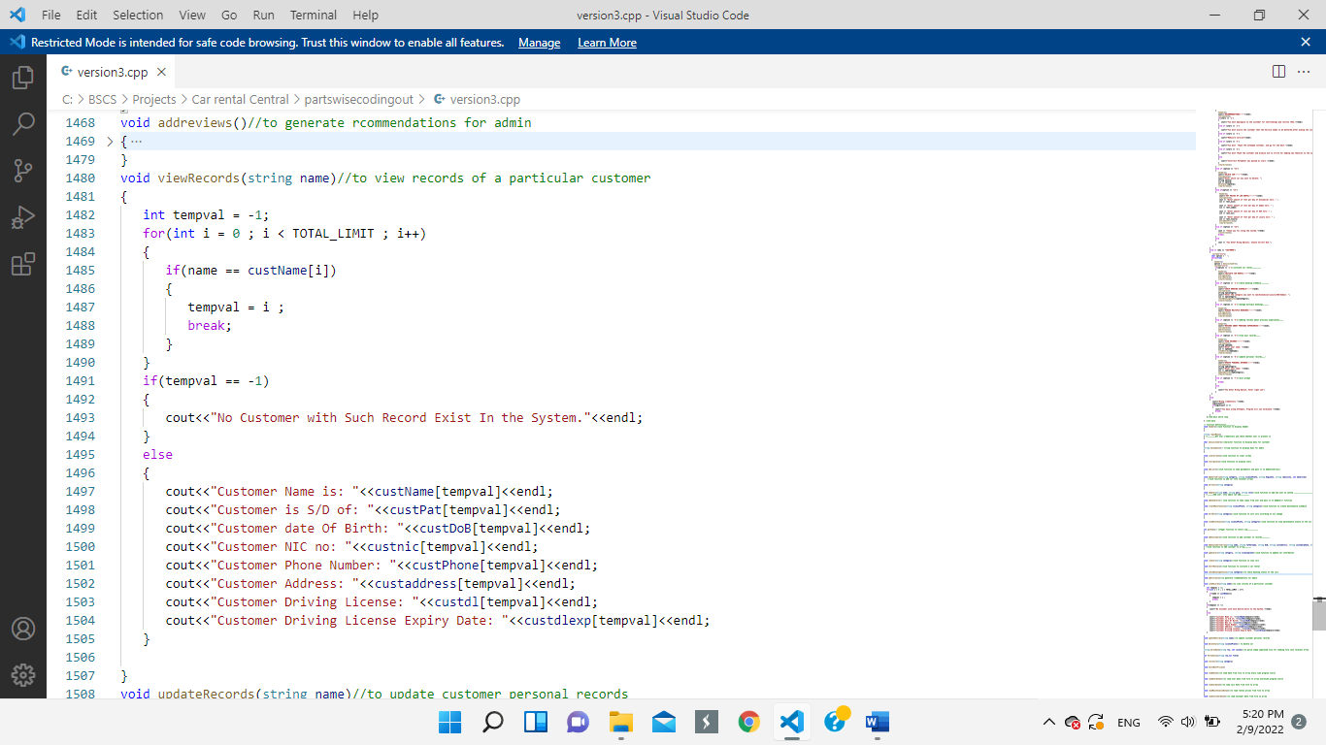

**Wireframe:**

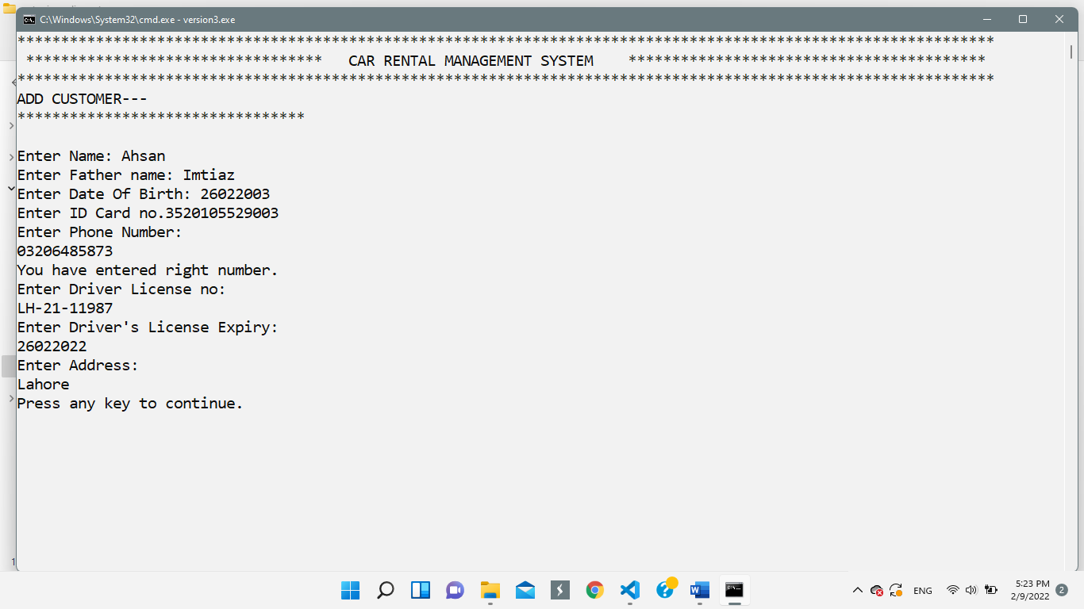

**Customer Option-6: To Update Personal Records:**

**Code:**

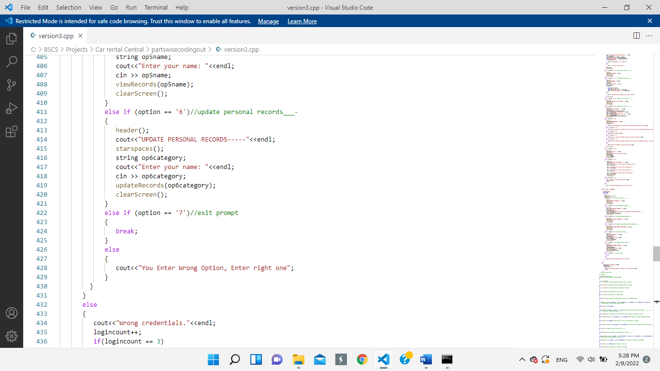

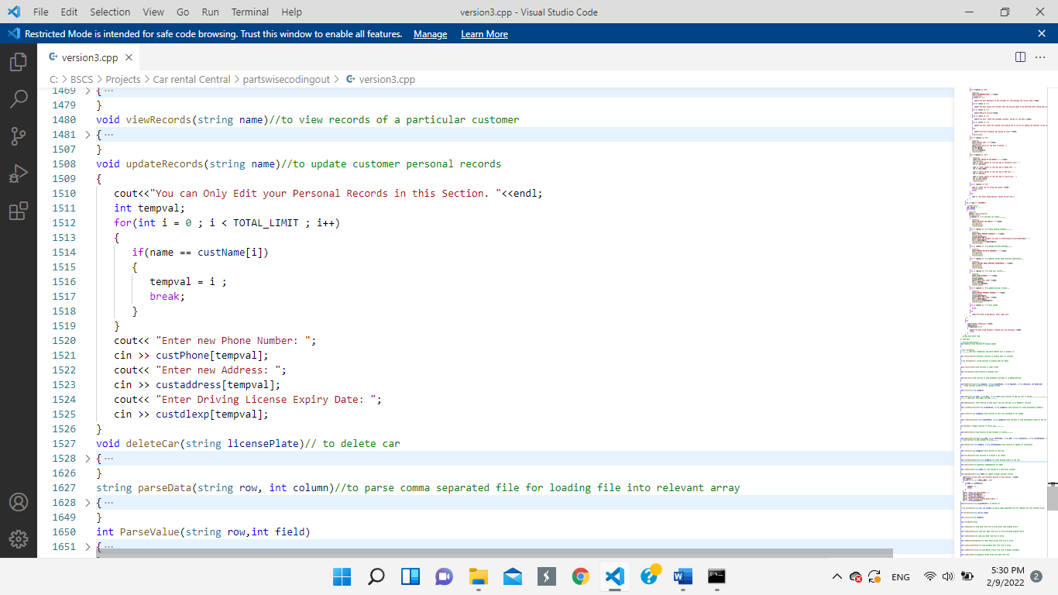

**Wireframe:**

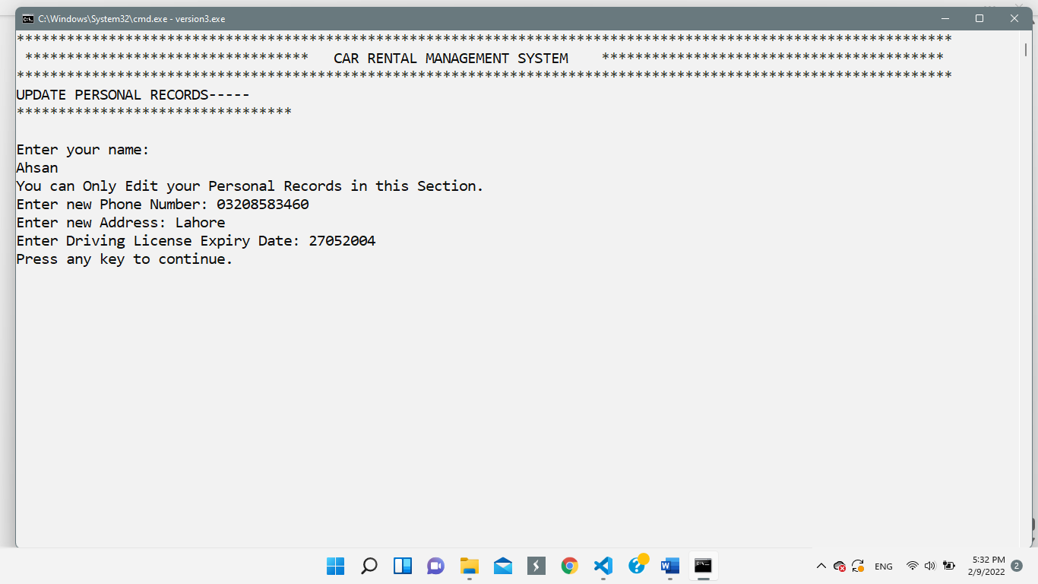

**Miscellaneous Functions:**

**Header:**

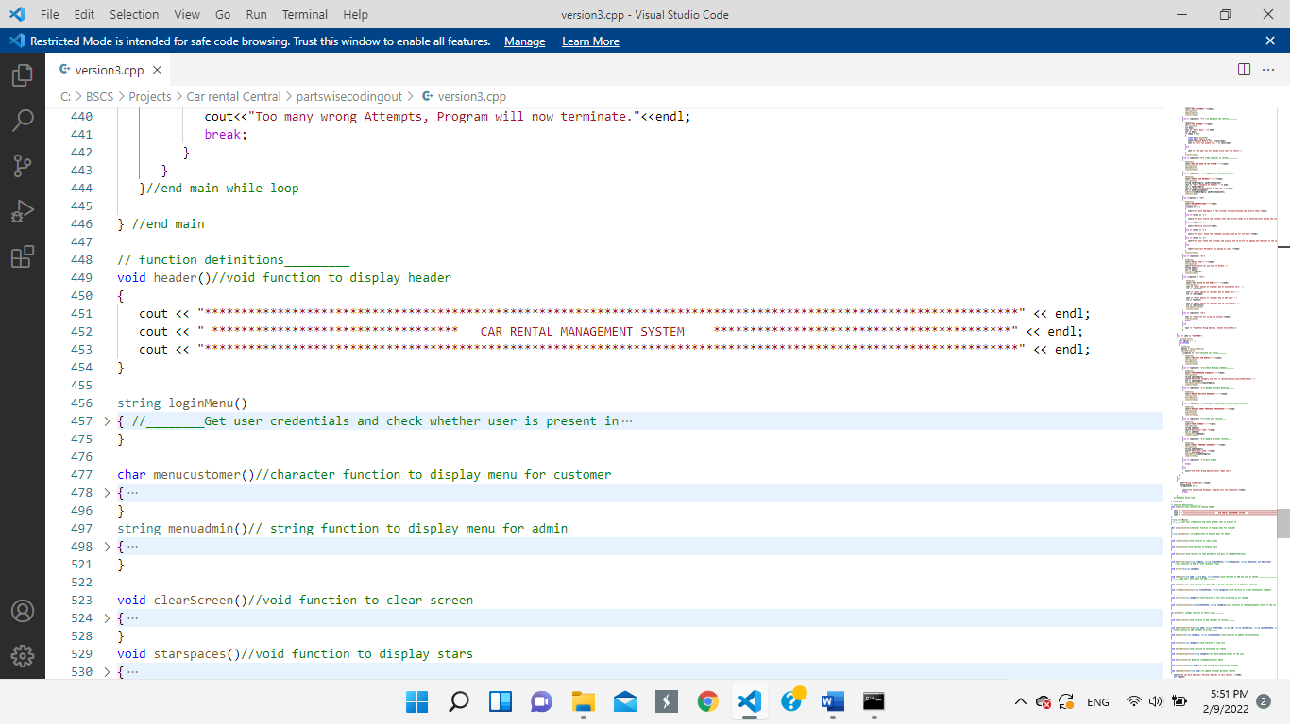

**Clear Screen:**

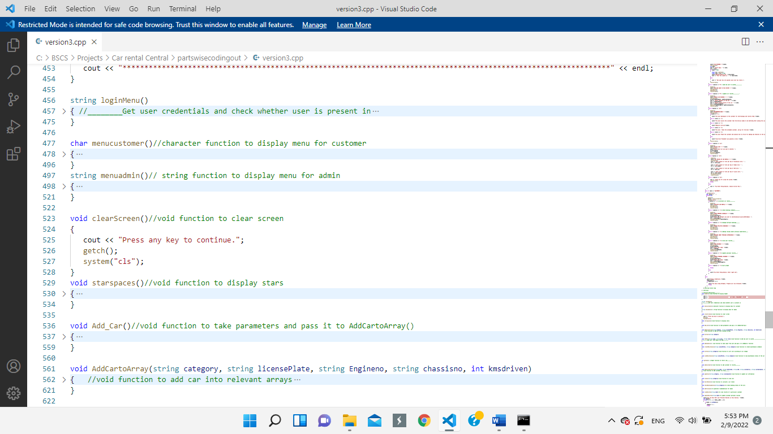

**Star Spaces:**

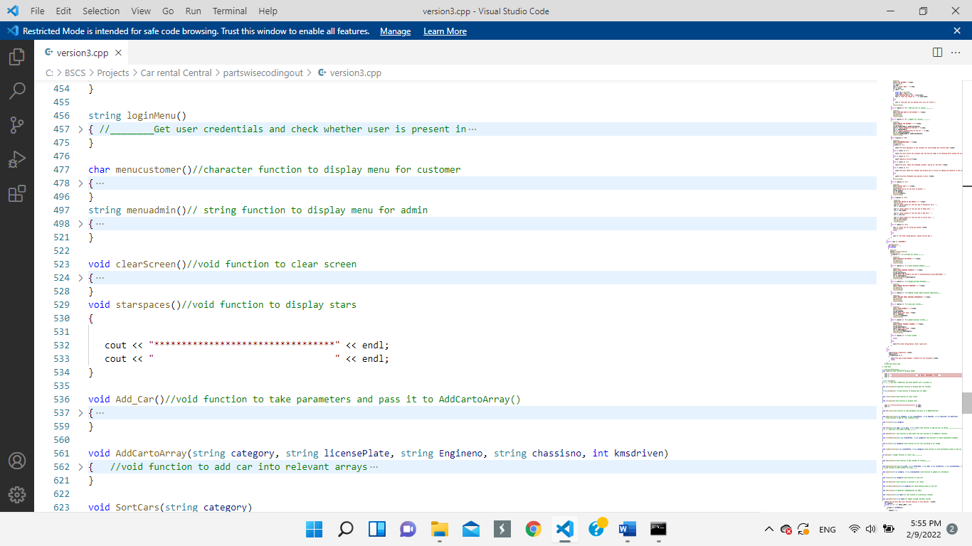

**Test Cases:**

**Login Prompt:**

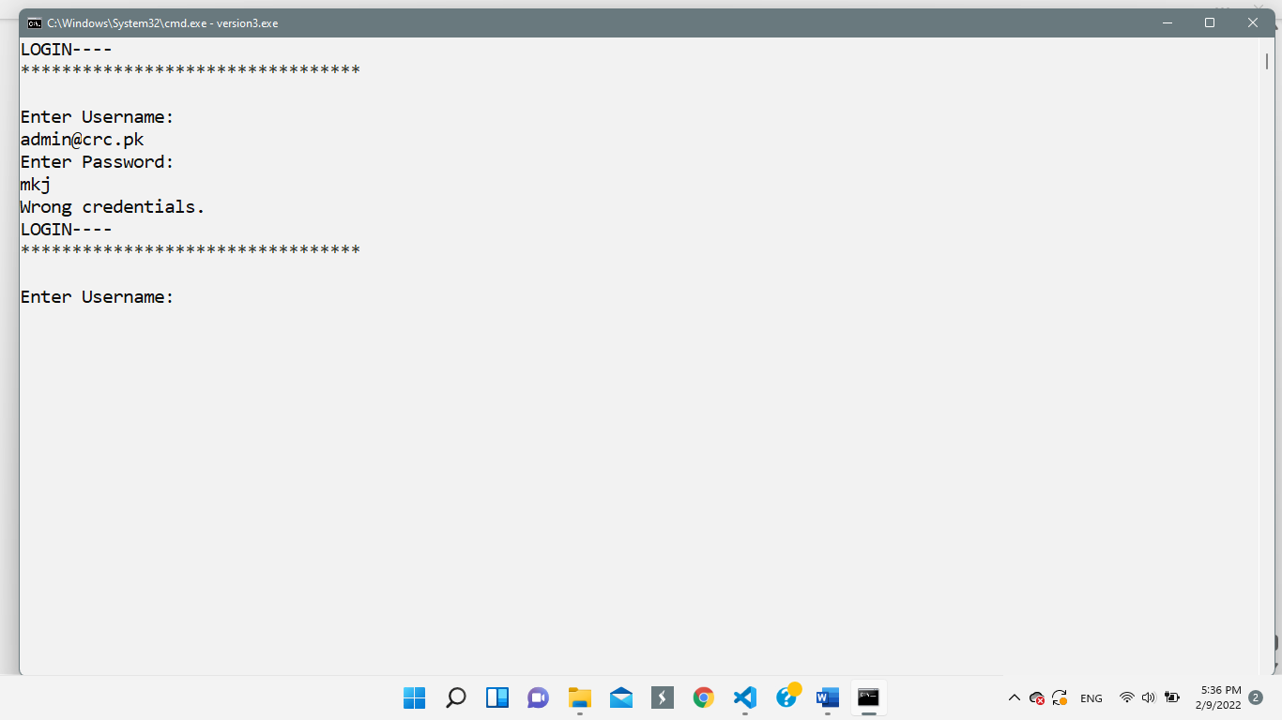

**Admin Side Options:**

1. **Add a car:**

The test case of this feature has already been shown in the “wireframes” section.

1. 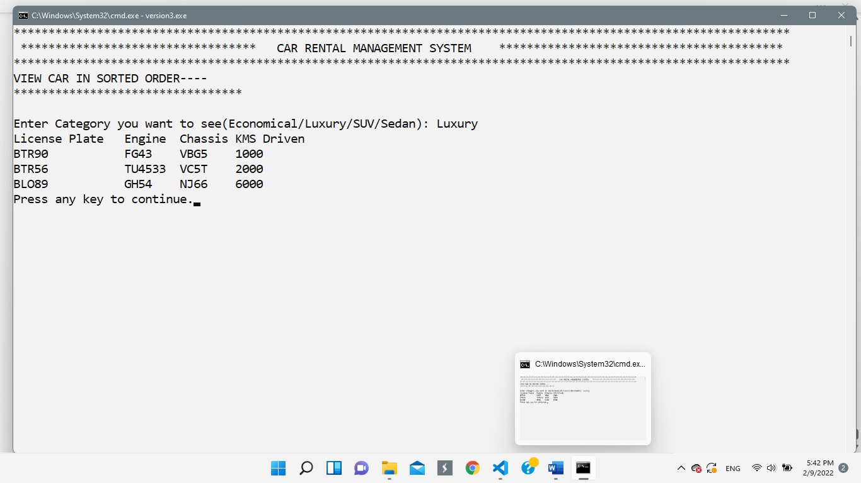**Sort And View:**

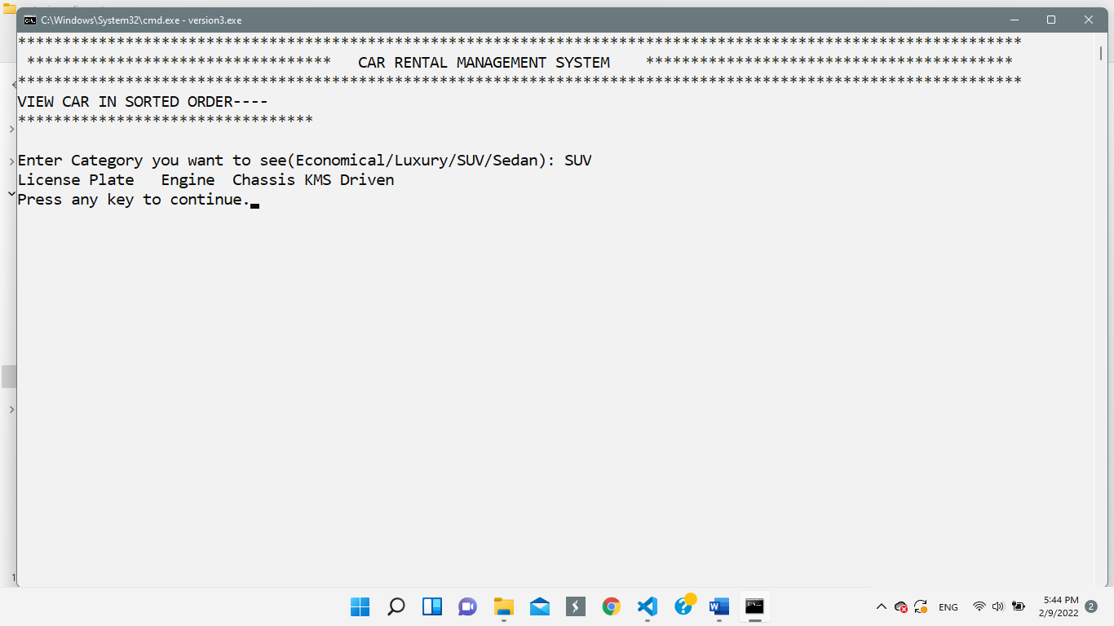If no car is added, it will show nothing below the column headers.

If entered category is wrong, it will straightforward terminate the working of the option and go to clearscreen prompt.

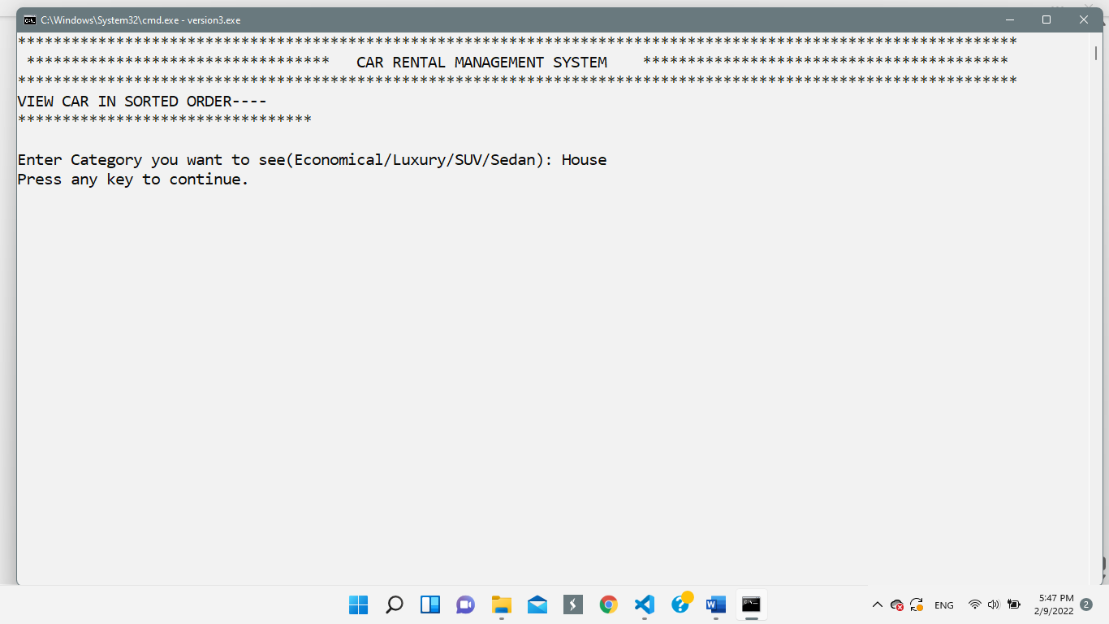

1. **Create Maintenance Schedule / View Maintenance Schedule:**

The working behind both these options validation is same.

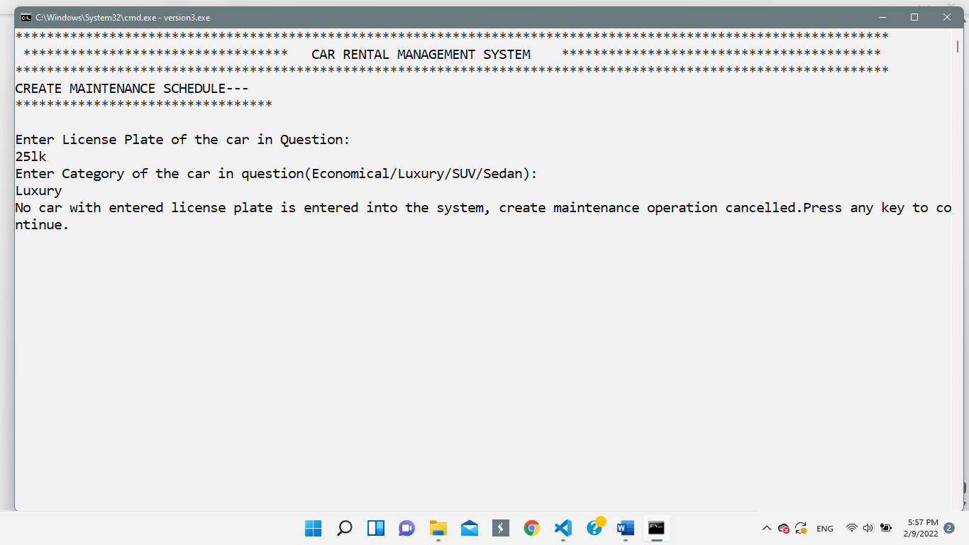

**5. Cash Reports:**

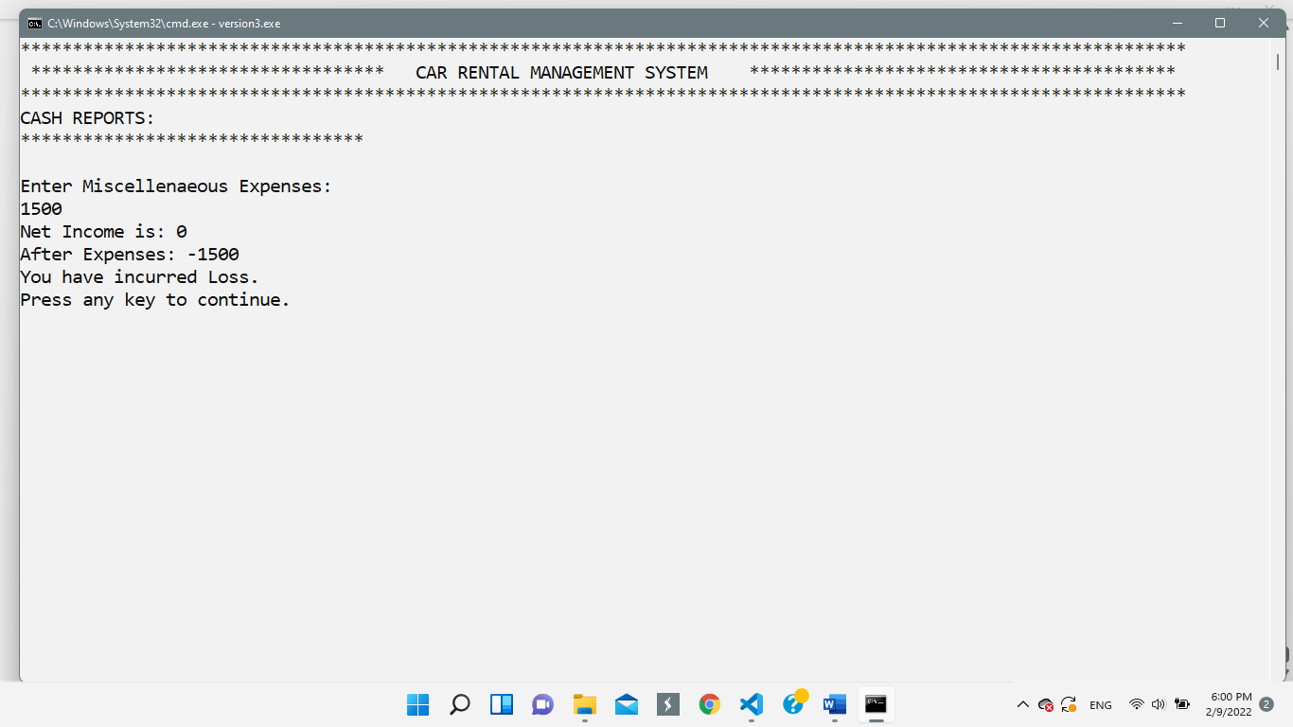

**6. Add/Validate Customer Records:**

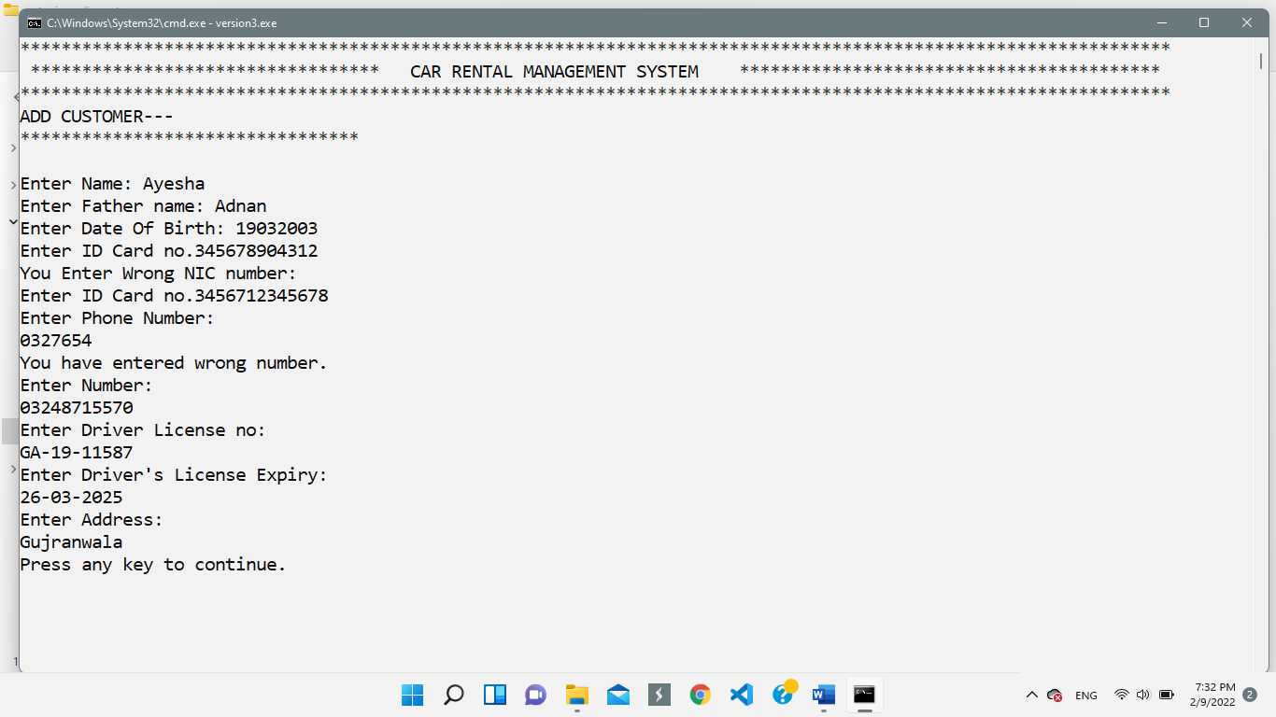

**7. Generate Tax Returns**

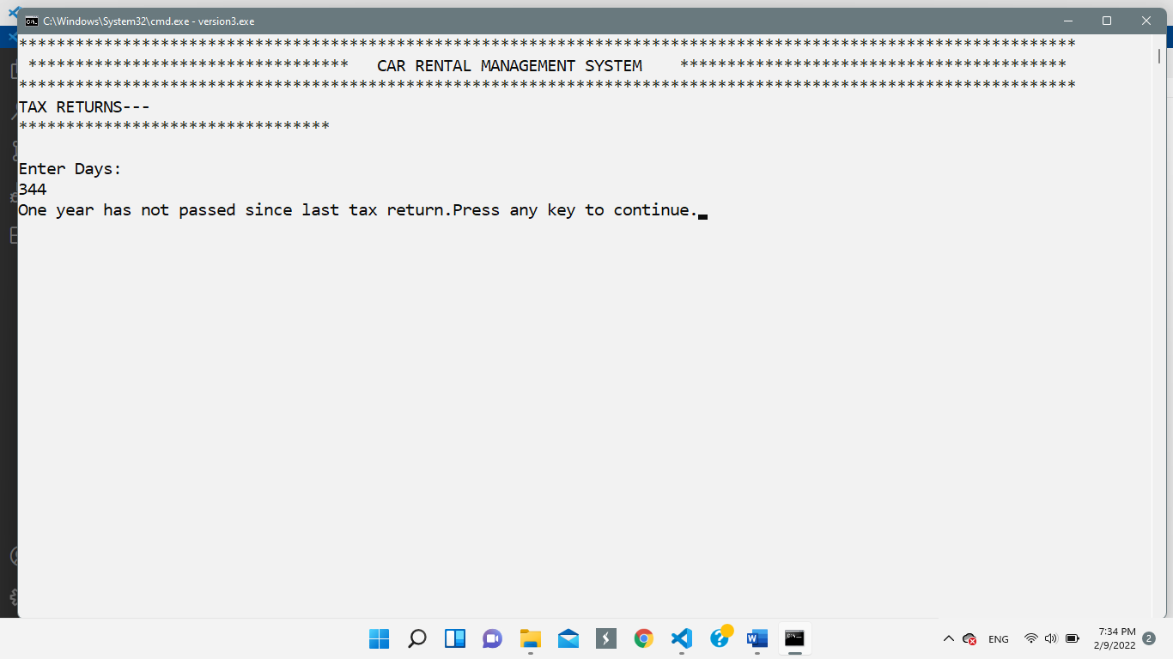

**8. Add Users to the system**

The test case of this option has already been elaborated in the “wireframes” section of this report.

**9. Update Car Information/Delete Car Information:**

The Principal type of validation is same in both these options.

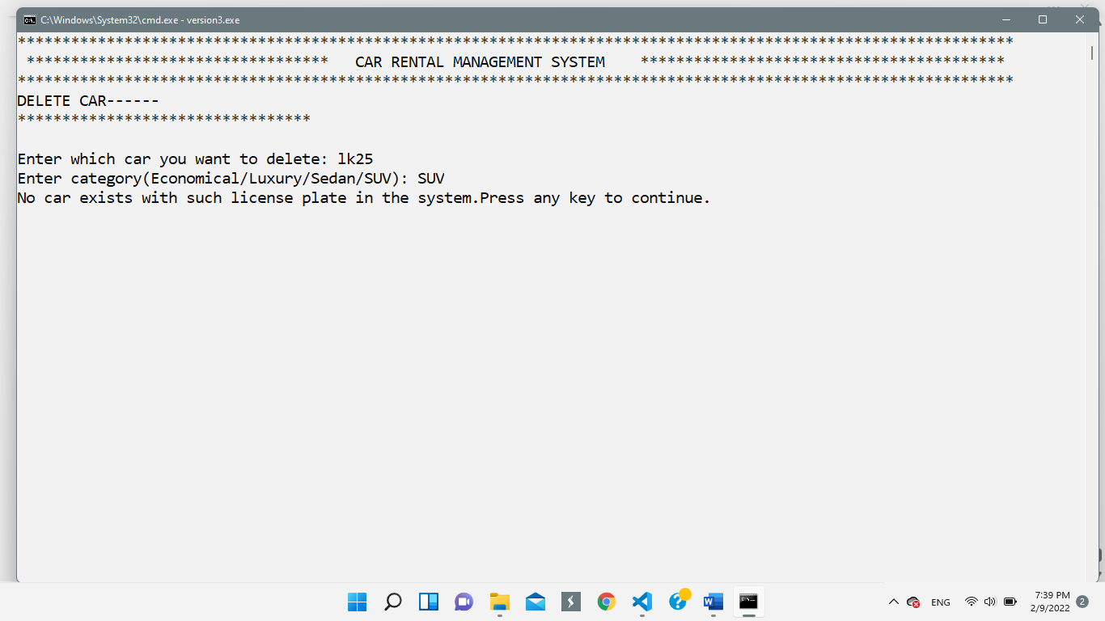

**10. Booking Schedules:**

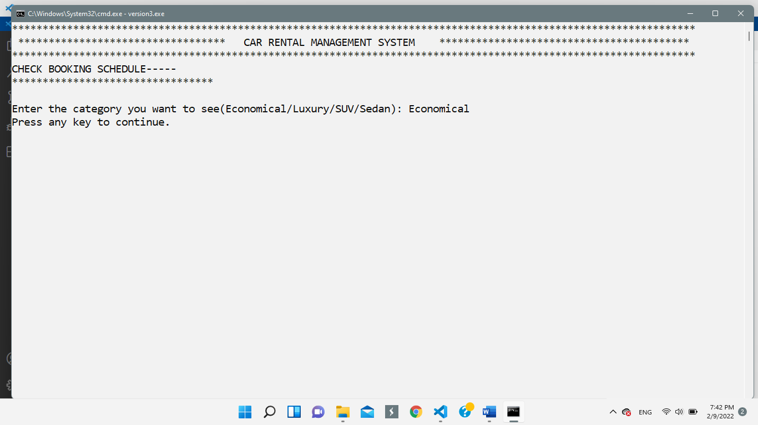

**11. View/Update Records:**

The principal type of validation is same in both these options.

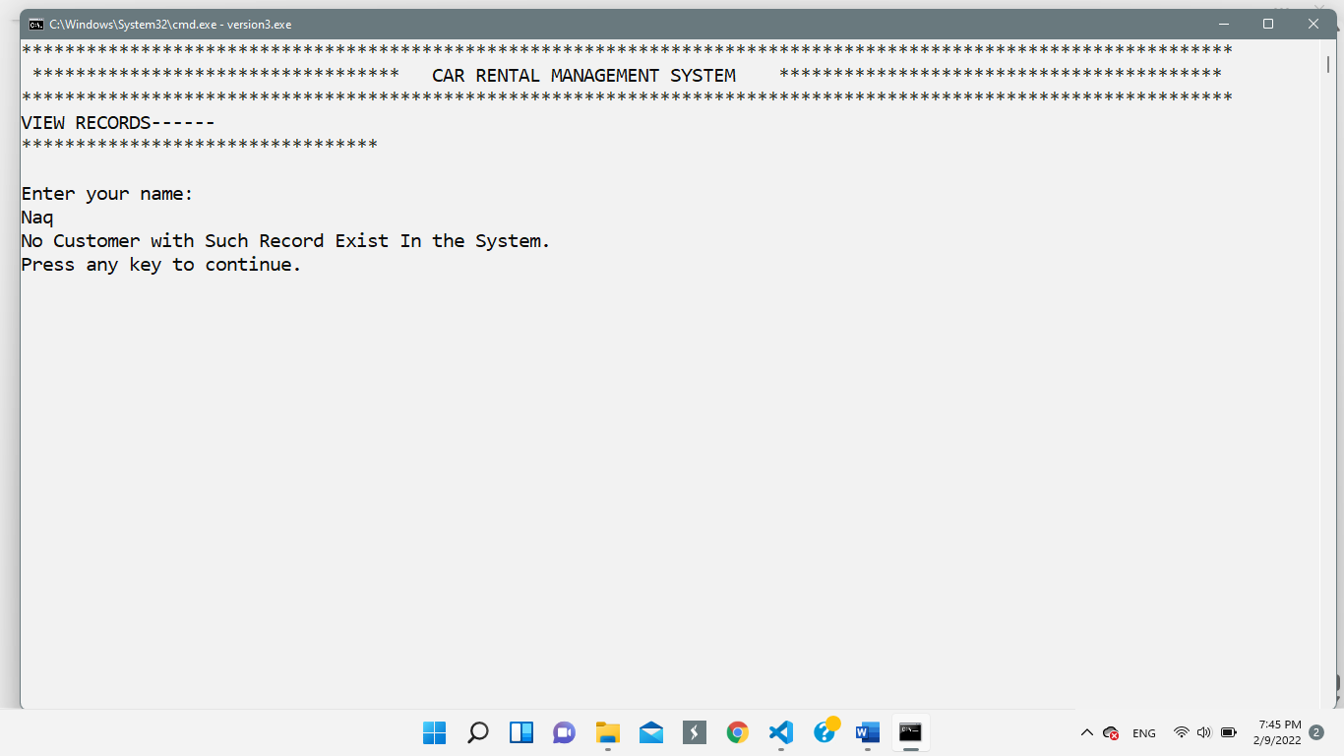

**Possible Weakness in the project and future Direction Pertaining to the Project:**

In my opinion, one possible weakness in the project (or constraint, should one say it) was the lack of flexibility, concept-wise, in the project. For example, the selection sort algorithm used in the project could have been replaced by more efficient ones like Bubble Sort etc. Similarly, the use of do-while loop in the menu driven program could have greatly simplified the logic of using a while (true) loop.

The future direction, related to this project, is to develop a web-based application of this program. In shaa ALLAH, I hope that in near future, I would be able to do it.

**Conclusion:**

During the making, implementation and execution of this program, I was able to revise and efficiently apply the concepts of variables, if-else statements, loops, arrays and parsing CSV files.

This project helped me to grasp these concepts more efficiently.

**Future Planning:**

In the very near future, when we study the concepts of classes in object oriented structures, I will develop a software for rolling a deck of playing cards (poker game). Then, I will pursue a career in E-commerce and AI. In shaa ALLAH.

**Student Reg. No. :**   **Student Name.**

|  |  |  |  |  |
| --- | --- | --- | --- | --- |
|  | **A-Extensive Evidence** | **B-Convincing Evidence** | **C-Limited Evidence** | **D-No Evidence** |
| Documentation Formatting **Grade:** | All the documentation meets all the criteria. | Documentation is well formatted but some of the criteria is not fulfilled. | Documentation is required a lot of improvement. | Documentation is not Available |
| **Documentation Formatting Criteria:** In **Binder**, **Title** Page, **Header**-Footers, Font **Style**, Font **Size** all are all consistence and according to given **guidelines**. Project **Poster** is professionally design and well presented | | | | |
| Documentation Contents  **Grade:** | Documentation includes all of the criteria. | Documentation meet more than 80% of the criteria given. | Documentation meet more than 50% of the criteria. | When the documentation meet less than 50% of the criteria. |
| **Documentation Contents Criteria:** **Title** Page - **Table** of Contents - Project **Abstract** - **Functional** Requirements - **Wire** Frames –**Data Flow** Diagram-**Data** Structure (Arrays)-**Function** Headers and Description - **Algorithms** and Flow Charts of all functions- **Test Cases** are defined -Project **Code.** - **Weakness** in the Project and **Future** Directions. - **Conclusion** and What your **Learn** from the Project and Course and What is your **Future** Planning. | | | | |
| Project Complexity  **Grade:** | Project has at least 2 user’s types and each user has at least 5 functionalities. | Project complexity meet 80% criteria given in extensive evidence | Project complexity meet 50% criteria given in extensive evidence | Project complexity meet less than 50% criteria given in extensive evidence |
| Code Style  **Grade:** | All Code style criteria is followed | All code style criteria followed but some improvements required | lot of improvements required in coding style. | **Did not follow** code style, |
| **Code Style Criteria:**  Consistent code style. Code is well indented. Variable and Function names are well defined.  White Spaces are well used. Comments are added. | | | | |
| Code Documentation Mapping  **Grade:** | Code and documentation is synchronized. | Code and documentation does not synchronized at **some** places | Code and documentation does not synchronized at **many** places | Code and documentation **does not** synchronized. |
| Data Structure (Arrays)  **Grade:** | Data structure is sufficient for the project requirements | Data Structure is sufficient but require improvement to meet project requirements. | Data structure is not sufficient and need a lot of improvement | Data Structure is not properly identified and declared. |
| Sorting Features  **Grade:** | Sort working 100% and generating useful report | Sorting Feature is working but sorted data is not useful for project. | Sorting feature is partial implemented | Project do not contain sorting |
| Modularity  **Grade:** | Meet all Modularity criteria | Meet all Modularity criteria but at some places it is missing | Do not sufficiently meet the modularity criteria. | No modularity or very minimum modularity. |
| **Modularity criteria:** Functions are defined for each major feature. Functions are independent (identify from parameter list and return types)- Demo Data Functionality Added-At least Two Unit Tests are defined. | | | | |
| Validations  **Grade:** | Validations on all number type inputs are applied | Validations are applied but at some places it is missing. | Validations are missing at lot of places | No Validations are used |
| Recommendation Feature | Proper meaning full recommendation is present into system | Partial Recommendation is implemented | Implemented but not meaning full. | Not implemented |
| Presentation and Demo  **Grade:** | Presentation and Demo was 100% working | Presentation and Demo require some improvements | Presentation and Demo require a lot of improvements | Presentation was not ok and Demo was not working |
| Student Understanding with the Code.  **Grade:** | Student has complete understanding how the code is working and knows the concept. | Student has good understand but some place he does not know the concepts | Student has a very little understand and lack the major concepts. | Student does not have any level of understanding of the code. |

|  |  |
| --- | --- |
| **Checked by:** | Click or tap here to enter text. |

**Student Reg. No. :**   **Student Name.**

|  |  |  |  |  |
| --- | --- | --- | --- | --- |
|  | **A-Extensive Evidence** | **B-Convincing Evidence** | **C-Limited Evidence** | **D-No Evidence** |
| Documentation Formatting **Grade:** | All the documentation meets all the criteria. | Documentation is well formatted but some of the criteria is not fulfilled. | Documentation is required a lot of improvement. | Documentation is not Available |
| **Documentation Formatting Criteria:** In **Binder**, **Title** Page, **Header**-Footers, Font **Style**, Font **Size** all are all consistence and according to given **guidelines**. Project **Poster** is professionally design and well presented | | | | |
| Documentation Contents  **Grade:** | Documentation includes all of the criteria. | Documentation meet more than 80% of the criteria given. | Documentation meet more than 50% of the criteria. | When the documentation meet less than 50% of the criteria. |
| **Documentation Contents Criteria:** **Title** Page - **Table** of Contents - Project **Abstract** - **Functional** Requirements - **Wire** Frames –**Data Flow** Diagram-**Data** Structure (Arrays)-**Function** Headers and Description - **Algorithms** and Flow Charts of all functions- **Test Cases** are defined -Project **Code.** - **Weakness** in the Project and **Future** Directions. - **Conclusion** and What your **Learn** from the Project and Course and What is your **Future** Planning. | | | | |
| Project Complexity  **Grade:** | Project has at least 2 user’s types and each user has at least 5 functionalities. | Project complexity meet 80% criteria given in extensive evidence | Project complexity meet 50% criteria given in extensive evidence | Project complexity meet less than 50% criteria given in extensive evidence |
| Code Style  **Grade:** | All Code style criteria is followed | All code style criteria followed but some improvements required | lot of improvements required in coding style. | **Did not follow** code style, |
| **Code Style Criteria:**  Consistent code style. Code is well indented. Variable and Function names are well defined.  White Spaces are well used. Comments are added. | | | | |
| Code Documentation Mapping  **Grade:** | Code and documentation is synchronized. | Code and documentation does not synchronized at **some** places | Code and documentation does not synchronized at **many** places | Code and documentation **does not** synchronized. |
| Data Structure (Arrays)  **Grade:** | Data structure is sufficient for the project requirements | Data Structure is sufficient but require improvement to meet project requirements. | Data structure is not sufficient and need a lot of improvement | Data Structure is not properly identified and declared. |
| Sorting Features  **Grade:** | Sort working 100% and generating useful report | Sorting Feature is working but sorted data is not useful for project. | Sorting feature is partial implemented | Project do not contain sorting |
| Modularity  **Grade:** | Meet all Modularity criteria | Meet all Modularity criteria but at some places it is missing | Do not sufficiently meet the modularity criteria. | No modularity or very minimum modularity. |
| **Modularity criteria:** Functions are defined for each major feature. Functions are independent (identify from parameter list and return types)- Demo Data Functionality Added-At least Two Unit Tests are defined. | | | | |
| Validations  **Grade:** | Validations on all number type inputs are applied | Validations are applied but at some places it is missing. | Validations are missing at lot of places | No Validations are used |
| Recommendation Feature | Proper meaning full recommendation is present into system | Partial Recommendation is implemented | Implemented but not meaning full. | Not implemented |
| Presentation and Demo  **Grade:** | Presentation and Demo was 100% working | Presentation and Demo require some improvements | Presentation and Demo require a lot of improvements | Presentation was not ok and Demo was not working |
| Student Understanding with the Code.  **Grade:** | Student has complete understanding how the code is working and knows the concept. | Student has good understand but some place he does not know the concepts | Student has a very little understand and lack the major concepts. | Student does not have any level of understanding of the code. |

|  |  |
| --- | --- |
| **Checked by:** | Click or tap here to enter text. |

**** THE END****